In this module, you will be introduced to databases. You will create a database instance on the cloud. You will learn some of the basic SQL statements. You will also write and practice basic SQL hands-on on a live database.

**Learning Objectives**

* Create an IBM Cloud Lite account.
* Demonstrate how to write basic SQL statements
* Describe SQL and Databases
* Create and execute CREATE TABLE, SELECT, INSERT, and DELETE SQL statements with a live database

# Welcome to SQL for Data Science

Notes

[**Discuss**](https://www.coursera.org/learn/sql-data-science/discussions/weeks/1)

0:00

Hello and welcome to SQL for data science.

The demand for data scientists is high,

boasting a median base salary of $110,000 and job satisfaction score of 4.4 out of five.

It's no wonder that it's the top spot on Glassdoor's best jobs in America.

Glassdoor analyzed data from data scientist job postings on

Glassdoor and found that SQL is listed

as one of the top three skills for a data scientist.

Before you step into the field of data science,

it is vitally important that you set yourself

apart by mastering the foundations of this field.

One of the foundational skills that you will require is SQL.

SQL is a powerful language that's used for communicating with databases.

Every application that manipulates any kind of data

needs to store that data somewhere; whether it's big data,

or just a table with a few simple rows for government, or a small startup,

or a big database that spans over

multiple servers or a mobile phone that runs its own small database.

Here are some of the advantages of learning SQL for someone interested in data science.

SQL will boost your professional profile as a data scientist,

as it is one of the most sought after skills by hiring employers.

Learning SQL will give you a good understanding of relational databases.

Tapping into all this information requires being able

to communicate with the databases that store the data.

Even if you work with reporting tools that generate SQL queries for you,

it may be useful to write your own SQL statements so that you need

not wait for other team members to create SQL statements for you.

In this course, you will learn the basics of

both the SQL language and relational databases.

The course includes interesting quizzes and hands on lab assignments,

where you can get experience working with databases.

In the first few modules,

you work directly with the database and develop a working knowledge of SQL.

Then, you will connect to a database and run

SQL queries like a data scientist typically would,

where you will use Python and Jupyter notebooks to connect

to relational databases to access and analyze data.

There is also an assignment included towards the end of the course,

where you will get an opportunity to apply the concepts that you learned.

So, let's get started with SQL for data science.

# About Hands-on Labs in this course

An important aspect of working with databases and SQL is developing hands-on skills. Therefore, each module in the course contains hands-on labs for you to practice what you learn in the videos. In this course, you will be using the **IBM Db2 database service** to practice and apply your skills. To provision an instance of Db2 you require an IBM Cloud account, for which you will be provided a feature code to create a trial account.

In case you encounter issues with creating an IBM Cloud account or provisioning a Db2 instance, the course also contains alternative labs using other database software that is marked **Optional**. If you are able to work with Db2, you do not need to complete the optional labs. However, if you encounter issues with Db2, you can practice using the optional labs instead.

# Introduction to Databases

Notes

[**Discuss**](https://www.coursera.org/learn/sql-data-science/discussions/weeks/1)

0:00

Hello and welcome to SQL for data science.

First, we will talk a little bit about what you'll learn in this course.

This course teaches you the basics of the SQL language and the relational database model.

There will be some lab exercises,

and at the end of each section

there are a few review questions.

And at the end, there is a final exam.

By the end of this course,

you will be able to discuss SQL basics and

explain various aspects of the relational database model.

In this video, we will learn about SQL and relational databases.

By the end of this video,

you will be able to describe SQL, data,

database, a relational database, and list five basic SQL commands.

But wait, what is SQL and what is a relational database? What is SQL?

SQL is a language used for relational databases to query or get data out of a database.

SQL is also referred to as SQL

and is short for its original name Structured English Query Language.

So SQL is a language used for a database to query data.

But what is data and what is a database?

Data is a collection of facts in the form of words,

numbers, or even pictures.

Data is one of the most critical assets of any business.

It is used and collected practically everywhere.

Your bank stores data about you, your name,

address, phone number, account number et cetera.

Your credit card company and your paypal accounts also store data about you.

Data is important; so, it needs to be

secure, and it needs to be stored and accessed quickly.

The answer is a database.

So, what is a database?

Databases are everywhere and used every day, but they are largely taken for granted.

A database is a repository of data.

It is a program that stores data.

A database also provides the functionality for adding,

modifying, and querying that data.

There are different kinds of databases of different requirements.

The data can be stored in various forms.

When data is stored in tabular form,

the data is organized in tables like in a spreadsheet,

which is columns and rows.

That's a relational database.

The columns contain properties about the item such as last name,

first name, email address, city.

A table is a collection of related things like

a list of employees or a list of book authors.

In a relational database,

you can form relationships between tables.

So a database is a repository of data.

A set of software tools for the data in the database is called

a database management system or DBMS for short.

The terms database, database server, database system,

data server, and database management systems are often used interchangeably.

For relational databases, it's called a relational database management system or RDBMS.

RDBMS is a set of software tools that controls

the data such as access, organization, and storage.

And RDBMS serves as the backbone of applications in many industries including banking,

transportation, health, and so on.

Examples of relational database management systems are

my SQL, Oracle Database,

DB2 Warehouse, and DB2 on Cloud. For the majority of people using a database,

there are five simple commands to create a table,

insert data to populate the table,

select data from the table,

update data in the table,

delete data from the table.

So those are the building blocks for SQL for data science.

You can now describe what is SQL, what is data,

what is a database, and what is a relational database.

You know that RDBMS stands for Relational Database Management System,

and you can list five basic SQL commands to create a table,

insert data to populate the table,

select data from the table,

update data in the table,

and delete data from the table.

Thanks for watching this video.

(Music)

# SELECT Statement

0:00

Hello and welcome to retrieving data with a SELECT statement.

In this video, we will learn about retrieving data from

a relational database table by selecting columns of a table.

At the end of this lesson,

you will be able to retrieve data from a relational database table,

to find the use of a predicate,

identify the syntax of the SELECT statement using the WHERE clause, and

list the comparison operators supported by a relational database management system.

The main purpose of a database management system,

is not just to store the data but also facilitate retrieval of the data.

So, after creating a relational database table and inserting data into the table,

we want to see the data.

To see the data, we use the SELECT statement.

The SELECT statement is a data manipulation language statement.

Data Manipulation Language statements or DML statements are used to read and modify data.

The SELECT statement is called a query,

and the output we get from executing this query is called a result set or a result table.

In its simplest form, a SELECT statement is select star from table name.

Based on the book entity example,

we would create the table using

the entity name book and the entity attributes as the columns of the table.

The data would be added to the book table by adding

rows to the table using the insert statement.

In the book entity example, select star from book gives the result set of four rows.

All the data rows for all columns in the table book are displayed.

In addition, you can also retrieve all the rows for all columns by

specifying the column names individually in the SELECT statement.

You don't always have to retrieve all the columns in a table.

You can retrieve just a subset of columns.

If you want, you can retrieve just two columns from the table book.

For example book\_id and title.

In this case, the select statement is select book\_id, title from book.

In this case, only the two columns display for each of the four rows.

Also notice that the order of the columns displayed

always matches the order in the SELECT statement.

However, what if we want to know the title of the book whose book\_id is B1.

Relational operation helps us in restricting

the result set by allowing us to use the clause WHERE.

The WHERE clause always requires a predicate.

A predicate is conditioned evaluates to true, false or unknown.

Predicates are used in the search condition of the WHERE clause.

So, if we need to know the title of the book whose book\_id is B1,

we use the WHERE clause with the predicate book\_id equals B1.

Select book\_id title from book where book\_id equals B1.

Notice the result set is now restricted to

just one row whose condition evaluates to true.

The previous example used comparison operator equal to in the WHERE clause.

There are other comparison operators supported by

a relational database management system: equal to,

greater than, less than,

greater than or equal to,

less than or equal to, and not equal to.

Now you can retrieve data and select columns from a relational database table,

define the use of a predicate,

identify the syntax of the SELECT statement using the WHERE clause, and

list the comparison operators supported by a relational database management system.

Thanks for watching this video.

## Reading: SELECT statement examples (2 mins)

## Objectives

At the end of this lab you will be able to:

* use SELECT queries to retrieve data from the database

**Effort:** 2 min

The general syntax of SELECT statments is:

**select COLUMN1, COLUMN2, ... from TABLE1 ;**

To retrieve all columns from the COUNTRY table we could use "\*" instead of specifying individual column names:

**select \* from COUNTRY ;**

The WHERE clause can be added to your query to filter results or get specific rows of data. To retrieve data for all rows in the COUNTRY table where the ID is less than 5:

**select \* from COUNTRY where ID < 5 ;**

In case of character based columns the values of the predicates in the where clause need to be enclosed in single quotes. To retrieve the data for the country with country code "CA" we would issue:

\*\*select \* from COUNTRY where CCODE = 'CA'; \*\*

In the lab that follows later in the module, you will apply these concepts and practice SELECT queries hands-on.

Good luck!

## Author(s)

#### Rav Ahuja

## Changelog

| **Date** | **Version** | **Changed by** | **Change Description** |
| --- | --- | --- | --- |
| 2020-08-31 | 2.0 | Malika Singla | Markdown file creation |



# Hands-on Lab : Basics of SQL SELECT Statement

**Estimated time needed:** 20 minutes

In this lab, you will learn one of the most commonly used statements of SQL (Structured Query Language), the SELECT statement. The SELECT statement is used to select data from a database.

**How does the syntax of a SELECT statement look?**

**SELECT** column1, column2, ...

**FROM** table\_name

**WHERE** condition

;

**What do the keywords / clauses of a SQL statement shown above do?**

* **FROM**: Specifies from which table to get the data. The clause can include optional JOIN subclauses to specify the rules for joining tables.
* [Optional Clause] **WHERE** : Specifies which rows to retrieve.

**Why is there a semicolon after the SQL statements?**

* Some database systems require a semicolon at the end of each SQL statement for execution. It is a standard way to separate one SQL statement from another which allows more than one SQL statement to be executed in the same call to the server. So, it is good practice to use a semicolon at the end of each SQL statement.

## Software Used in this Lab

In this lab, you will use [Datasette](https://github.com/simonw/datasette?utm_medium=Exinfluencer&utm_source=Exinfluencer&utm_content=000026UJ&utm_term=10006555&utm_id=NA-SkillsNetwork-Channel-SkillsNetworkCoursesIBMDeveloperSkillsNetworkDB0201ENSkillsNetwork22-2022-01-01" \t "_blank), an open source multi-tool for exploring and publishing data.

## Database Used in this Lab

The database used in this lab comes from the following dataset source: [Film Locations in San Francisco](https://data.sfgov.org/Culture-and-Recreation/Film-Locations-in-San-Francisco/yitu-d5am?utm_medium=Exinfluencer&utm_source=Exinfluencer&utm_content=000026UJ&utm_term=10006555&utm_id=NA-SkillsNetwork-Channel-SkillsNetworkCoursesIBMDeveloperSkillsNetworkDB0201ENSkillsNetwork22-2022-01-01) under a [PDDL: Public Domain Dedication and License](https://opendatacommons.org/licenses/pddl/1-0/?utm_medium=Exinfluencer&utm_source=Exinfluencer&utm_content=000026UJ&utm_term=10006555&utm_id=NA-SkillsNetwork-Channel-SkillsNetworkCoursesIBMDeveloperSkillsNetworkDB0201ENSkillsNetwork22-2022-01-01).

## Objectives

After completing this lab, you will be able to:

* Query a database
* Retrieve data records from one or more tables of a database as resultset according to the criteria you specify

# Task A: Exploring the Database

Let us first explore the **SanFranciscoFilmLocations** database using the **Datasette** tool:

1. If the first statement listed below is not already in the Datasette textbox on the right, then copy the code below by clicking on the little copy button on the bottom right of the codeblock below and then paste it into the textbox of the Datasette tool using either **Ctrl+V** or right-click in the text box and choose **Paste**.
2. **SELECT** \* **FROM** FilmLocations;

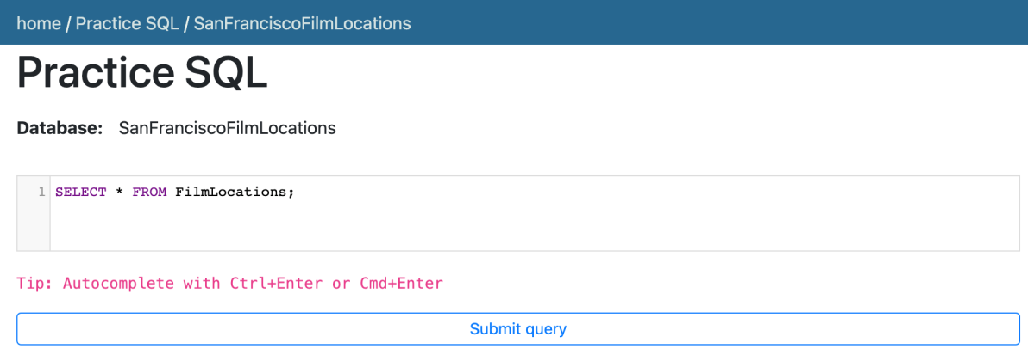

1. Click **Submit Query**.
2. Now you can scroll down the table and explore all the columns and rows of the **FilmLocations** table to get an overall idea of the table contents.

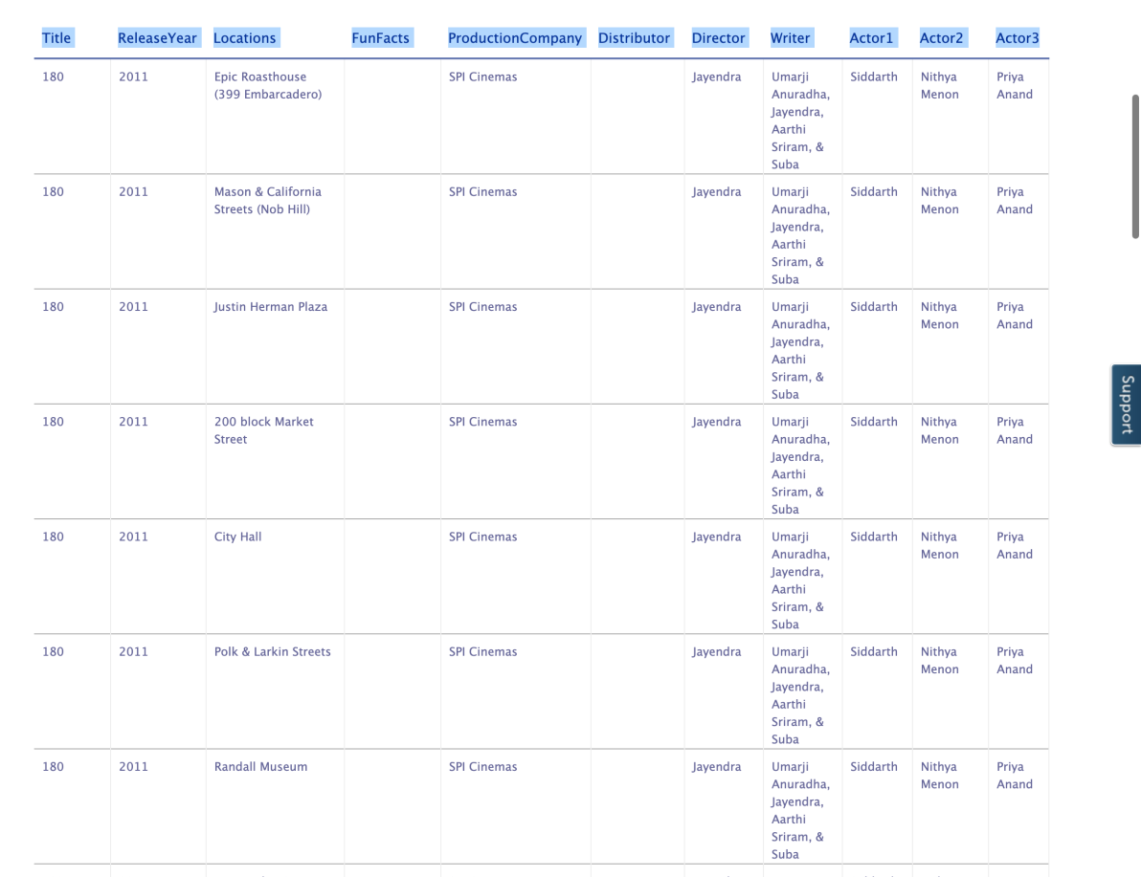

1. These are the column attribute descriptions from the **FilmLocations** table:
2. FilmLocations(
3. Title: titles of the films,
4. ReleaseYear: time of public release of the films,
5. Locations: locations of San Francisco where the films were shot,
6. FunFacts: funny facts about the filming locations,
7. ProductionCompany: companies who produced the films,
8. Distributor: companies who distributed the films,
9. Director: people who directed the films,
10. Writer: people who wrote the films,
11. Actor1: person 1 who acted in the films,
12. Actor2: person 2 who acted in the films,
13. Actor3: person 3 who acted in the films
14. )

# Task B: Example exercises on SELECT statement

Now let us go through some examples of SELECT queries:

1. In this example, suppose we want to retrieve details of all the films from the "FilmLocations" table. The details of each film record should contain all the film columns.
   1. Problem:

Retrieve all records with all columns from the "FilmLocations" table.

* 1. Solution:
  2. **SELECT** \* **FROM** FilmLocations;
  3. Copy the solution code above by clicking on the little copy button on the bottom right of the codeblock below and paste it to the textbox of the Datasette tool. Then click **Submit query**.

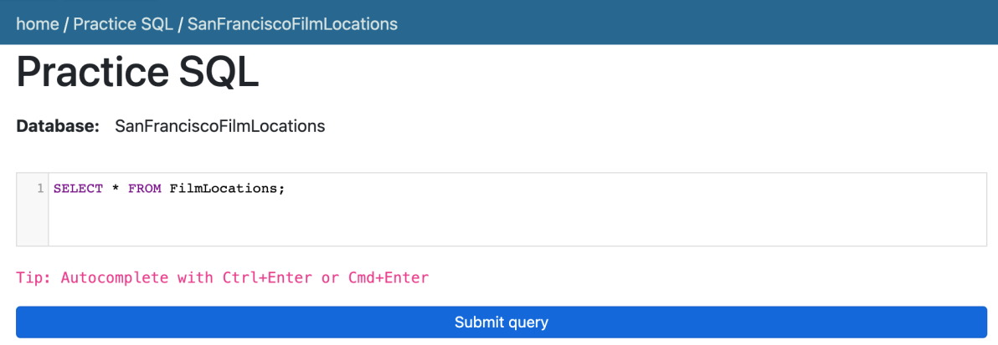

* 1. Your output resultset should match like below:

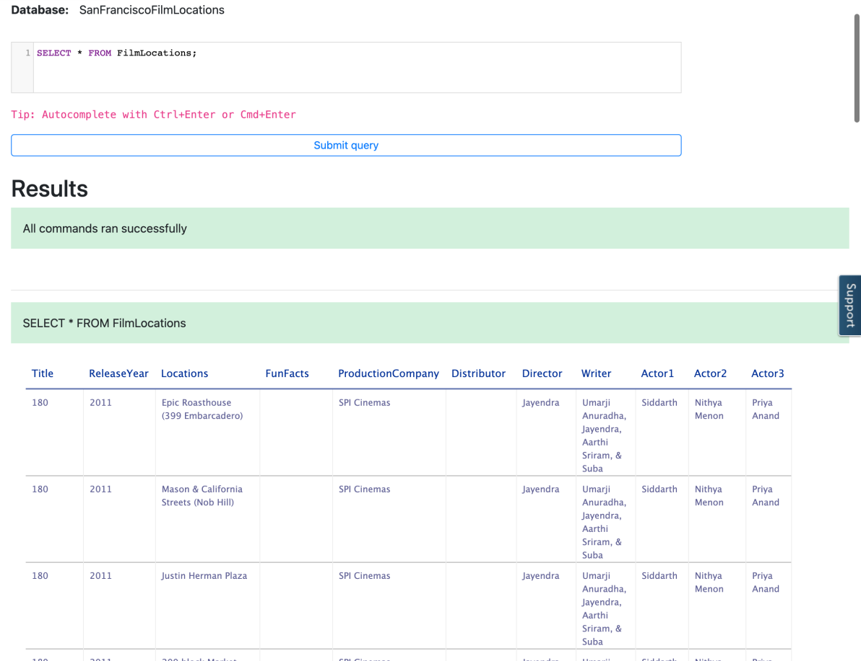

1. In this example, now we want to retrieve selective details of all the film records. Let us retrieve the names of all the films along with director names and writer names.
   1. Problem:

Retrieve the names of all films with director names and writer names.

* 1. Solution:
  2. SELECT Title, Director, Writer FROM FilmLocations;
  3. Copy the solution code above by clicking on the little copy button on the bottom right of the codeblock below and paste it to the textbox of the Datasette tool. Then click **Submit query**.

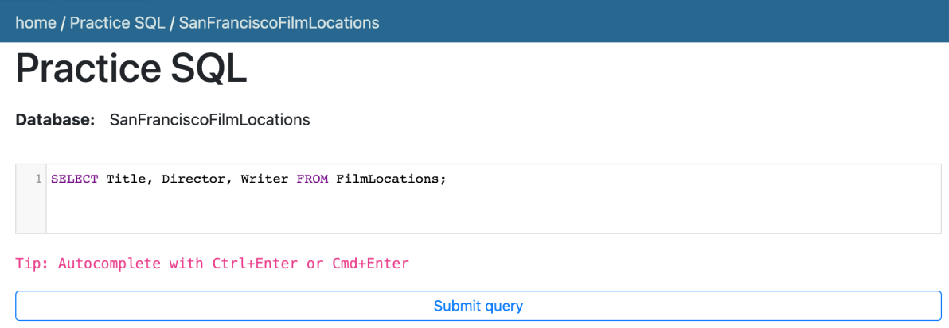

* 1. Your output resultset should match like below:

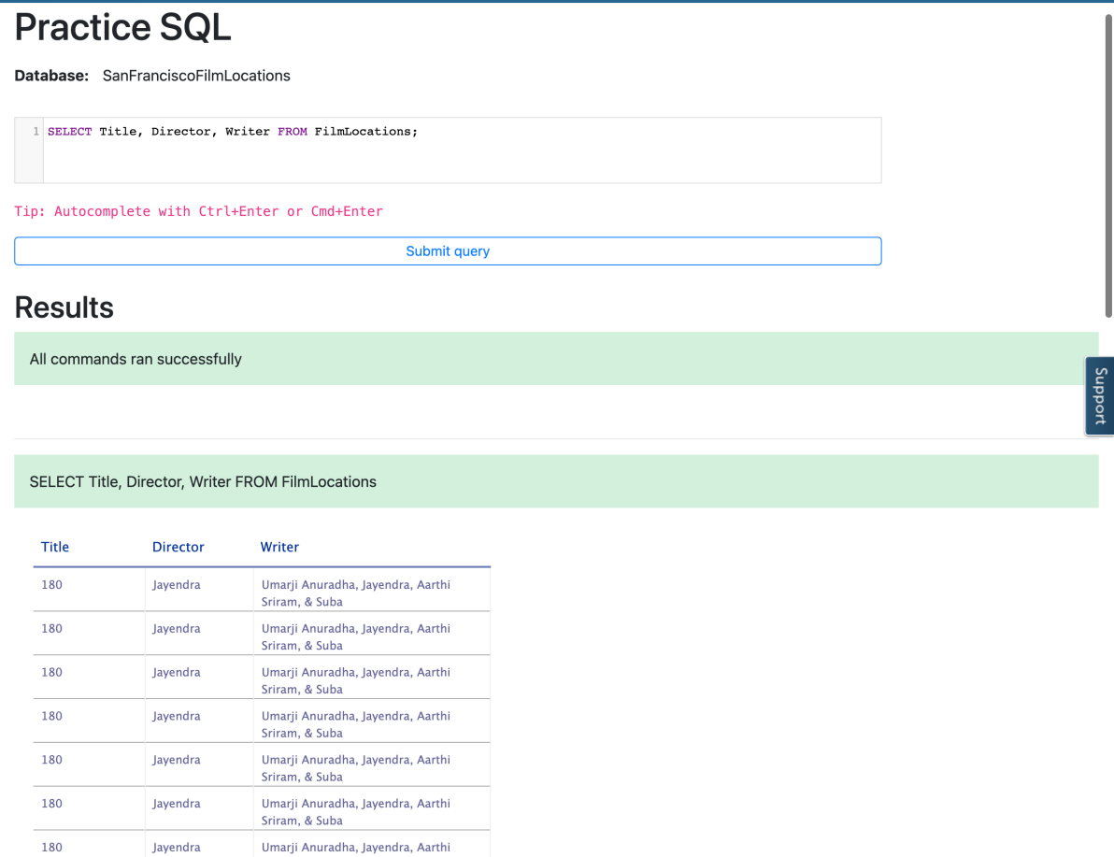

1. In this example, we want to retrieve film names along with filming locations and release years. But we also want to restrict the output resultset so that we can retrieve only the film records released in 2001 and onwards (release years after 2001 including 2001).
   1. Problem:

Retrieve the names of all films released in the 21st century and onwards (release years after 2001 including 2001), along with filming locations and release years.

* 1. Solution:
  2. **SELECT** Title, ReleaseYear, Locations **FROM** FilmLocations **WHERE** ReleaseYear>=2001;
  3. Copy the solution code above by clicking on the little copy button on the bottom right of the codeblock below and paste it to the textbox of the Datasette tool. Then click **Submit query**.

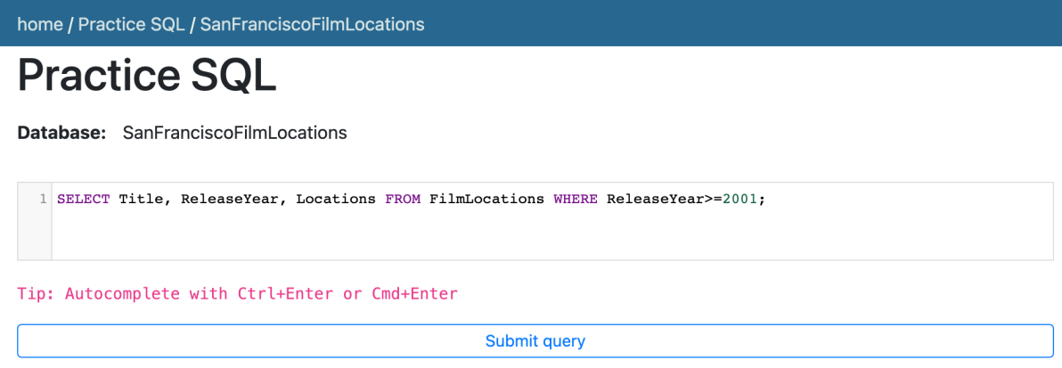

* 1. Your output resultset should match like below:

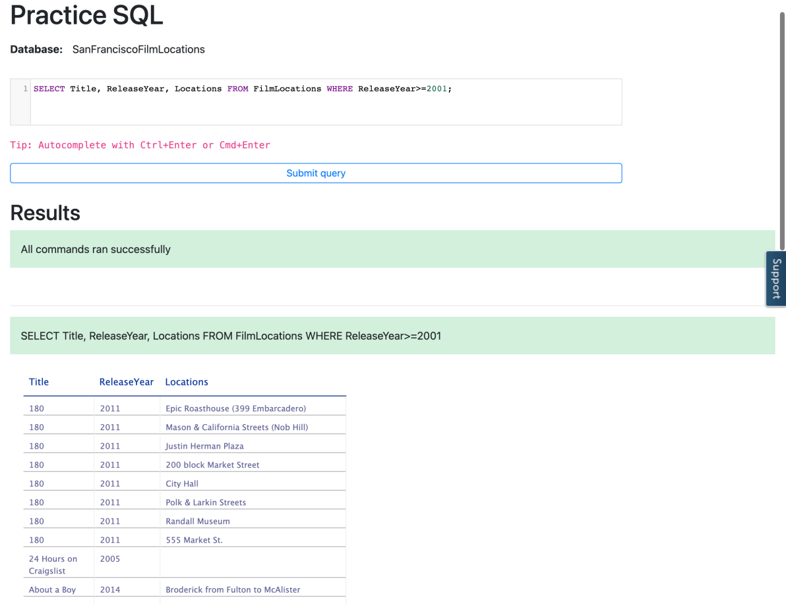

# Task C: Practice exercises on SELECT statement

Finally, let us practice creating and running some SELECT queries.

1. Problem:

Retrieve the fun facts and filming locations of all films.

Click here for Hint

Click here for Solution

Click here for Output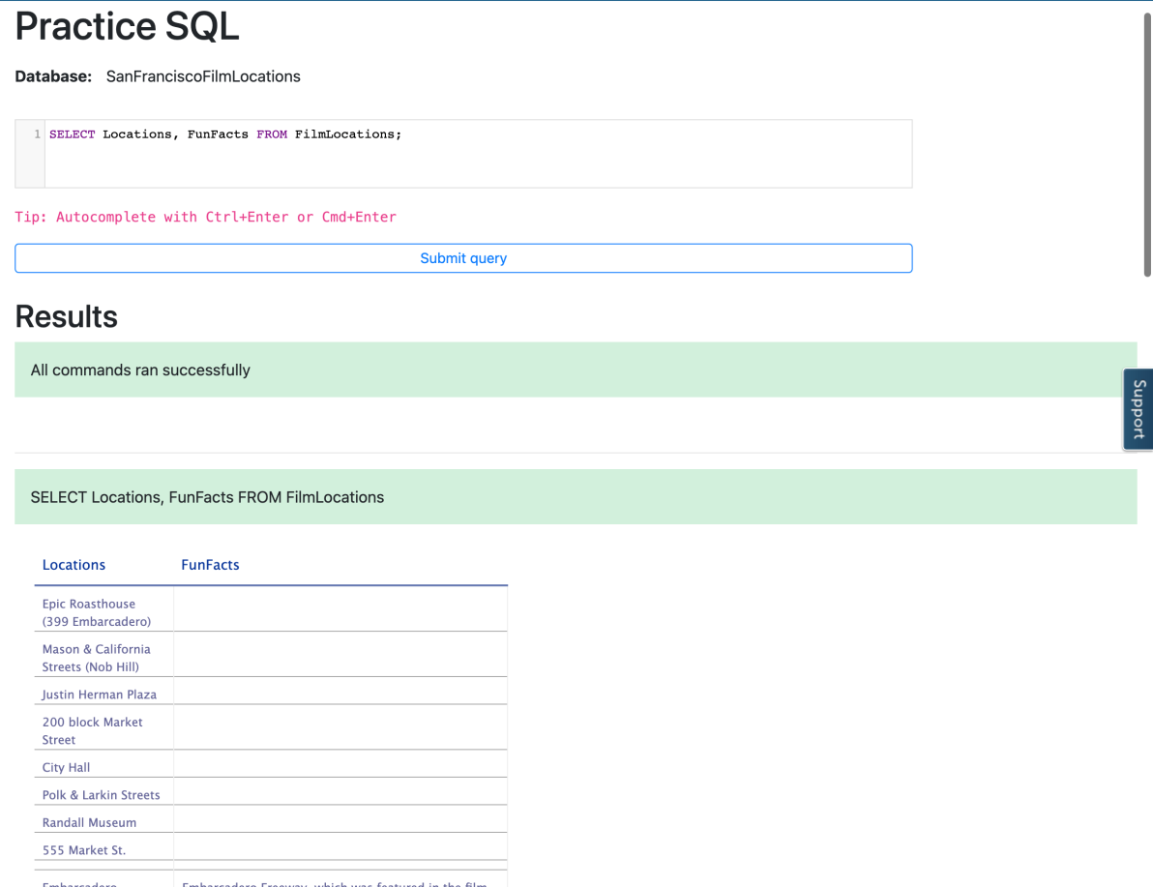

1. Problem:

Retrieve the names of all films released in the 20th century and before (release years before 2000 including 2000) that, along with filming locations and release years.

Click here for Hint

Click here for Solution

Click here for Output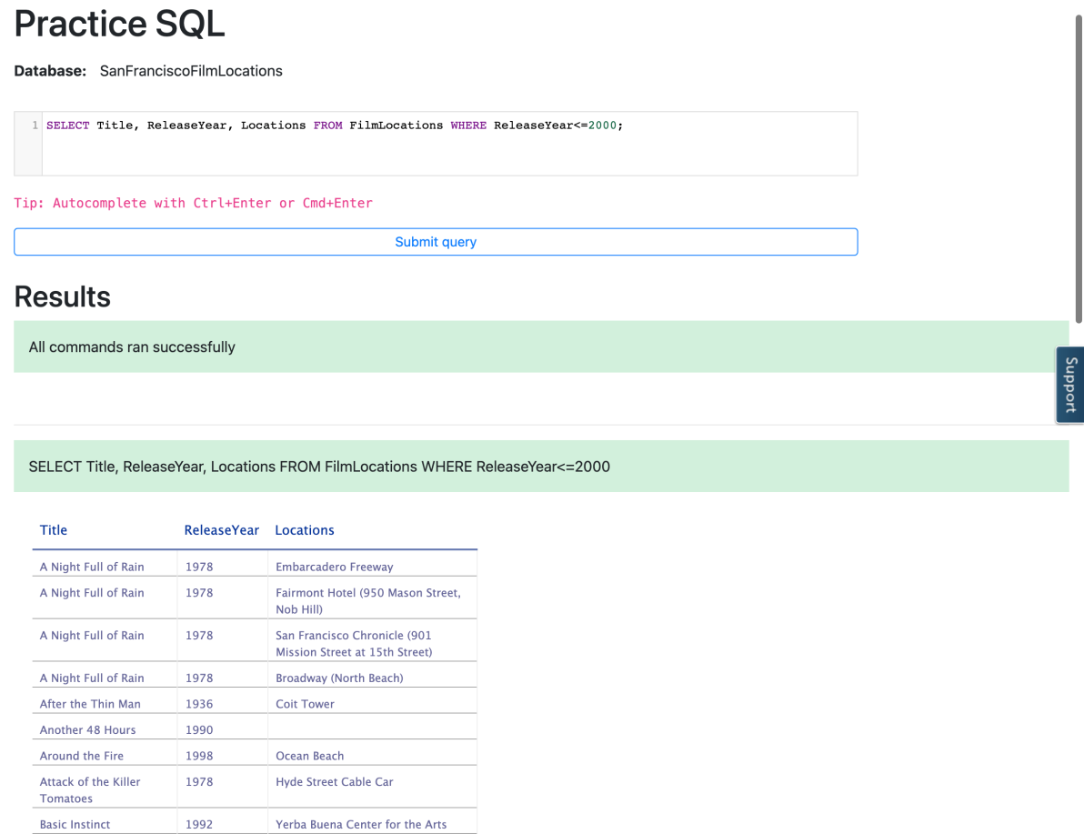

1. Problem:

Retrieve the names, production company names, filming locations, and release years of the films which are not written by James Cameron.

Click here for Hint

Click here for Solution

Click here for Output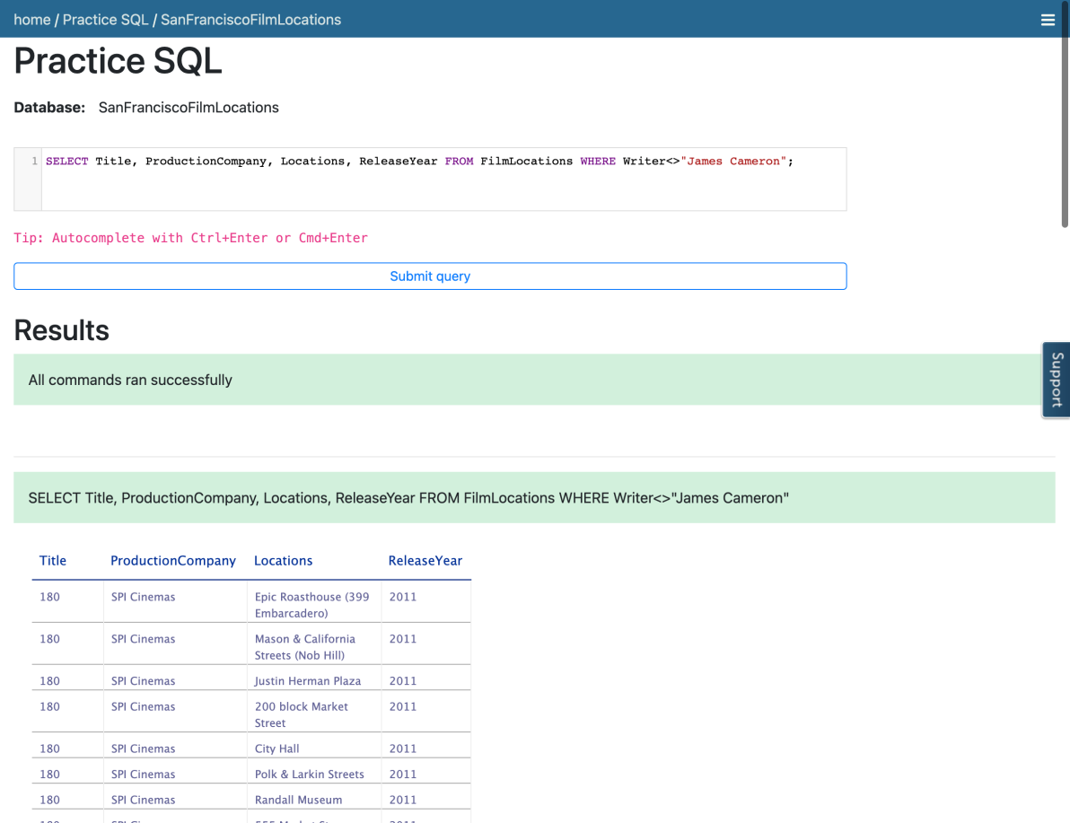

### Congratulations! You have completed this Lab.

## Author(s)

* [Sandip Saha Joy](https://www.linkedin.com/in/sandipsahajoy/?utm_medium=Exinfluencer&utm_source=Exinfluencer&utm_content=000026UJ&utm_term=10006555&utm_id=NA-SkillsNetwork-Channel-SkillsNetworkCoursesIBMDeveloperSkillsNetworkDB0201ENSkillsNetwork22-2022-01-01)

## Other Contributor(s)

## Changelog

| **Date** | **Version** | **Changed by** | **Change Description** |
| --- | --- | --- | --- |
| 2022-07-27 | 1.2 | Lakshmi Holla | Updated html tag |
| 2020-11-23 | 1.1 | Steve Ryan | ID Review |
| 2020-11-20 | 1.0 | Sandip Saha Joy | Initial version created |

### © IBM Corporation 2020. All rights reserved.

# COUNT, DISTINCT, LIMIT

0:00

[MUSIC]

Hello and welcome.

In this video, we'll briefly present a few useful expressions that

are used with select statements.

The first one is COUNT, COUNT is a built-in database function that

retrieves the number of rows that match the query criteria.

For example, get the total number of rows in a given table,

select COUNT(\*) from tablename.

Let's say you create a table called MEDALS which has a column called COUNTRY, and

you want to retrieve the number of rows where the medal recipient is from Canada.

You can issue a query like this:

Select COUNT(COUNTRY) from MEDALS where COUNTRY='CANADA.'

The second expression is DISTINCT.

DISTINCT is used to remove duplicate values from a result set.

Example, to retrieve unique values in a column,

select DISTINCT columnname from tablename.

In the MEDALS table mentioned earlier,

a country may have received a gold medal multiple times.

Example, retrieve the list of unique countries that received gold medals.

That is, removing all duplicate values of the same country.

Select DISTINCT COUNTRY from MEDALS where MEDALTYPE = 'GOLD'.

The third expression is LIMIT, LIMIT is used for

restricting the number of rows retrieved from the database.

Example, retrieve just the first 10 rows in a table.

Select \* from tablename LIMIT 10.

This can be very useful to examine the results set by looking at just a few

rows instead of retrieving the entire result set which may be very large.

Example, retrieve just a few rows in the MEDALS table for a particular year.

Select \* from MEDALS where YEAR = 2018 LIMIT 5.

In this video we looked at some useful expressions that are used with select

statements, namely the COUNT, DISTINCT, and LIMIT built-in functions.

Thanks for watching this video.

[MUSIC]

# Hands-on Lab : COUNT, DISTINCT, LIMIT

**Estimated time needed:** 35 minutes

In this lab, you will learn a few useful expressions that are used with SELECT statements. First, you will learn COUNT, which is an aggregate function that retrieves the number of rows that matches the query criteria. Next, you will learn DISTINCT, which is used to remove duplicate values from a specified result set and only return the unique values. Lastly, you will learn LIMIT, which is used for restricting the number of rows retrieved from the table.

## Software Used in this Lab

In this lab, you will use [Datasette](https://github.com/simonw/datasette?utm_medium=Exinfluencer&utm_source=Exinfluencer&utm_content=000026UJ&utm_term=10006555&utm_id=NA-SkillsNetwork-Channel-SkillsNetworkCoursesIBMDeveloperSkillsNetworkDB0201ENSkillsNetwork22-2022-01-01" \t "_blank), an open source multi-tool for exploring and publishing data.

## Database Used in this Lab

The database used in this lab comes from the following dataset source: [Film Locations in San Francisco](https://data.sfgov.org/Culture-and-Recreation/Film-Locations-in-San-Francisco/yitu-d5am?utm_medium=Exinfluencer&utm_source=Exinfluencer&utm_content=000026UJ&utm_term=10006555&utm_id=NA-SkillsNetwork-Channel-SkillsNetworkCoursesIBMDeveloperSkillsNetworkDB0201ENSkillsNetwork22-2022-01-01) under a [PDDL: Public Domain Dedication and License](https://opendatacommons.org/licenses/pddl/1-0/?utm_medium=Exinfluencer&utm_source=Exinfluencer&utm_content=000026UJ&utm_term=10006555&utm_id=NA-SkillsNetwork-Channel-SkillsNetworkCoursesIBMDeveloperSkillsNetworkDB0201ENSkillsNetwork22-2022-01-01).

## Objectives

After completing this lab, you will be able to:

* Retrieve the number of rows that match a query criteria
* Remove duplicate values from a result set and return the unique values
* Restrict the number of rows retrieved from a table

# Exploring the Database

Let us first explore the **SanFranciscoFilmLocations** database using the **Datasette** tool:

1. If the first statement listed below is not already in the Datasette textbox on the right, then copy the code below by clicking on the little copy button on the bottom right of the codeblock below and then paste it into the textbox of the Datasette tool using either **Ctrl+V** or right-click in the text box and choose **Paste**.
2. **SELECT** \* **FROM** FilmLocations;

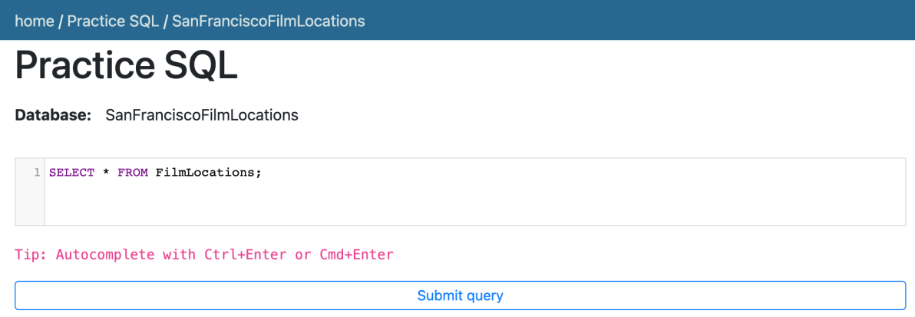

1. Click **Submit Query**.
2. Now you can scroll down the table and explore all the columns and rows of the **FilmLocations** table to get an overall idea of the table.

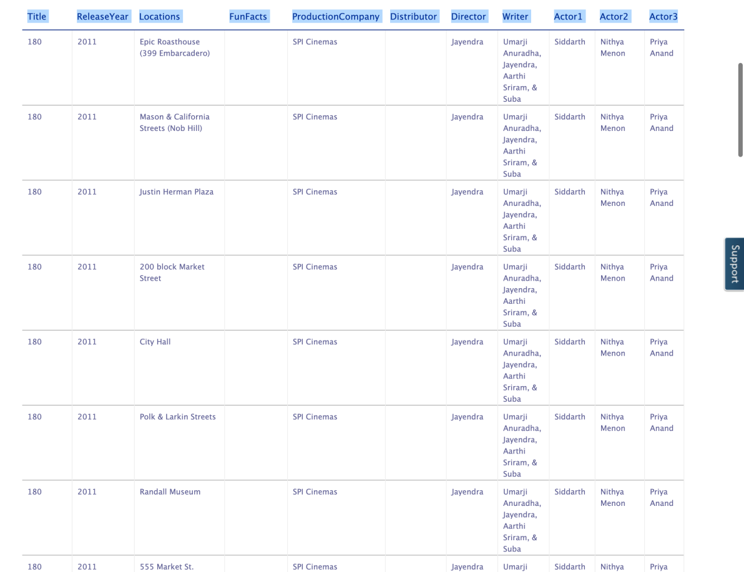

1. These are the column attribute descriptions from the **FilmLocations** table:
2. FilmLocations(
3. Title: titles of the films,
4. ReleaseYear: time of public release of the films,
5. Locations: locations of San Francisco where the films were shot,
6. FunFacts: funny facts about the filming locations,
7. ProductionCompany: companies who produced the films,
8. Distributor: companies who distributed the films,
9. Director: people who directed the films,
10. Writer: people who wrote the films,
11. Actor1: person 1 who acted in the films,
12. Actor2: person 2 who acted in the films,
13. Actor3: person 3 who acted in the films
14. )

# Exercise 1: COUNT

In this exercise, you will first go through some examples of using COUNT in queries and then solve some exercise problems by using it.

## Task A: Example exercises on COUNT

Let us go through some examples of COUNT related queries:

1. In this example, suppose we want to count the number of records or rows of the "FilmLocations" table.
   1. Problem:

Retrieve the number of rows from the "FilmLocations" table.

* 1. Solution:
  2. **SELECT** COUNT(\*) **FROM** FilmLocations;
  3. Copy the solution code above by clicking on the little copy button on the bottom right of the codeblock below and paste it to the textbox of the Datasette tool. Then click **Submit query**.
  4. Your output resultset should look like the image below:

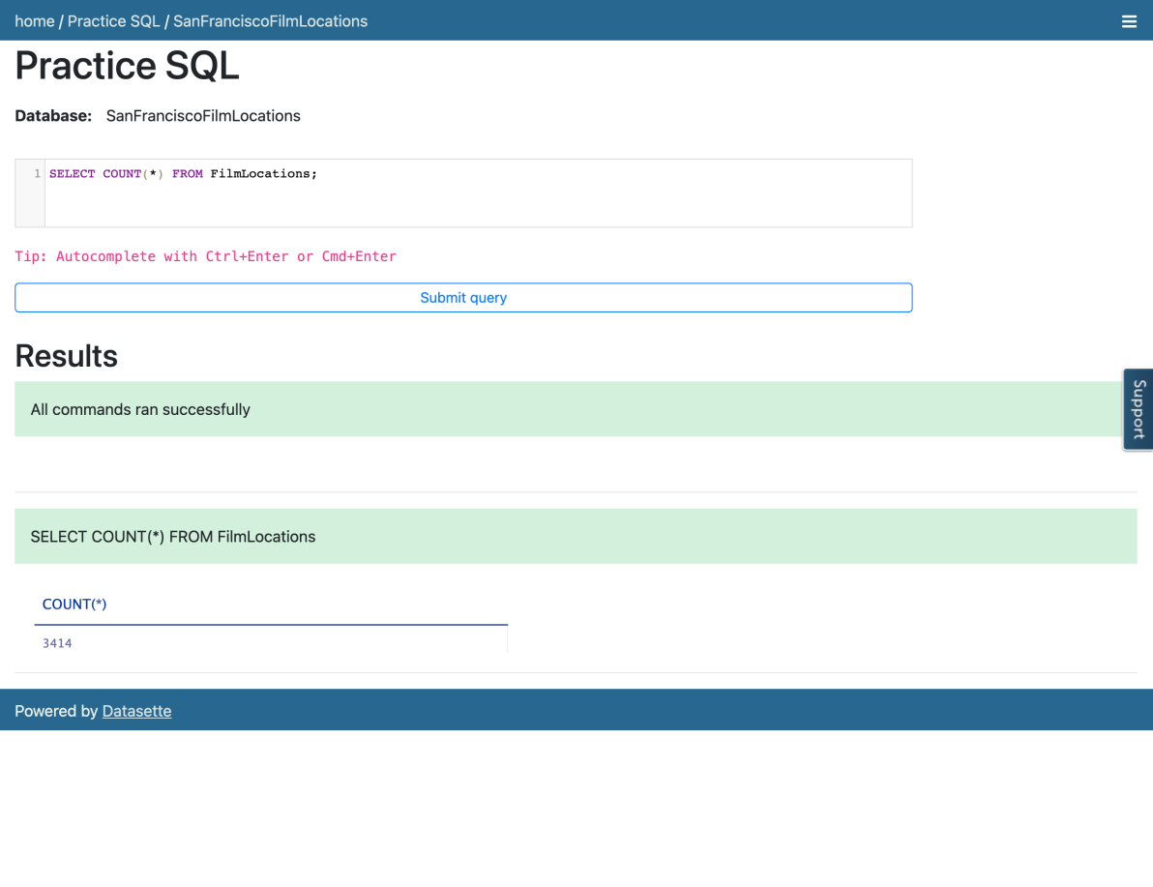

1. In this example, now we want to count the number of locations of the films. But we also want to restrict the output resultset in such a way that we only retrieve the number of locations of the films written by a certain writer.
   1. Problem:

Retrieve the number of locations of the films which are written by James Cameron.

* 1. Solution:
  2. **SELECT** COUNT(Locations) **FROM** FilmLocations **WHERE** Writer="James Cameron";
  3. Copy the solution code above by clicking on the little copy button on the bottom right of the codeblock below and paste it to the textbox of the Datasette tool. Then click **Submit query**.

* 1. Your output resultset should look like the image below:

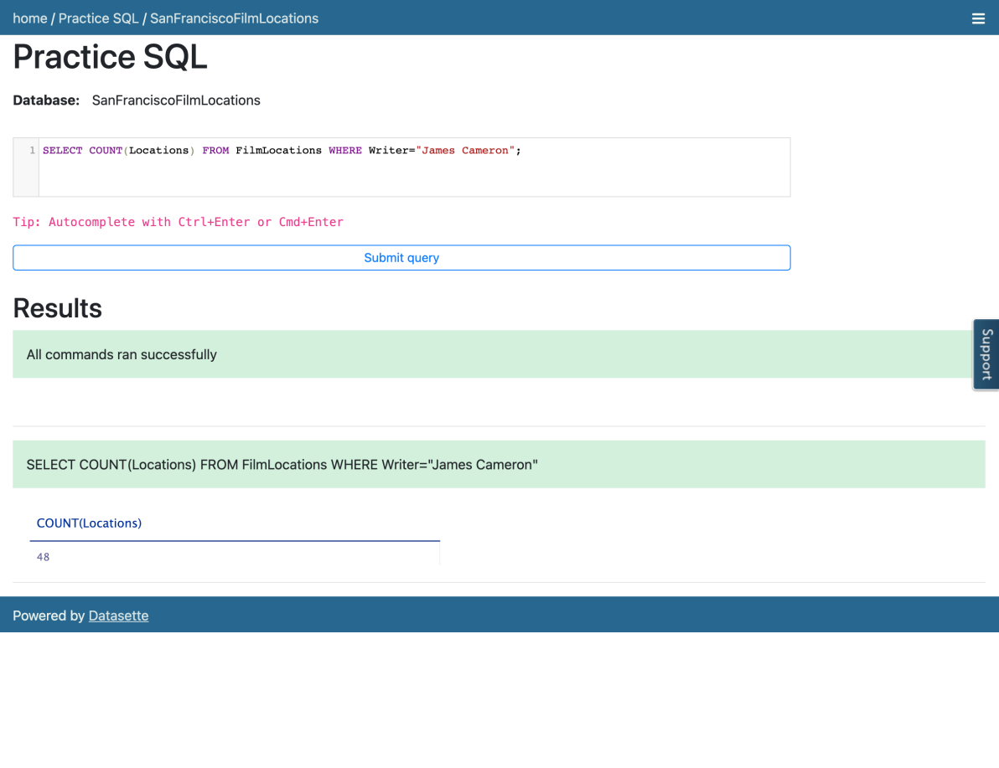

## Task B: Practice exercises on COUNT

Now, let us practice creating and running some COUNT related queries.

1. Problem:

Retrieve the number of locations of the films which are directed by Woody Allen.

Hint

Solution

Output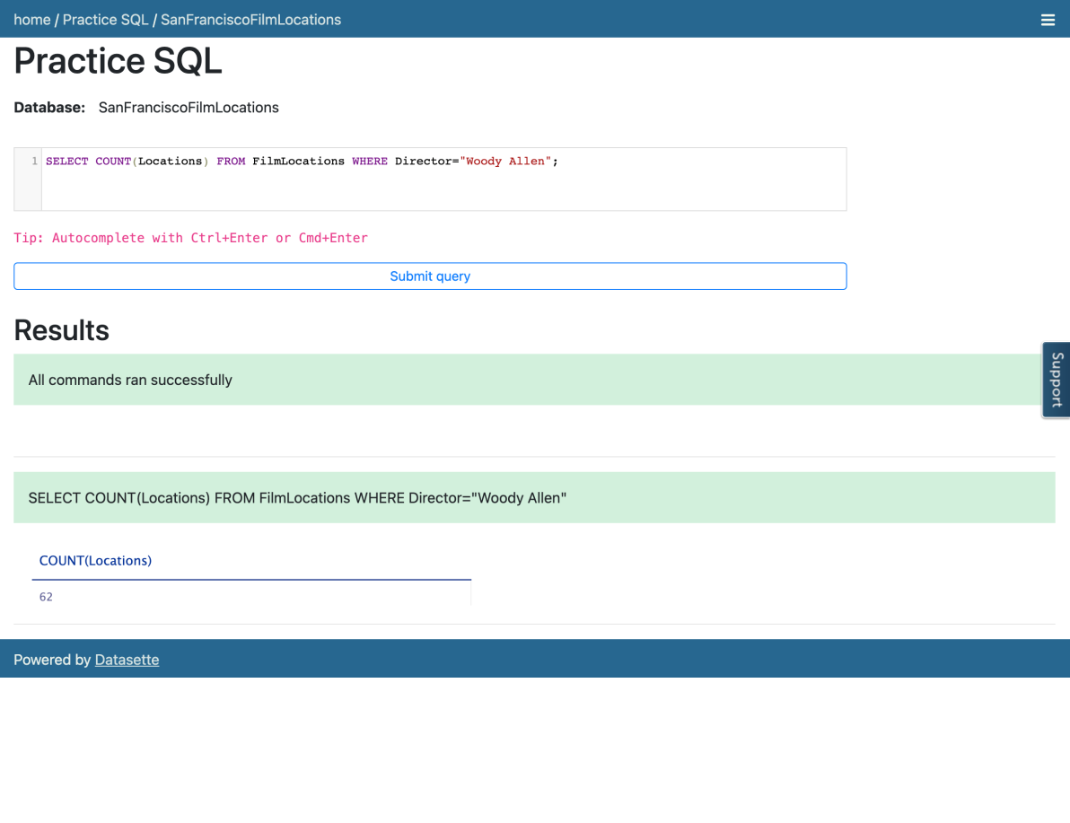

1. Problem:

Retrieve the number of films shot at Russian Hill.

Hint

Solution

Output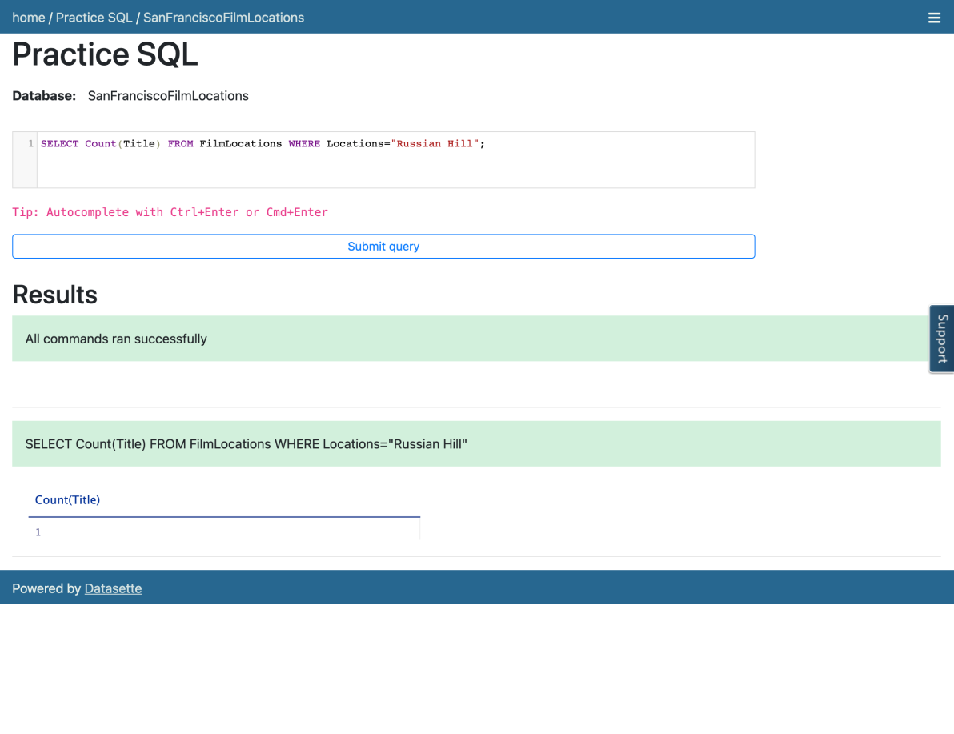

1. Problem:

Retrieve the number of rows having a release year older than 1950 from the "FilmLocations" table.

Hint

Solution

Output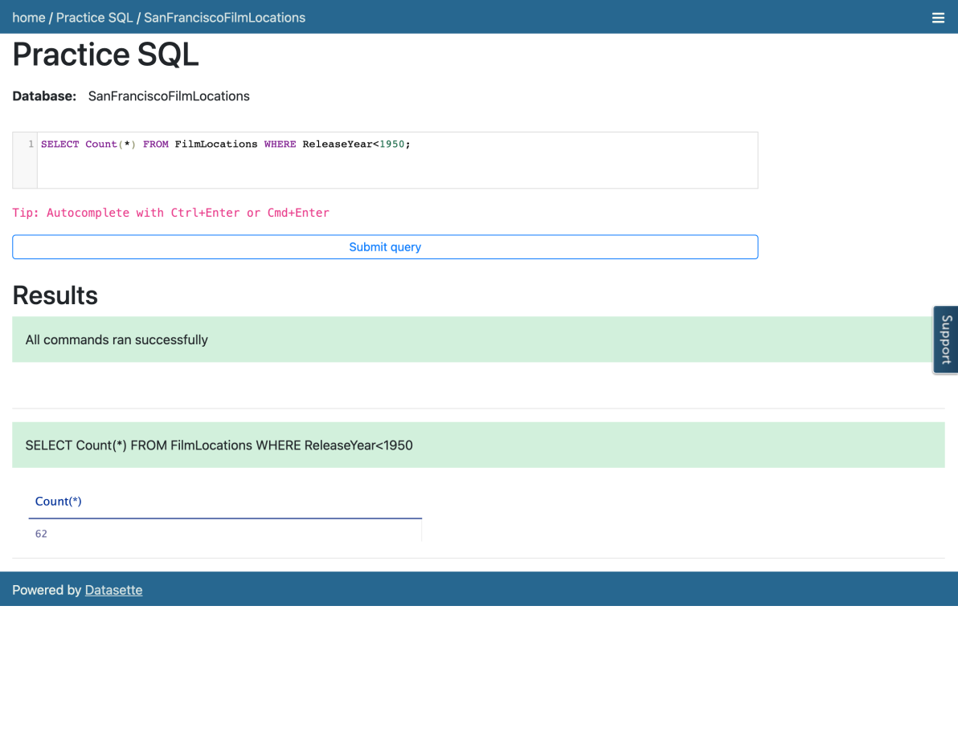

# Exercise 2: DISTINCT

In this exercise, you will first go through some examples of using DISTINCT in queries, and then solve some exercise problems by using it.

## Task A: Example exercises of DISTINCT

Let us go through some examples of DISTINCT related queries:

1. In this example, we want to retrieve the title of all films in the table in such a way that duplicates will be discarded in the output resultset.
   1. Problem:

Retrieve the name of all films without any repeated titles.

* 1. Solution:
  2. **SELECT** **DISTINCT** Title **FROM** FilmLocations;
  3. Copy the solution code above by clicking on the little copy button on the bottom right of the codeblock below and paste it to the textbox of the Datasette tool. Then click **Submit query**.
  4. Your output resultset should look like the image below:

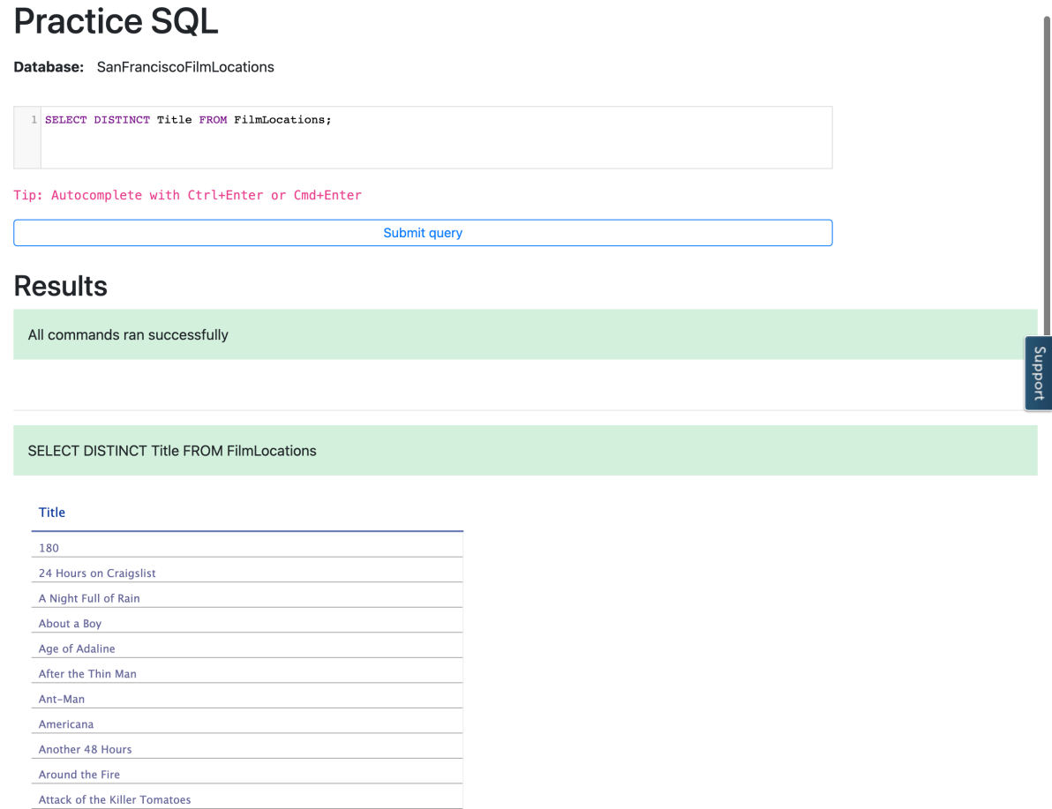

1. In this example, we want to retrieve the count of release years of the films produced by a specific company in such a way that duplicate release years of those films will be discarded in the count.
   1. Problem:

Retrieve the number of release years of the films distinctly, produced by Warner Bros. Pictures.

* 1. Solution:
  2. **SELECT** COUNT(**DISTINCT** ReleaseYear) **FROM** FilmLocations **WHERE** ProductionCompany="Warner Bros. Pictures";
  3. Copy the solution code above by clicking on the little copy button on the bottom right of the codeblock below and paste it to the textbox of the Datasette tool. Then click **Submit query**.
  4. Your output resultset should look like the image below:

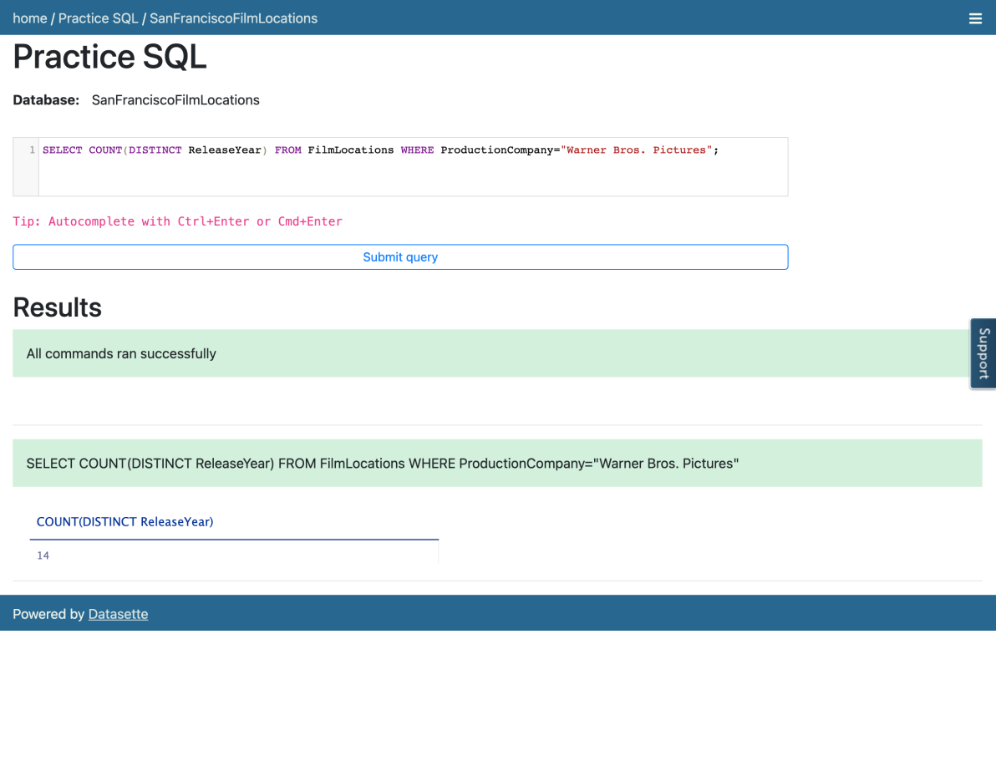

## Task B: Practice exercises on DISTINCT

Now, let us practice creating and running some DISTINCT related queries.

1. Problem:

Retrieve the name of all unique films released in the 21st century and onwards, along with their release years.

Hint

Solution

Output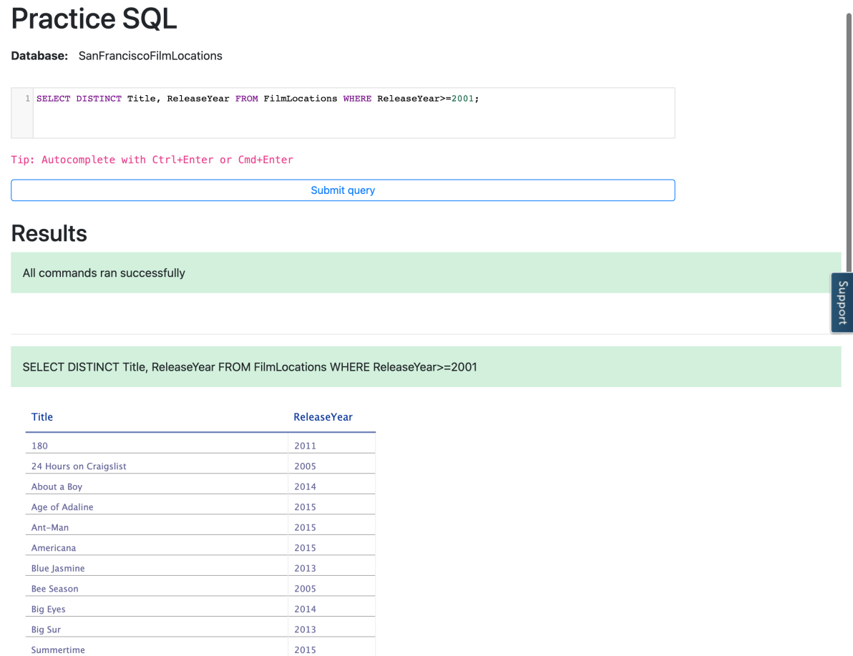

1. Problem:

Retrieve the names of all the directors and their distinct films shot at City Hall.

Hint

Solution

Output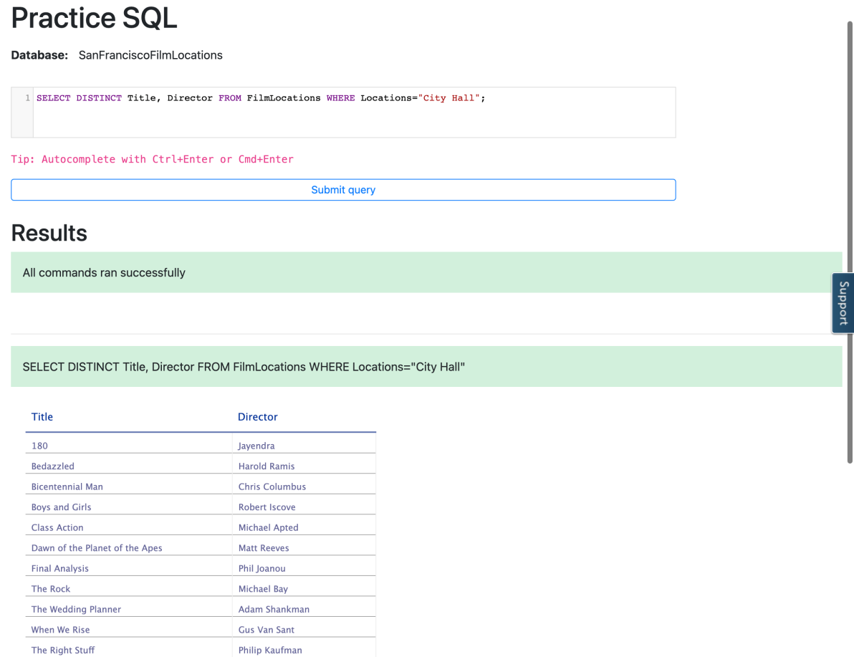

1. Problem:

Retrieve the number of distributors distinctly who distributed films acted by Clint Eastwood as 1st actor.

Hint

Solution

Output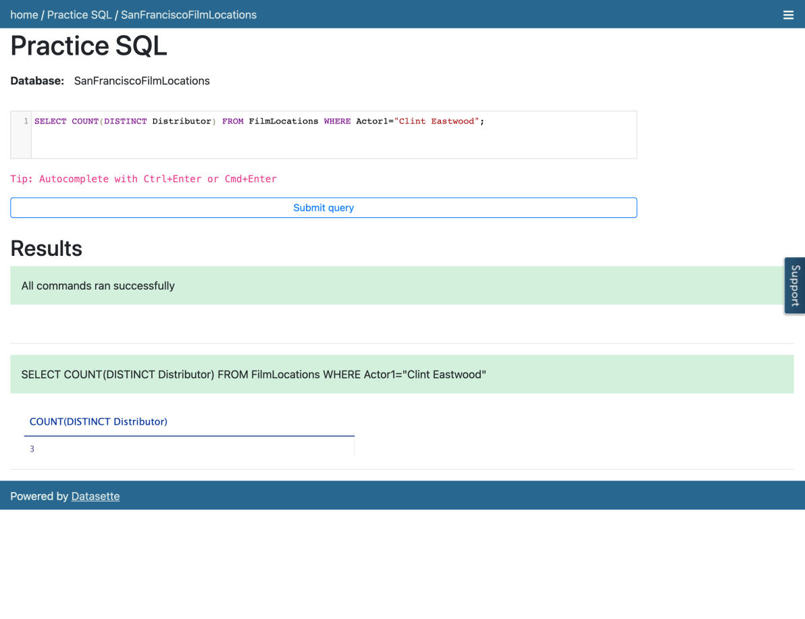

# Exercise 3: LIMIT

In this exercise, you will first go through some examples of using LIMIT in queries and then solve some exercise by using it.

## Task A: Example exercises of LIMIT

Let us go through some examples of LIMIT related queries:

1. In this example, let us retrieve a specific number of rows from the top of the table in such a way that rows other than those are not in the output resultset.
   1. Problem:

Retrieve the first 25 rows from the "FilmLocations" table.

* 1. Solution:
  2. **SELECT** \* **FROM** FilmLocations **LIMIT** 25;
  3. Copy the solution code above by clicking on the little copy button on the bottom right of the codeblock below and paste it to the textbox of the Datasette tool. Then click **Submit query**.
  4. Your output resultset should look like the image below:

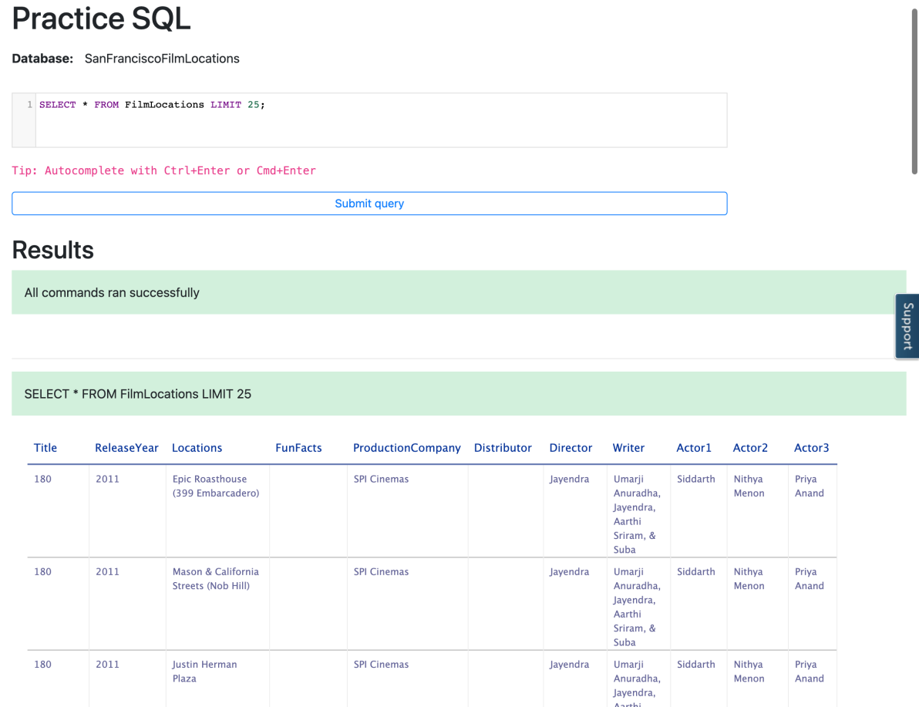

1. In this example, let us take the first example to a more advanced level. Now we want to retrieve a specific number of rows from the table, but thid time, not from the top of the table. This time we want to retrieve a specific number of rows starting from a specific row in the table.
   1. Problem:

Retrieve the first 15 rows from the "FilmLocations" table starting from row 11.

* 1. Solution:
  2. **SELECT** \* **FROM** FilmLocations **LIMIT** 15 **OFFSET** 10;
  3. Copy the solution code above by clicking on the little copy button on the bottom right of the codeblock below and paste it to the textbox of the Datasette tool. Then click **Submit query**.
  4. Your output resultset should look like the image below:

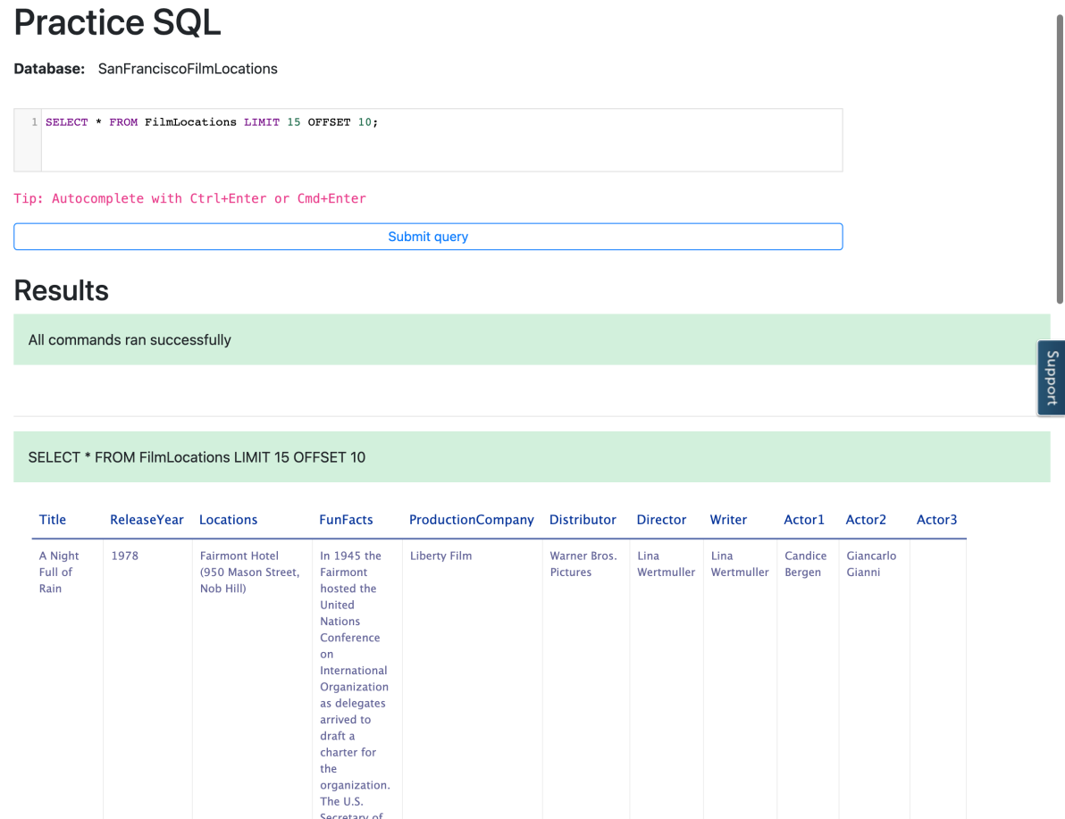

## Task B: Practice exercises on LIMIT

Now, let us practice creating and running some LIMIT related queries.

1. Problem:

Retrieve the name of first 50 films distinctly.

Hint

Solution

Output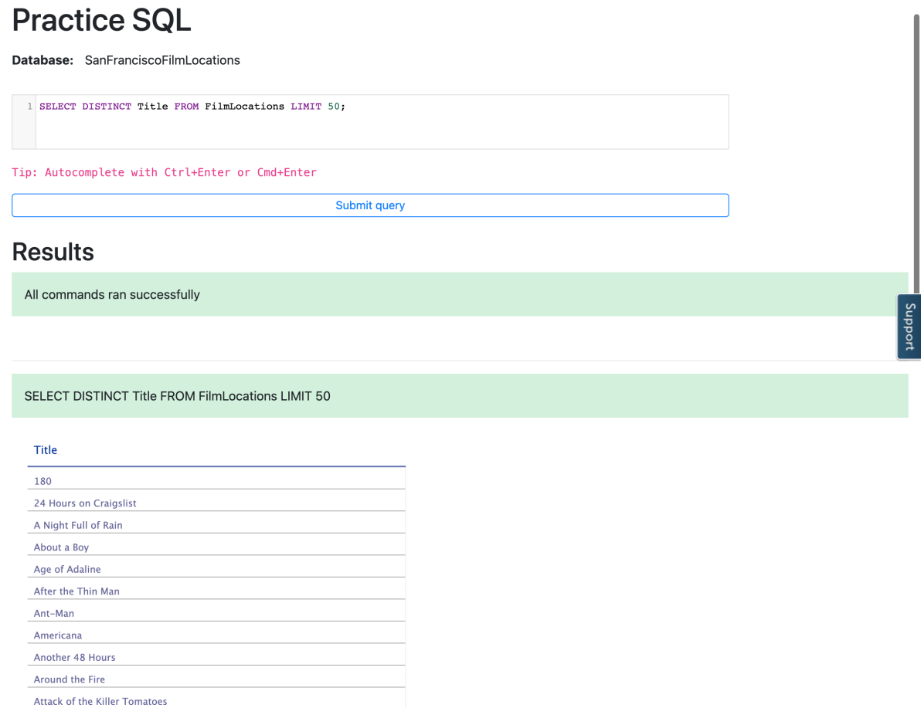

1. Problem:

Retrieve first 10 film names distinctly released in 2015.

Hint

Solution

Output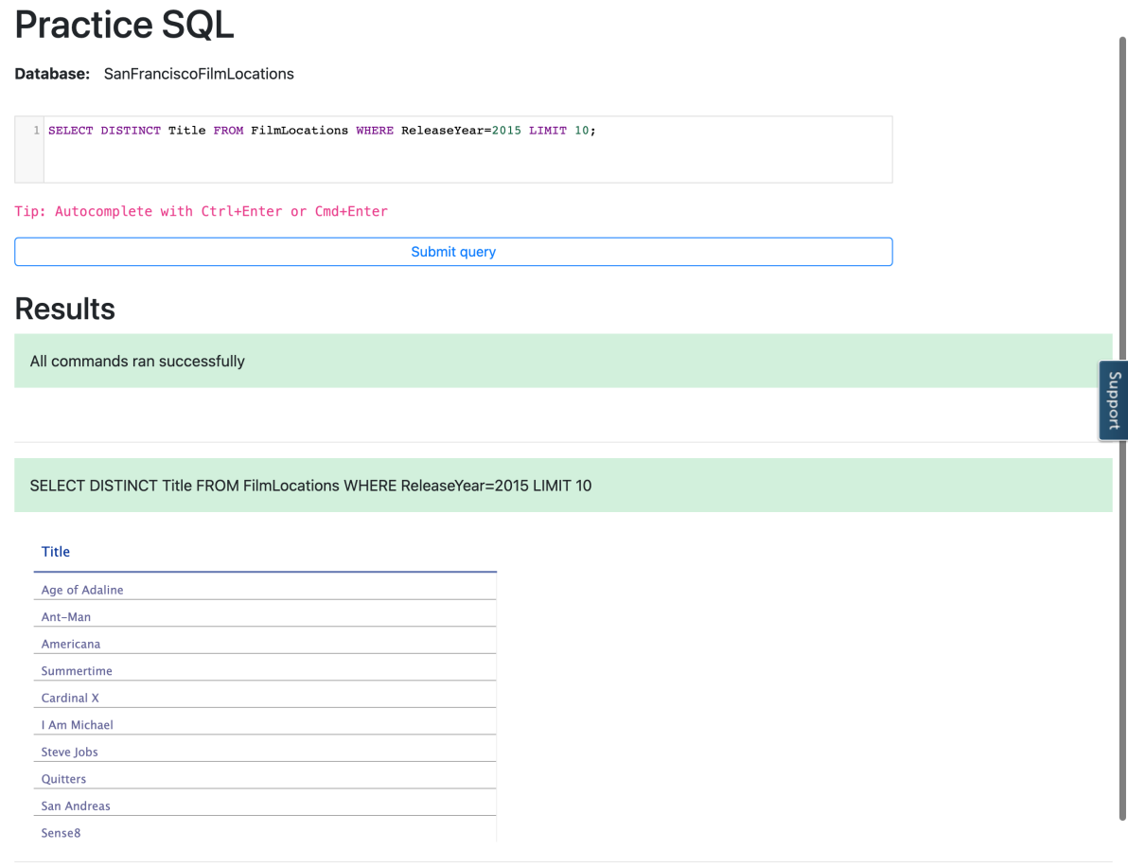

1. Problem:

Retrieve the next 3 film names distinctly after first 5 films released in 2015.

Hint

Solution

Output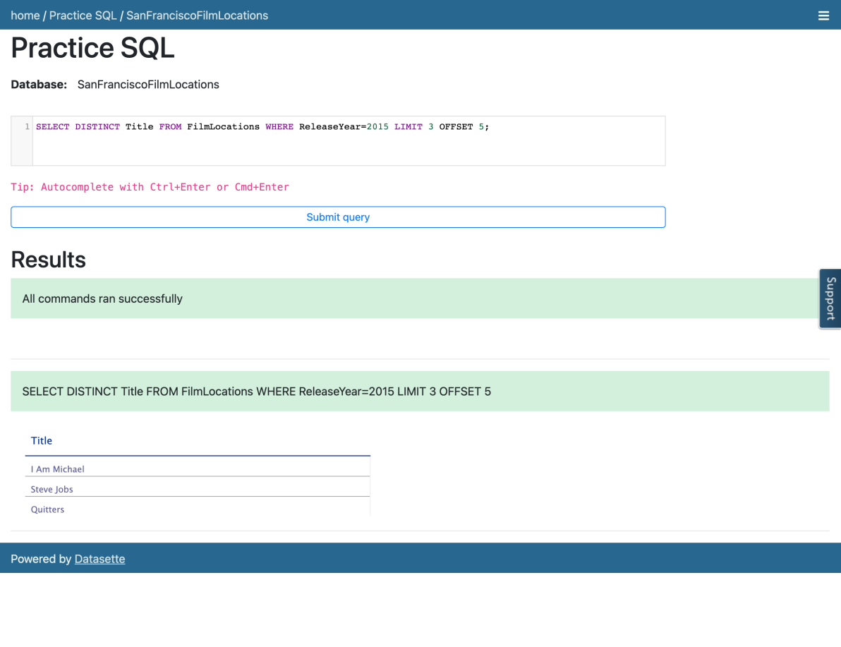

### Congratulations! You have completed this Lab.

## Author(s)

* [Sandip Saha Joy](https://www.linkedin.com/in/sandipsahajoy/?utm_medium=Exinfluencer&utm_source=Exinfluencer&utm_content=000026UJ&utm_term=10006555&utm_id=NA-SkillsNetwork-Channel-SkillsNetworkCoursesIBMDeveloperSkillsNetworkDB0201ENSkillsNetwork22-2022-01-01)

## Other Contributor(s)

## Changelog

| **Date** | **Version** | **Changed by** | **Change Description** |
| --- | --- | --- | --- |
| 2022-07-27 | 1.2 | Lakshmi Holla | Updated html tag |
| 2020-12-23 | 1.1 | Steve Ryan | ID Review |
| 2020-11-24 | 1.0 | Sandip Saha Joy | Initial version created |

### © IBM Corporation 2020. All rights reserved.

# INSERT Statement

Notes

[**Discuss**](https://www.coursera.org/learn/sql-data-science/discussions/weeks/1)

0:00

Hello, and welcome to the INSERT statement.

In this video, we will learn about populating a relational database table.

At the end of this video, you'll be able to identify the syntax of

the INSERT statement and explain two methods to add rows to a table.

After table is created,

the table needs to be populated with data.

To insert data into a table,

we use the INSERT statement.

The INSERT statement is used to add new rows to a table.

The INSERT statement is one of the data manipulation language statements.

Data manipulation language statements or DML statements are used to read and modify data.

Based on the author entity example,

we created the table using the entity name author,

and the entity attributes as the columns of the table.

Now we will add the data to the author table by adding rows to the table.

To add the data to the author table,

we use the INSERT statement.

The syntax of the INSERT statement looks like this,

insert into table name, column name, values.

In this statement, table name identifies the table,

the column name list identifies each column in the table,

and the values clause specifies the data values to be added to the columns in the table.

To add a row with the data for Raul Chong,

we insert a row with an author underscore ID of A one,

the last name is Chong,

the first name as Raul,

the email as RFC@IBM.com,

the city is Toronto,

and the country as CA for Canada.

The author table has six columns,

so the INSERT statement lists the six column names separated by commas,

followed by a value for each of the columns also separated by commas.

It is important that the number of values provided in the values clause

is equal to the number of column names specified in the column name list.

This ensures that each column has a value.

Tables do not need to be populated one row at a time,

multiple rows can be inserted by specifying each row in the values clause.

In the values clause,

each row is separated by a comma.

For example, in this INSERT statement we are inserting two rows,

one for Raul Chong and one for Rav Ahuja.

Now you can identify the syntax of the INSERT statement,

and explain the two methods to add rows to a table.

One row at a time or multiple rows.

Thanks for watching this video.

# UPDATE and DELETE Statements

Notes

[**Discuss**](https://www.coursera.org/learn/sql-data-science/discussions/weeks/1)

0:00

Hello and welcome to the UPDATE statement and the DELETE statement.

In this video, we will learn about altering and

deleting data in a relational database table.

At the end of this lesson,

you will be able to identify the syntax of the UPDATE statement and

DELETE statement and explain the importance of the WHERE clause in these statements.

After a table is created and populated with data,

the data in a table can be altered with the UPDATE statement.

The UPDATE statement is one of the data manipulation language or DML statements.

DML statements are used to read and modify data.

Based on the author entity example,

we created the table using the entity name

Author and the entity attributes as the columns of the table.

Rows were added to the Author table to populate the table.

Sometime later, you want to alter the data in the table.

To alter or modify the data in the Author table,

we use the UPDATE statement.

The syntax of the UPDATE statement looks like this,

UPDATE [TableName] SET [ColumnName] = [Value] ]> <WHERE [Condition] >.

In the statement, TableName identifies the table.

The ColumnName identifies the column value to be changed,

as specified in the <WHERE [Condition] >.

Let's look at an example.

In this example, you want to update the FIRSTNAME and LASTNAME of

the author with AUTHOR\_ID A2 from Rav Ahuja to Lakshmi Katta.

In this example, to see the UPDATE statement in action,

we start by selecting all rows from the author table to see the values.

To change the first name and last name to Lakshmi Katta where the AUTHOR\_ID = A2,

enter the UPDATE statement as follows.

UPDATE AUTHOR SET LAST NAME = KATTA,

FIRST NAME = LAKSHMI WHERE AUTHOR\_ID = A2.

Now, to see the result of the update,

select all rows again from the Author table and you will see that in row

to the name changed from Rav Ahuja to Lakshmi Katta.

Note that if you do not specify the WHERE clause,

all the rows in the table will be updated.

In this example, without specifying the WHERE clause all rows in

the table would have changed the first and last names to Lakshmi Katta.

Sometime later, there might be a need to remove one or more rows from a table.

The rows are removed with the DELETE statement.

The DELETE statement is one of

the data manipulation language statements used to read and modify data.

The syntax of the DELETE statement looks like this,

DELETE FROM [TABLEName] <WHERE [Condition] >.

The rows to be removed are specified in the WHERE condition.

Based on the author entity example,

we want to delete the rows for AUTHOR\_ID A2 and A3.

Let's look at an example.

DELETE FROM AUTHOR WHERE AUTHOR\_ID IN ('A2','A3').

Note that if you do not specify the WHERE clause,

all the rows in the table will be removed.

Now you can identify the syntax of the UPDATE statement and

DELETE statement and explain the importance of the WHERE clause in these statements.

Thanks for watching this video.

(Musi)



# Hands-on Lab : INSERT, UPDATE, DELETE

**Estimated time needed:** 20 minutes

In this lab, you will learn some commonly used DML (Data Manipulation Language) statements of SQL other than SELECT. First, you will learn the INSERT statement, which is used to insert new rows into a table. Next, you will learn the UPDATE statement which is used to update the data in existing rows in the table. Lastly, you will learn the DELETE statement which is used to remove rows from a table.

**How does the syntax of an INSERT statement look?**

**INSERT** INTO table\_name (column1, column2, ... )

**VALUES** (value1, value2, ... )

;

**How does the syntax of an UPDATE statement look?**

**UPDATE** table\_name

**SET** column1 = value1, column2 = value2, ...

**WHERE** condition

;

**How does the syntax of a DELETE statement look?**

**DELETE** **FROM** table\_name

**WHERE** condition

;

## Software Used in this Lab

In this lab, you will use [Datasette](https://github.com/simonw/datasette?utm_medium=Exinfluencer&utm_source=Exinfluencer&utm_content=000026UJ&utm_term=10006555&utm_id=NA-SkillsNetwork-Channel-SkillsNetworkCoursesIBMDeveloperSkillsNetworkDB0201ENSkillsNetwork22-2022-01-01" \t "_blank), an open source multi-tool for exploring and publishing data.

## Database Used in this Lab

The dataset used in this lab is an internal database.

## Objectives

After completing this lab, you will be able to:

* Insert new rows into a table
* Update data in existing rows of the table
* Remove rows from a table

# Exploring the Database

Let us first explore the **Instructors** database using the **Datasette** tool:

1. If the first statement listed below is not already in the Datasette textbox on the right, then copy the code below by clicking on the little copy button on the bottom right of the codeblock below and then paste it into the textbox of the Datasette tool using either **Ctrl+V** or right-click in the text box and choose **Paste**.
2. **SELECT** \* **FROM** Instructor;

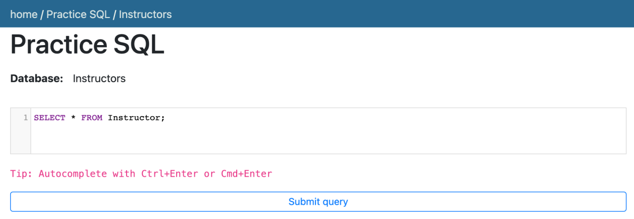

1. Click **Submit Query**.
2. Now you can scroll down the table and explore all the columns and rows of the **Instructor** table to get an overall idea of the table contents.

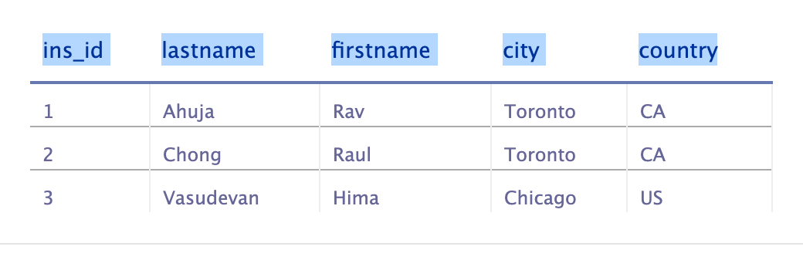

1. These are the column attribute descriptions from the **Instructor** table:
2. Instructor (
3. ins\_id: unique identification number **of** **the** instructors,
4. lastname: **last** name **of** **the** instructors,
5. firstname: **first** name **of** **the** instructors,
6. city: name **of** **the** cities where instructors are located,
7. country: two-letter country code **of** **the** countries where instructors are located
8. )

# Exercise 1: INSERT

In this exercise, you will first go through some examples of using INSERT in queries and then solve some exercise problems by using it.

## Task A: Example exercises on INSERT

Let us go through some examples of INSERT related queries:

1. In this example, suppose we want to insert a new single row into the **Instructor** table.
   1. Problem:

Insert a new instructor record with id 4 for Sandip Saha who lives in Edmonton, CA into the "Instructor" table.

* 1. Solution:
  2. INSERT INTO Instructor(**ins\_id**, lastname, firstname, city, country)
  3. VALUES(**4**, 'Saha', 'Sandip', 'Edmonton', 'CA');
  4. Copy the solution code above by clicking on the little copy button on the bottom right of the codeblock below and paste it to the textbox of the Datasette tool. Then click **Submit query**.
  5. Copy the code below by clicking on the little copy button on the bottom right of the codeblock below and paste it to the textbox of the Datasette tool. Then click **Submit query**.
  6. **SELECT** \* **FROM** Instructor;
  7. Your output resultset should look like the image below:

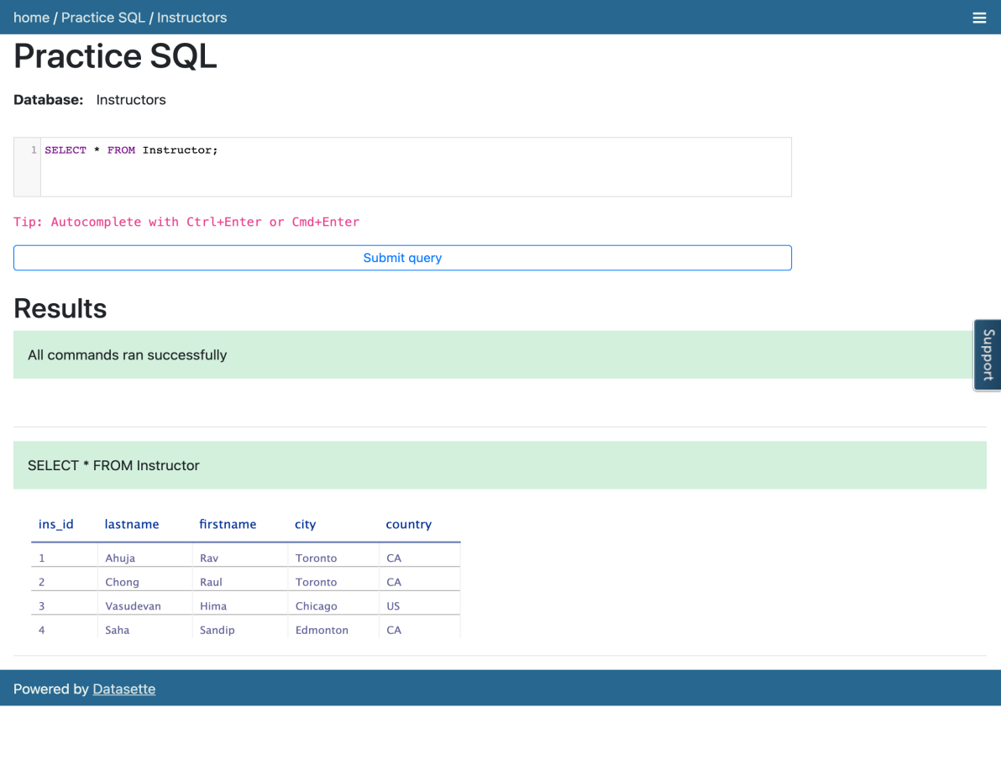

1. In this example, suppose we want to insert some new multiple rows into the **Instructor** table.
   1. Problem:

Insert two new instructor records into the "Instructor" table. First record with id 5 for John Doe who lives in Sydney, AU. Second record with id 6 for Jane Doe who lives in Dhaka, BD.

* 1. Solution:
  2. INSERT INTO Instructor(**ins\_id**, lastname, firstname, city, country)
  3. VALUES(**5**, 'Doe', 'John', 'Sydney', 'AU'), (**6**, 'Doe', 'Jane', 'Dhaka', 'BD');
  4. Copy the solution code above by clicking on the little copy button on the bottom right of the codeblock below and paste it to the textbox of the Datasette tool. Then click **Submit query**.
  5. Copy the code below by clicking on the little copy button on the bottom right of the codeblock below and paste it to the textbox of the Datasette tool. Then click **Submit query**.
  6. **SELECT** \* **FROM** Instructor;
  7. Your output resultset should look like the image below:

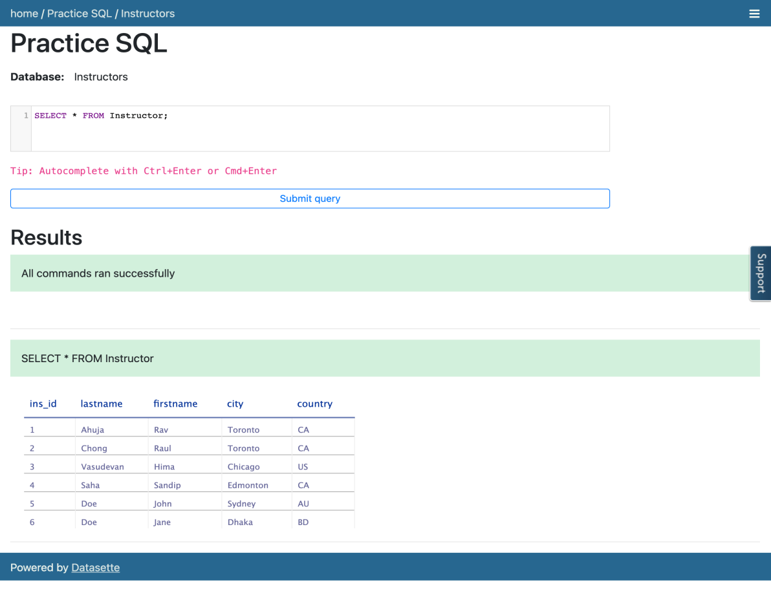

## Task B: Practice exercises on INSERT

Now, let us practice creating and running some INSERT related queries.

1. Problem:

Insert a new instructor record with id 7 for Antonio Cangiano who lives in Vancouver, CA into the "Instructor" table.

Hint

Solution

Output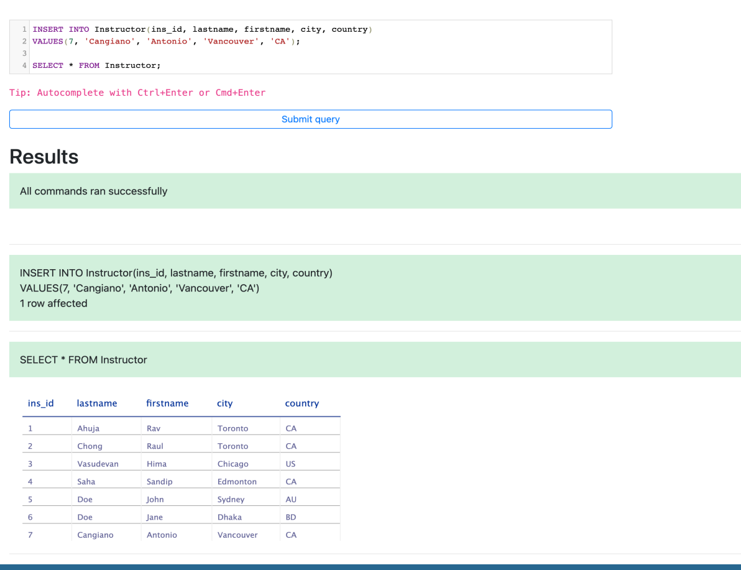

1. Problem:

Insert two new instructor records into the "Instructor" table. First record with id 8 for Steve Ryan who lives in Barlby, GB. Second record with id 9 for Ramesh Sannareddy who lives in Hyderabad, IN.

Hint

Solution

Output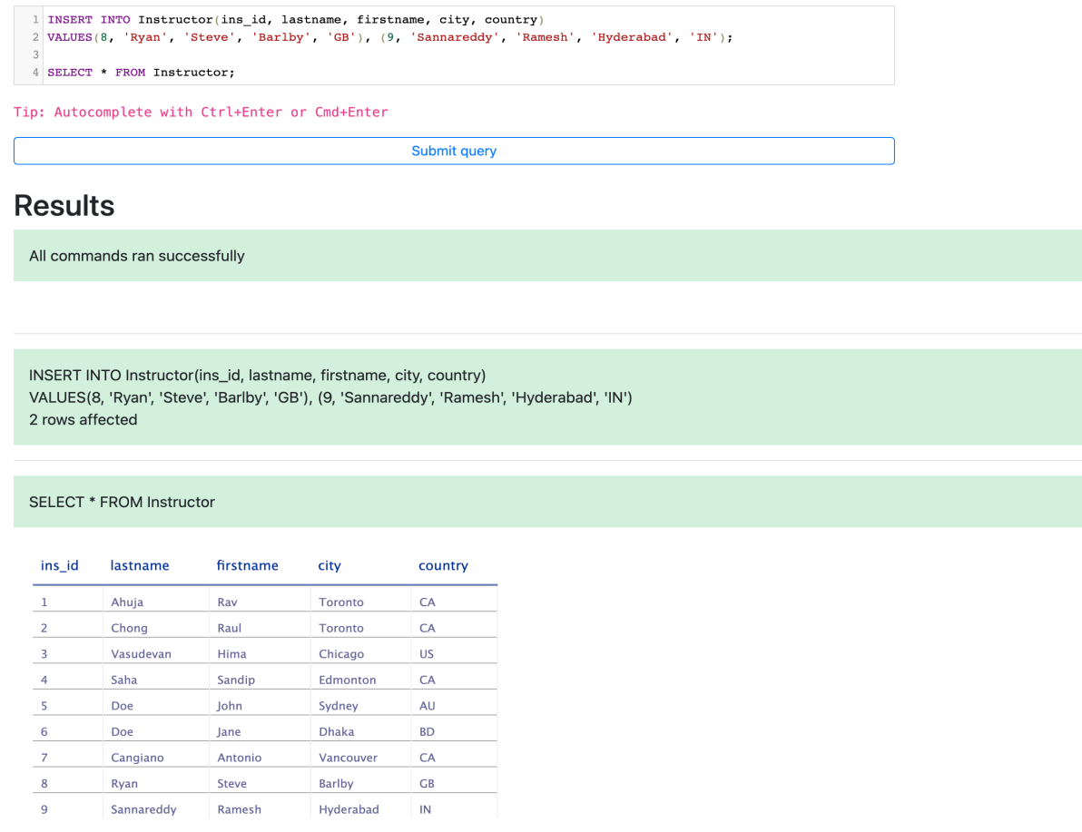

# Exercise 2: UPDATE

In this exercise, you will first go through some examples of using UPDATE in queries and then solve some exercise problems by using it.

## Task A: Example exercises on UPDATE

Let us go through some examples of UPDATE related queries:

1. In this example, we want to update one column of an existing row of the table.
   1. Problem:

Update the city for Sandip to Toronto.

* 1. Solution:
  2. UPDATE Instructor
  3. SET city='Toronto'
  4. WHERE firstname="Sandip";
  5. Copy the solution code above by clicking on the little copy button on the bottom right of the codeblock below and paste it to the textbox of the Datasette tool. Then click **Submit query**.
  6. Copy the code below by clicking on the little copy button on the bottom right of the codeblock below and paste it to the textbox of the Datasette tool. Then click **Submit query**.
  7. **SELECT** \* **FROM** Instructor;
  8. Your output resultset should look like the image below:

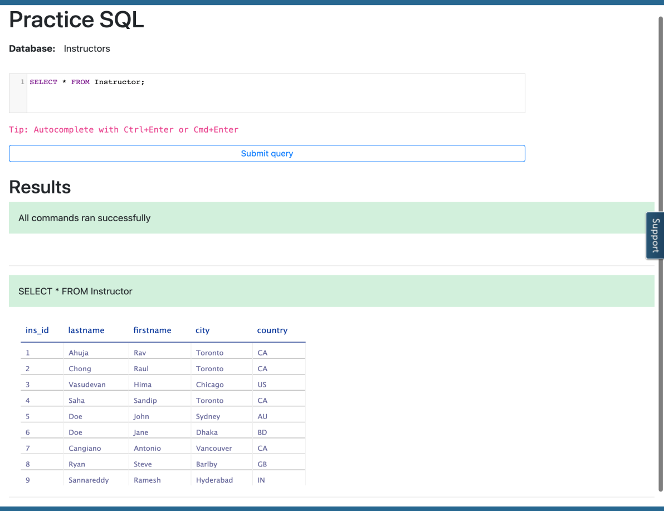

1. In this example, we want to update multiple columns of an existing row of the table.
   1. Problem:

Update the city and country for Doe with id 5 to Dubai and AE respectively.

* 1. Solution:
  2. UPDATE Instructor
  3. SET **city**='Dubai', **country**='AE'
  4. WHERE **ins\_id**=5;
  5. Copy the solution code above by clicking on the little copy button on the bottom right of the codeblock below and paste it to the textbox of the Datasette tool. Then click **Submit query**.
  6. Copy the code below by clicking on the little copy button on the bottom right of the codeblock below and paste it to the textbox of the Datasette tool. Then click **Submit query**.
  7. **SELECT** \* **FROM** Instructor;
  8. Your output resultset should look like the image below:

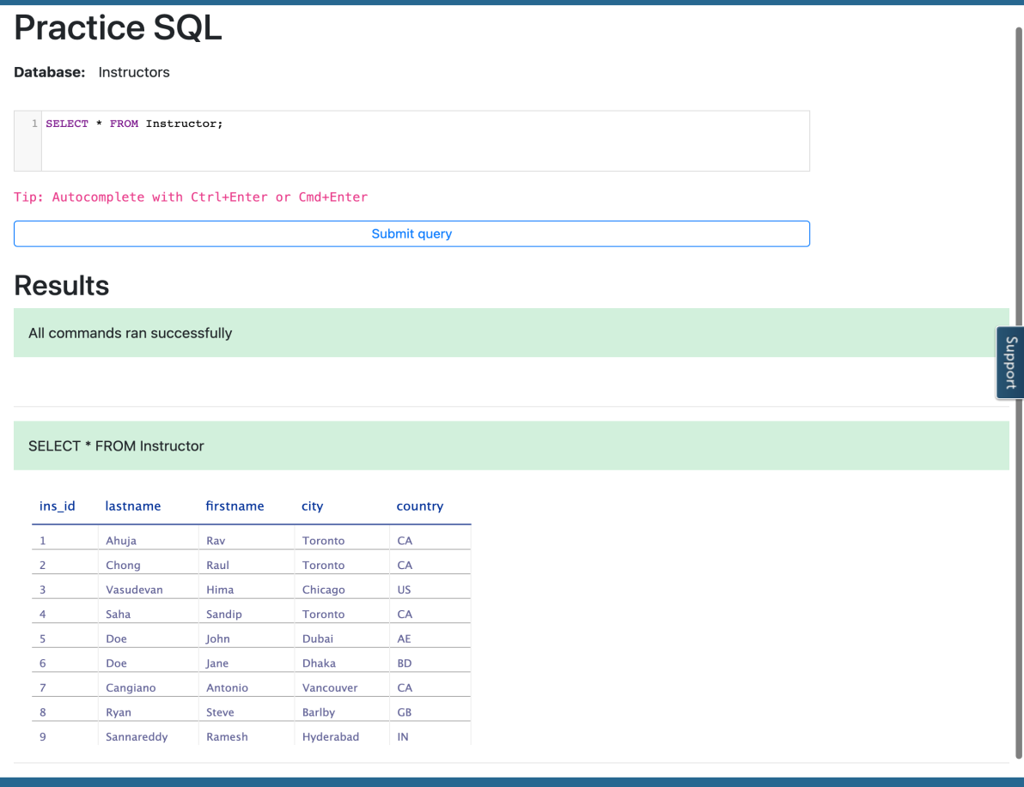

## Task B: Practice exercises on UPDATE

Now, let us practice creating and running some UPDATE related queries.

1. Problem:

Update the city of the instructor record to Markham whose id is 1.

Hint

Solution

Output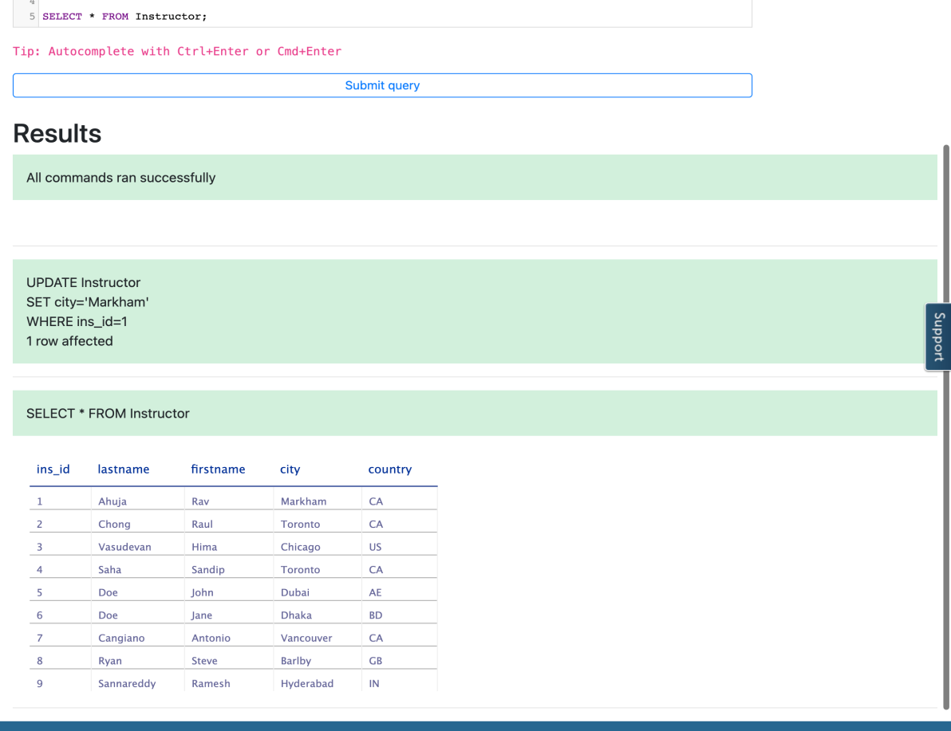

1. Problem:

Update the city and country for Sandip with id 4 to Dhaka and BD respectively.

Hint

Solution

Output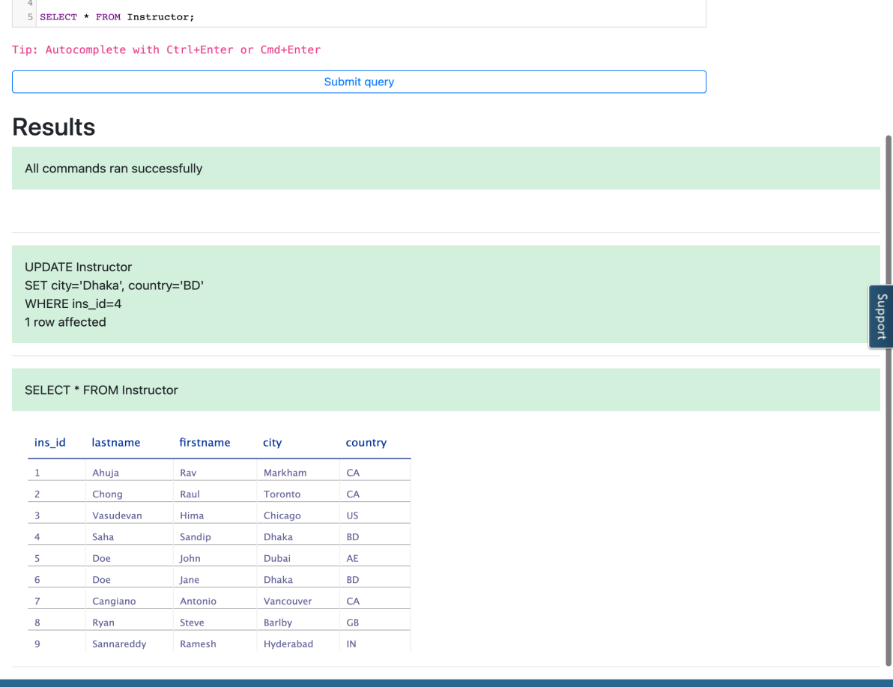

# Exercise 3: DELETE

In this exercise, you will first go through an example of using DELETE in a query and then solve an exercise problem by using it.

## Task A: Example exercise on DELETE

Let us go through an example of a DELETE related query:

1. In this example, we want to remove a row from the table.
   1. Problem:

Remove the instructor record of Doe whose id is 6.

* 1. Solution:
  2. DELETE FROM instructor
  3. WHERE ins\_id = 6;
  4. Copy the solution code above by clicking on the little copy button on the bottom right of the codeblock below and paste it to the textbox of **Custom SQL query** of the Datasette tool. Then click **Submit query**.
  5. Copy the code below by clicking on the little copy button on the bottom right of the codeblock below and paste it to the textbox of the Datasette tool. Then click **Submit query**.
  6. **SELECT** \* **FROM** Instructor;
  7. Your output resultset should look like the image below:

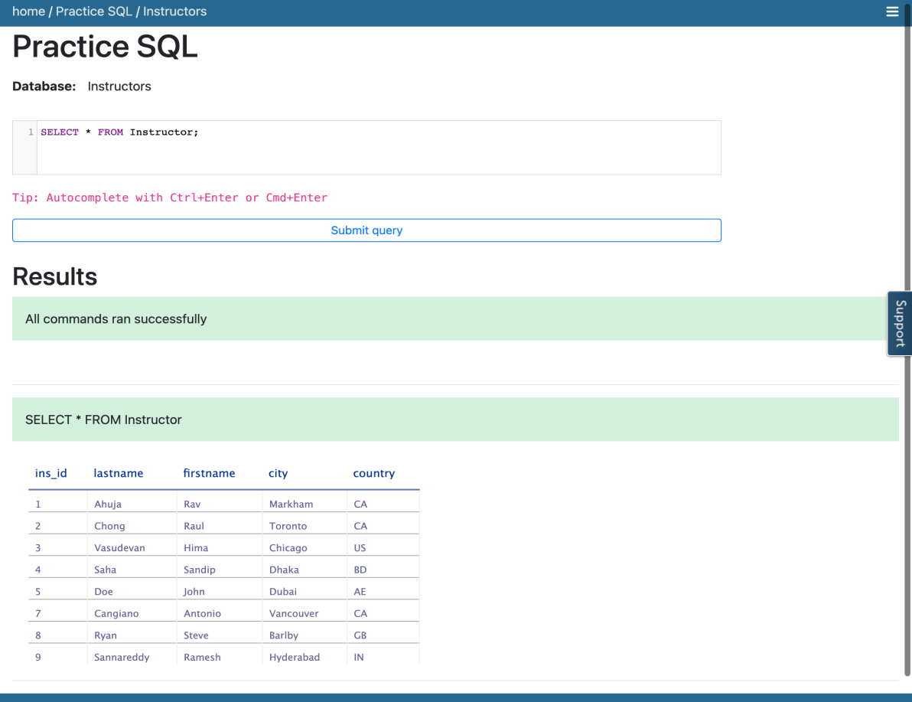

## Task B: Practice exercise on DELETE

Now, let us practice creating and running a DELETE related query.

1. Problem:

Remove the instructor record of Hima.

Hint

Solution

Output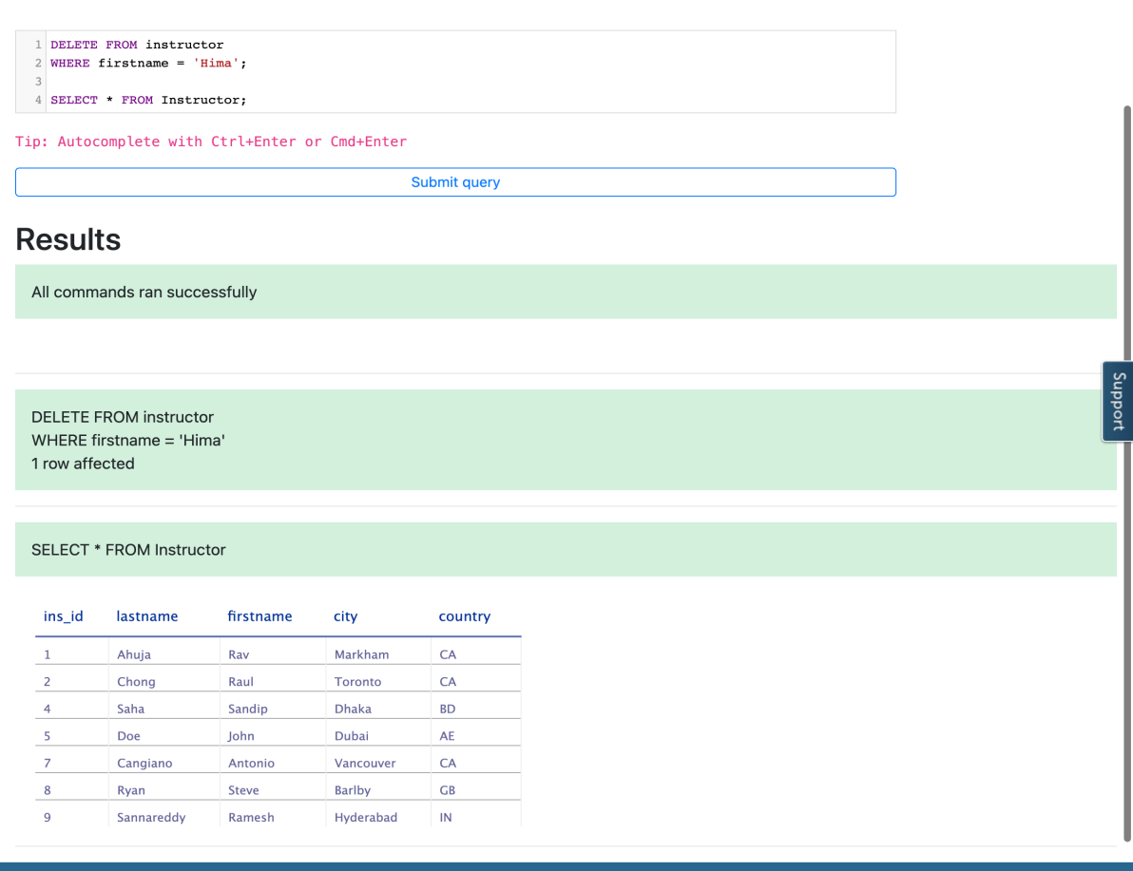

### Congratulations! You have completed this Lab.

## Author(s)

* [Sandip Saha Joy](https://www.linkedin.com/in/sandipsahajoy/?utm_medium=Exinfluencer&utm_source=Exinfluencer&utm_content=000026UJ&utm_term=10006555&utm_id=NA-SkillsNetwork-Channel-SkillsNetworkCoursesIBMDeveloperSkillsNetworkDB0201ENSkillsNetwork22-2022-01-01)

## Other Contributor(s)

## Changelog

| **Date** | **Version** | **Changed by** | **Change Description** |
| --- | --- | --- | --- |
| 2022-08-03 | 1.3 | Sathya Priya | updated HTML tag |
| 2022-07-27 | 1.2 | Lakshmi Holla | updated HTML tag |
| 2020-12-23 | 1.1 | Steve Ryan | ID Review |
| 2020-11-30 | 1.0 | Sandip Saha Joy | Initial version created |

### © IBM Corporation 2020. All rights reserved.

# Summary & Highlights

Congratulations! You have completed this lesson. At this point in the course, you know:

* You can use Data Manipulation Language (DML) statements to read and modify data.
* The search condition of the WHERE clause uses a predicate to refine the search.
* COUNT, DISTINCT, and LIMIT are expressions that are used with SELECT statements.
* INSERT, UPDATE, and DELETE are DML statements for populating and changing tables.

## SQL Cheat Sheet: Basics - SELECT, INSERT, UPDATE, DELETE, COUNT, DISTINCT, LIMIT



|  |  |  |  |
| --- | --- | --- | --- |
| **Command** | **Syntax** | **Description** | **Example** |
| SELECT | SELECT column1, column2, ... FROM table\_name; | SELECT statement is used to fetch data from a database. | SELECT city FROM placeofinterest; |
| WHERE | SELECT column1, column2, ...FROM table\_name WHERE condition; | WHERE clause is used to extract only those records that fulfill a specified condition. | SELECT \* FROM placeofinterest WHERE city == 'Rome' ; |
| COUNT | SELECT COUNT \* FROM table\_name ; | COUNT is a function that takes the name of a column as argument and counts the number of rows when the column is not NULL. | SELECT COUNT(country) FROM placeofinterest WHERE country='Canada'; |
| DISTINCT | SELECT DISTINCT columnname FROM table\_name; | DISTINCT function is used to specify that the statement is a query which returns unique values in specified columns. | SELECT DISTINCT country FROM placeofinterest WHERE type='historical'; |
| LIMIT | SELECT \* FROM table\_name LIMIT number; | LIMIT is a clause to specify the maximum number of rows the result set must have. | SELECT \* FROM placeofinterest WHERE airport="pearson" LIMIT 5; |
| INSERT | INSERT INTO table\_name (column1,column2,column3...) VALUES(value1,value2,value3...); | INSERT is used to insert new rows in the table. | INSERT INTO placeofinterest (name,type,city,country,airport) VALUES('Niagara Waterfalls','Nature','Toronto','Canada','Pearson'); |
| UPDATE | UPDATE table\_name SET[[column1]=[VALUES]] WHERE [condition]; | UPDATE used to update the rows in the table. | UPDATE placeofinterest SET name = 'Niagara Falls' WHERE name = "Niagara Waterfalls"; |
| DELETE | DELETE FROM table\_name WHERE [condition]; | DELETE statement is used to remove rows from the table which are specified in the WHERE condition. | DELETE FROM placeofinterest WHERE city IN ('Rome','Vienna'); |

## Author(s)

[Malika Singla](https://www.linkedin.com/in/malika-goyal-04798622/?utm_medium=Exinfluencer&utm_source=Exinfluencer&utm_content=000026UJ&utm_term=10006555&utm_id=NA-SkillsNetwork-Channel-SkillsNetworkCoursesIBMDeveloperSkillsNetworkDB0201ENSkillsNetwork20127838-2022-01-01)

## Changelog

| **Date** | **Version** | **Changed by** | **Change Description** |
| --- | --- | --- | --- |
| 2021-07-27 | 1.0 | Malika | Initial Version |

# Relational Database Concepts

Notes

[**Discuss**](https://www.coursera.org/learn/sql-data-science/discussions/weeks/2)

0:00

(Music)

Hello and welcome to Database Concepts. In this video, we will learn about

different types of models, how we use models to map data to tables, and define

relationships between tables. At the end of this lesson, you will be able to

explain the advantage of the relational model, explain how the entity name and

attributes map to a relational database table, describe the difference between an

entity and an attribute, identify some commonly used data types, and describe

the function of primary keys. The relational model is the most used

data model for databases because this model allows for data independence.

Data is stored in a simple data structure. Tables: this provides logical data

independence, physical data independence, and physical storage independence.

An entity relationship data model, or ER data model, is an alternative to a

relational data model. Using a simplified library database as an example, this

figure shows an entity relationship diagram or ERD that represents entities

called tables and their relationships. In the library example, we have books. A book

can be written by one or many authors. The library can have one or many copies

of a book. Each copy can be borrowed by only one borrower at a time. An entity

relationship model proposes thinking of a database as a collection of entities

rather than being used as a model on its own. The ER model is used as a tool to

design relational databases. In the ER model, entities are objects that exist

independently of any other entities in the database.

The building blocks of an ER diagram are entities and attributes. An entity can be

a noun: person, place, or thing. In an ER diagram,

an entity is drawn as a rectangle. Entities have attributes which are the

data elements that characterize the entity. Attributes tell us more about the

entity. In an ER diagram, attributes are drawn as ovals. Using a simplified

library as an example, the book is an example of an entity. Attributes are

certain properties or characteristics of an entity and tell us more about the

entity. The entity book has attributes such as book title, the edition of the

book, the year the book was written, etc Attributes are connected to exactly one

entity. The entity book becomes a table in the database and the attributes

become the columns in a table. A table is a combination of rows and columns. While

mapping, the entity becomes the table. Having said that, the table has not yet

taken the form of rows and columns. The attributes get translated into columns

in a table providing the actual table form of rows and columns. Later, we add

some data values to each of the columns, which completes the table form. Each

attribute stores data values of different formats, characters, numbers

dates, currency, and many more besides. In the book table example, the title is made

up of characters. As book titles vary in length, we can set the variable character

data type for the title column: VAR char. For character columns that do not vary

in length, we use character or char. The Edition and year columns would be

numeric. The ISBN column would be carved because it contains dashes as well as

numbers and so on. Using the book entity mapping as an example, we can create the

tables for the remainder of our simplified library example using entity

names, like author, author list, borrower, loan, and copy. The entity

attributes will be the columns of the tables. Each table is assigned a primary

key. The primary key of a relational table uniquely identifies each tuple or

row in a table, preventing duplication of data and providing a way of defining

relationships between tables. Tables can also contain foreign keys which are

primary keys defined in other tables, creating a link between the tables. Now

you know that the key advantage of the relational model is logical and physical

data independence and storage independence. Entities are independent

objects which can have multiple characteristics called attributes. When

mapping to a relational database, entities are represented as tables and

attributes map to columns. Common data types include characters

such as car and VAR char, numbers such as integer and decimal, and timestamps

including date and time. A primary key uniquely identifies a specific row in a

table and prevents duplication of data.

(Music)

# How to create a Database instance on Cloud

0:00

(Music)

Hello and welcome.

This video will cover

the key concepts around databases in the Cloud.

In order to learn SQL,

you first need to have a database

available to practice your SQL queries.

An easy way to do so is to create an instance of

a database in the Cloud and

use it to execute your SQL queries.

After completing this lesson,

you will be able to understand

basic concepts related to Cloud databases,

list a few Cloud databases,

describe database service instances,

as well as demonstrate how to create

a service instance on an IBM Db2 on Cloud.

A Cloud database is a database service

built and accessed through a Cloud platform.

It serves many of the same functions as

traditional databases with

the added flexibility of Cloud computing.

Some advantages of using

Cloud databases include; ease of use,

users can access Cloud databases from virtually

anywhere using a vendor's API or web interface,

or your own applications whether on Cloud or Remote.

Scalability.

Cloud databases can expand

and shrink their storage and compute

capacities during runtime to

accommodate changing needs and usage demands,

so organizations only pay for what they actually use.

Disaster recovery.

In the event of a natural disaster

or equipment failure or power outage,

data is kept secure through backups on Remote Servers

on Cloud in geographically distributed regions.

A few examples of relational databases on Cloud include,

IBM Db2 on Cloud,

databases for PostgreSQL on IBM Cloud,

Oracle Database Cloud Service,

Microsoft Azure SQL Database,

and Amazon Relational Database Services.

These Cloud databases can run in

the Cloud either as a Virtual Machine,

which you can manage,

or delivered as a Managed Service

depending on the vendor.

The database services can either be single

or multi-tenant depending on the service plan.

To run a database in Cloud,

you must first provision an instance of

the database service on

the Cloud platform of your choice.

An instance of a Database-as-a-Service or

DBaaS provides users with

access to database resources in Cloud

without the need for setting

up of the underlying hardware,

installing the database software,

and administering the database.

The database service instance will

hold your data in related tables.

Once your data is loaded into the database instance,

you can connect to the database instance using

a web interface or APIs in your applications.

Once connected, your application can send

SQL queries across to the database instance.

The database instance then

resolves the SQL statements into

operations against the data and objects in the database.

Any data retrieved is returned

to the application as a result set.

Now let's see how a database instance

is created for Db2 on Cloud.

IBM Db2 on Cloud is

a SQL database provisioned for you in the Cloud.

You can use Db2 on Cloud

just as you would use any database software,

but without the overhead and

expensive hardware setup or

software installation and maintenance.

Now let's see how we can set up

a service instance of Bb2.

Navigate to IBM Cloud catalog and select the Db2 service.

Note there are several variations of the Db2 service,

including Db2 Hosted and Db2 Warehouse.

For our purposes, we will choose

the Db2 service which comes with a free lite plan.

Select the lite plan.

If need to, change the defaults.

You can type a service instance name,

choose the region to deploy to,

as well as an org and space for

the service, then click "Create".

You can view the IBM Db2 service that you created by

selecting services from your IBM Cloud dashboard.

From this dashboard, you can

manage your database instance.

For example, you can click on

the "Open Console" button to launch

the Web Console for your database instance.

The Web Console allows you to create tables, load data,

explore data in your tables,

and issue SQL queries.

In order to access your database instance

from your applications,

you will need the service credentials.

For the first time around,

you'll need to create a set of new credentials.

You can also choose to create multiple sets of

credentials for different applications and users.

Once a set of service credentials is created,

you can view it as adjacent snippet.

The credentials include the necessary details

to establish a connection to the database,

and includes the following;

a database name and port number,

a host name, which is the name of the server on

the Cloud on which your database instance resides,

a username, which is the user

ID you'll use to connect along with the password.

Note that your username is also the schema name

in which your tables will be created by default.

Now that you know how to

create a database instance on Cloud,

the next step is to actually go and create one.

Thank you for watching this video.

(Music)

# Hands-on Lab: Create Db2 service instance and Get started with the Db2 console

**Estimated time needed:** 15 minutes

From now on, the hands-on labs for this course require an environment for working with a relational database. To get you up and running quickly we will do so on the Cloud, so you don't have to worry about downloading or installing anything, rather, simply access your database from your web browser. IBM Cloud provides a large number of Data and Analytics services, including IBM Db2, a next generation SQL database.

# Objectives

After completing this lab, you will be able to:

* Use IBM cloud account to create and use resources
* Create an instance of a Db2 service
* Locate and explore the Db2 console

## Pre-requisites

You will need an IBM Cloud account to do this lab. If you have not created one already, click on this [link](https://cf-courses-data.s3.us.cloud-object-storage.appdomain.cloud/IBM-CC0100EN-SkillsNetwork/labs/IBMCloud_accountCreation/CreateIBMCloudAccount.md.html) and follow the instructions to create an IBM Cloud account.

# Task 1: Create an instance of IBM Db2 Lite plan

Now let us introduce you to Db2 on IBM Cloud. IBM Db2 is a next generation SQL database provisioned for you in the cloud. You can use Db2 on IBM Cloud just as you would use any database software (RDBMS), but without the overhead and expense of hardware setup or software installation and maintenance. Among the service plans offered for Db2 on IBM Cloud is the Lite plan, which is free to use. You can use your database instance to store relational data, analyze data using a built-in SQL editor, or by connecting your own apps.

Note that IBM Cloud also provides other variants of Db2 such as Db2 Hosted and Db2 Warehouse on Cloud, which is also referred to in this course. However, for the labs in this course, we will utilize the Db2 service since it comes with a Lite plan which is free to use.

Please follow the steps given below to provision an instance of Db2 on IBM Cloud.

1. Login to [IBM Cloud](https://cloud.ibm.com/?utm_medium=Exinfluencer&utm_source=Exinfluencer&utm_content=000026UJ&utm_term=10006555&utm_id=NA-SkillsNetwork-Channel-SkillsNetworkCoursesIBMDeveloperSkillsNetworkDB0201ENSkillsNetwork22-2022-01-01)
2. Go to [the DB2 Services page on IBM Catalog](https://cloud.ibm.com/catalog/services/db2?utm_medium=Exinfluencer&utm_source=Exinfluencer&utm_content=000026UJ&utm_term=10006555&utm_id=NA-SkillsNetwork-Channel-SkillsNetworkCoursesIBMDeveloperSkillsNetworkDB0201ENSkillsNetwork22-2022-01-01).
3. Select a location where you want the service to be hosted.

**Note**: Depending on the Country of your IBM Cloud account, a location to deploy will be pre-selected. For example, if you are in the US, the default region will be Dallas. Users from the UK will see London and so on. Select either **DALLAS** or **LONDON** as the location. Make sure a **Region** is selected as the location, not a **Data center.**

1. Scroll down to the Pricing Plans section and select the **Lite plan** (it’s a free plan, and available only in **DALLAS** and **LONDON** at this point of time) or any other plans as required.
2. Then click on the **Create** button towards the lower-right of the page. It will spin for a few seconds (typically less than 30s) and then you should see a Service Created message indicating that your instance of Db2 was created successfully.

# Task 2: Locate and Explore the Db2 console

Now that you have created your database instance, you need to know how to get to it, explore the console and start working with it.

* **NOTE:** You are not required to compose and run any SQL query on this exercise.

1. To access your database instance, go to your IBM Cloud Resource List (you may need to log into IBM Cloud in the process) directly at: [cloud.ibm.com/resources](https://cloud.ibm.com/resources?utm_medium=Exinfluencer&utm_source=Exinfluencer&utm_content=000026UJ&utm_term=10006555&utm_id=NA-SkillsNetwork-Channel-SkillsNetworkCoursesIBMDeveloperSkillsNetworkDB0201ENSkillsNetwork22-2022-01-01)
   * **Alternative**: Go to your IBM Cloud dashboard (you may need to login to IBM Cloud in the process) at: [cloud.ibm.com](https://cloud.ibm.com/?utm_medium=Exinfluencer&utm_source=Exinfluencer&utm_content=000026UJ&utm_term=10006555&utm_id=NA-SkillsNetwork-Channel-SkillsNetworkCoursesIBMDeveloperSkillsNetworkDB0201ENSkillsNetwork22-2022-01-01) and click **Services**.
2. In the Resource list, expand the **Services** and locate and click on your instance of Db2 you provisioned in exercise 2 (the name typically starts with Db2-xx for example Db2-fk, Db2-50, etc.)
3. Click on the **Go to UI** button.
4. The Db2 console will open in a new tab in your web browser. Click on the 3-bar menu icon in the top left corner and then click on **RUN SQL**.
5. On the next screen click on **Create new**.
6. The SQL editor will open where you can start typing and running queries.
7. The SQL editor has several areas for performing different tasks.
8. Click on the **Add New Script +** icon if you want to add a new script for composing queries and then select **Create new**.
9. When you are asked in the upcoming labs, compose the appropriate SQL query for each problem and run by clicking **Run all** .
10. When you will run the script, looking at the Result section of the executed queries you will know whether the SQL statements ran successfully or not.
11. By clicking the Result section of the executed queries, you can see the query error details or result set to check and ensure the output is what you expected.
    * **NOTE:** You may find that some results don't appear in the result set pane; in this case, click the highlighted **diagonal arrow (View More)** and it will open the full Result Set window containing the results.

# Summary

You can now find your way into and around the database instance, and you will use these skills in later labs.

### Congratulations! You have completed this lab, and you are ready for the next topic.

# Author(s)

* [Rav Ahuja](https://www.linkedin.com/in/ravahuja/?utm_medium=Exinfluencer&utm_source=Exinfluencer&utm_content=000026UJ&utm_term=10006555&utm_id=NA-SkillsNetwork-Channel-SkillsNetworkCoursesIBMDeveloperSkillsNetworkDB0201ENSkillsNetwork22-2022-01-01)
* [Sandip Saha Joy](https://www.linkedin.com/in/sandipsahajoy/?utm_medium=Exinfluencer&utm_source=Exinfluencer&utm_content=000026UJ&utm_term=10006555&utm_id=NA-SkillsNetwork-Channel-SkillsNetworkCoursesIBMDeveloperSkillsNetworkDB0201ENSkillsNetwork22-2022-01-01)

# Other Contributor(s)

# Changelog

| **Date** | **Version** | **Changed by** | **Change Description** |
| --- | --- | --- | --- |
| 23-08-2022 | 2.5 | Appalabhaktula Hema | Updated instructions |
| 11-05-2022 | 2.4 | Hema | Updated instruction |
| 28-04-2022 | 2.3 | Hema | Updated screenshots |
| 08-07-2021 | 2.2 | Malika | Updated screenshots |
| 23-12-2020 | 2.1 | Steve Ryan | ID Review |
| 07-12-2020 | 2.0 | Sandip Saha Joy | Created revised version from DB0201EN |
| 06-03-2020 | 1.0 | Rav Ahuja | Created initial version |

### © IBM Corporation 2020. All rights reserved.

# Types of SQL statements (DDL vs. DML)

Notes

[**Discuss**](https://www.coursera.org/learn/sql-data-science/discussions/weeks/2)

0:07

Welcome to Types of SQL Statements.

At the end of the video, you will be able to distinguish between data definition language

statements and data manipulation language statements.

SQL Statements are used for interacting with Entities (that is, tables),

Attributes (that is, columns) and their tuples (or rows with data values) in relational databases.

SQL statements fall into two different categories:

Data Definition Language statements and Data Manipulation Language statements.

Data Definition Language (or DDL) statements are used to define, change, or drop database

objects such as tables.

Common DDL statement types include CREATE, ALTER, TRUNCATE, and DROP.

CREATE: which is used for creating tables and defining its columns;

ALTER: is used for altering tables including adding and dropping columns and modifying

their datatypes;

TRUNCATE: is used for deleting data in a table but not the table itself;

DROP: is used for deleting tables.

Data Manipulation Language (or DML) statements are used to read and modify data in tables.

These are also sometimes referred to as CRUD operations,

that is, Create, Read, Update and Delete rows in a table.

Common DML statement types include INSERT, SELECT, UPDATE, and DELETE.

INSERT: is used for inserting a row or several rows of data into a table;

SELECT: reads or selects row or rows from a table;

UPDATE: edits row or rows in a table;

And DELETE: removes a row or rows of data from a table.

Now you know that:

DDL or Data Definition Language statements are used for defining or changing objects

in a database such as tables.

And DML or Data Manipulation Language statements are used for manipulating or working with

data in tables.

Thanks for watching this video.

# CREATE TABLE Statement

0:07

Welcome to CREATE TABLE Statement.

At the end of this video, you will be able to explain how the entity name and

attributes are used to create a relational database table.

Now let's look at the most common DDL statement: Create.

The syntax of the CREATE table is shown here:

You start with “CREATE TABLE” followed by the name of the table you want to create.

Then enclose rest of the statement inside a pair of parenthesis or round brackets.

Each row inside the parenthesis specifies the name of a column followed by its datatype

and possibly some additional optional values that we will see later.

Each attribute or column definition is separated by a comma.

Play video starting at ::55 and follow transcript0:55

For example, if we want to create a table for provinces in Canada you would specify:

CREATE TABLE provinces (id char(2) Primary key not null comma name varchar(24) close parenthesis.

In this example, the data types used are:

CHAR which is a character string of a fixed length, in this case 2.

And VARCHAR, which is a character string of a variable length.

In this case, this variable character field can be up to 24 characters long.

Issuing this statement would create a table in the database with 2 columns.

The first column id for storing the abbreviated 2 letter province short codes such as AB , BC, etc.

And the second column called name for storing the full name of the province,

such as ALBERTA, BRITISH COLUMBIA, etc.

Now, let’s look at a more elaborate example based on the Library database.

This database includes several entities such as AUTHOR, BOOK, BORROWER, etc.

Let’s start by creating the table for the AUTHOR entity.

The name of the table will be AUTHOR, and its attributes

such as AUTHOR\_ID, FIRSTNAME, LASTNAME, etc. will be the columns of the table.

In this table, we will also assign the Author\_ID attribute as the Primary Key,

so that no duplicate values can exist.

Recall, the Primary Key of a relational table

uniquely identifies each tuple (or row) in a table.

Play video starting at :2:39 and follow transcript2:39

To create the Author table, issue the following command:

CREATE TABLE author ( author\_id CHAR(2) PRIMARY KEY NOT NULL, lastname VARCHAR(15) NOT NULL,

firstname VARCHAR(15) NOT NULL, email VARCHAR(40), city VARCHAR(15),

Play video starting at :3:9 and follow transcript3:09

country CHAR(2) )

Play video starting at :3:13 and follow transcript3:13

Note that the Author\_ID is the Primary Key.

This constraint prevents duplicate values in the table.

Also note that Last Name and First Name have the constraint NOT NULL.

This ensures that these fields cannot contain a NULL value, since an author must have a name.

Play video starting at :3:34 and follow transcript3:34

Now you know that:

CREATE is a DDL statement for creating Entities or tables in a database.

The CREATE TABLE statement includes definition of attributes of columns in the table, including

Names of columns;

Datatypes of columns;

and other Optional values if required such as the Primary Key constraint.

Thanks for watching this video.

# ALTER, DROP, and Truncate tables

Notes

[**Discuss**](https://www.coursera.org/learn/sql-data-science/discussions/weeks/2)

0:07

Hello, and welcome to ALTER, DROP, and TRUNCATE tables.

After watching this video, you will be able to:

Describe the ALTER TABLE, DROP TABLE, and TRUNCATE statements.

Explain the syntax.

Use the statements in queries.

You use the ALTER TABLE statement to add or remove columns from a table, to modify the

data type of columns, to add or remove keys, and to add or remove constraints.

The syntax of the ALTER TABLE statement is shown here.

You start with ALTER TABLE followed by the name of the table that you want to alter.

Differently to the CREATE TABLE statement though, you do not use parentheses to enclose

the parameters for the ALTER TABLE statement.

Each row in the ALTER TABLE statement specifies one change that you want to make to the table.

For example, to add a telephone number column to the AUTHOR table in the Library database

to store the author’s telephone number, use the following statement:

ALTER TABLE author ADD COLUMN telephone\_number BIGINT;

In this example, the data type for the column is BIGINT which can hold a number up to 19

digits long.

You also use the ALTER TABLE statement to modify the data type of a column.

To do this, use the ALTER COLUMN clause specifying the new data type for the column.

For example, using a numeric data type for telephone number means that you cannot include

parentheses, plus signs, or dashes as part of the number.

You can change the column to use the CHAR data type to overcome this.

This code shows how to alter the author table:

ALTER TABLE author ALTER COLUMN telephone\_number SET DATA TYPE CHAR(20 );

Altering the data type of a column containing existing data can cause problems though if

the existing data is not compatible with the new data type.

For example, changing a column from the CHAR data type to a numeric data type will not

work if the column already contains non-numeric data.

If you try to do this, you will see an error message in the notification log and the statement

will not run.

If your spec changes and you no longer need this extra column, you can again use the ALTER

TABLE statement, this time with the DROP COLUMN clause, to remove the column as shown:

ALTER TABLE author DROP COLUMN telephone\_number;

Similar to using DROP COLUMN to delete a column from a table, you use the DROP TABLE statement

to delete a table from a database.

If you delete a table that contains data, by default the data will be deleted alongside

the table.

The syntax for the DROP TABLE statement is:

DROP TABLE table\_name ;

So, you use this statement:

DROP TABLE author;

to remove the table from the database.

Sometimes you might want to just delete the data in a table rather than deleting the table

itself.

While you can use the DELETE statement without a WHERE clause to do this, it is generally

quicker and more efficient to truncate the table instead.

You use the TRUNCATE TABLE statement to delete all of the rows in a table.

The syntax of the statement is:

TRUNCATE TABLE table\_name IMMEDIATE;

The IMMEDIATE specifies to process the statement immediately and that it cannot be undone.

So, to truncate the author table, you use this statement:

TRUNCATE TABLE author IMMEDIATE;

In this video, you learned that:

The ALTER TABLE statement changes the structure of an existing table, for example, to add,

modify, or drop columns.

The DROP TABLE statement deletes an existing table.

The TRUNCATE TABLE statement deletes all rows of data in a table.



## Reading: Examples to CREATE and DROP tables (5 mins)

## Objective(s)

At the end of this lab you will be able to:

* Create and Drop tables in the database

**Effort:** 5 min

Here we will look at some examples to create and drop tables. In the previous video we saw the general syntax to create a table: create table TABLENAME ( COLUMN1 datatype, COLUMN2 datatype, COLUMN3 datatype, ... );

Therefore to create a table called TEST with two columns - ID of type integer, and Name of type varchar, we could create it using the following SQL statement:



Now let's create a table called COUNTRY with an ID column, a two letter country code column, and a variable length country name column:



Sometimes you may see additional keywords in a create table statement:



In the above example the ID column has the **NOT NULL** constraint added after the datatype - meaning that it cannot contain a NULL or an empty value. If you look at the last row in the create table statement above you will note that we are using ID as a Primary Key and the database does not allow Primary Keys to have NULL values. A Primary Key is a unique identifier in a table, and using Primary Keys can help speed up your queries significantly. If the table you are trying to create already exists in the database, you will get an error indicating **table XXX.YYY already exists**. To circumvent this error, either create a table with a different name or first DROP the existing table. It is quite common to issue a DROP before doing a CREATE in test and development scenarios. Here is an example:



WARNING: before dropping a table ensure that it doesn't contain important data that can't be recovered easily. Note that if the table does not already exist and you try to drop it, you will see an error like **XXX.YYY is an undefined name**. You can ignore this error as long as the subsequent CREATE statement executed successfully.

In the lab later in this module you will practice creating tables and other SQL statements hands-on.

## Author(s)

#### Rav Ahuja

## Changelog

| **Date** | **Version** | **Changed by** | **Change Description** |
| --- | --- | --- | --- |
| 2020-08-31 | 2.0 | Malika Singla | Markdown file creation |



# Hands-on Lab : CREATE, ALTER, TRUNCATE, DROP

**Estimated time needed:** 15 minutes

In this lab, you will learn some commonly used DDL (Data Definition Language) statements of SQL. First you will learn the CREATE statement, which is used to create a new table in a database. Next, you will learn the ALTER statement which is used to add, delete, or modify columns in an existing table. Then, you will learn the TRUNCATE statement which is used to remove all rows from an existing table without deleting the table itself. Lastly, you will learn the DROP statement which is used to delete an existing table in a database.

**How does the syntax of a CREATE statement look?**

CREATE TABLE table\_name (

column1 data**type**,

column2 data**type**,

column3 data**type**,

....

);

**How does the syntax of an ALTER statement look?**

**ALTER** **TABLE** table\_name

**ADD** **COLUMN** column\_name data\_type column\_constraint;

**ALTER** **TABLE** table\_name

**DROP** **COLUMN** column\_name;

**ALTER** **TABLE** table\_name

**ALTER** **COLUMN** column\_name **SET DATA** **TYPE** data\_type;

**ALTER** **TABLE** table\_name

**RENAME** **COLUMN** current\_column\_name **TO** new\_column\_name;

**How does the syntax of a TRUNCATE statement look?**

**TRUNCATE** **TABLE** table\_name;

**How does the syntax of a DROP statement look?**

**DROP** **TABLE** table\_name;

## Software Used in this Lab

In this lab, you will use [IBM Db2 Database](https://www.ibm.com/products/db2-database?utm_medium=Exinfluencer&utm_source=Exinfluencer&utm_content=000026UJ&utm_term=10006555&utm_id=NA-SkillsNetwork-Channel-SkillsNetworkCoursesIBMDeveloperSkillsNetworkDB0201ENSkillsNetwork22-2022-01-01). Db2 is a Relational Database Management System (RDBMS) from IBM, designed to store, analyze and retrieve the data efficiently.

To complete this lab you will utilize a Db2 database service on IBM Cloud. If you did not already complete this lab task earlier in this module, you will not yet have access to Db2 on IBM Cloud, and you will need to follow this lab first:

* [Hands-on Lab : Sign up for IBM Cloud, Create Db2 service instance and Get started with the Db2 console](https://cf-courses-data.s3.us.cloud-object-storage.appdomain.cloud/IBMDeveloperSkillsNetwork-DB0201EN-SkillsNetwork/labs/Labs_Coursera_V5/labs/Lab%20-%20Sign%20up%20for%20IBM%20Cloud%20-%20Create%20Db2%20service%20instance%20-%20Get%20started%20with%20the%20Db2%20console/instructional-labs.md.html)

## Database Used in this Lab

The databases used in this lab are internal databases.

## Objectives

After completing this lab, you will be able to:

* Create a new table in a database
* Add, delete, or modify columns in an existing table
* Remove all rows from an existing table without deleting the table itself
* Delete an existing table in a database

## Instructions

When you approach the exercises in this lab, follow the instructions to run the queries on Db2:

* Go to the [Resource List](https://cloud.ibm.com/resources?utm_medium=Exinfluencer&utm_source=Exinfluencer&utm_content=000026UJ&utm_term=10006555&utm_id=NA-SkillsNetwork-Channel-SkillsNetworkCoursesIBMDeveloperSkillsNetworkDB0201ENSkillsNetwork22-2022-01-01) of IBM Cloud by logging in where you can find the Db2 service instance that you created in a previous lab under **Services** section. Click on the **Db2-xx service**. Next, open the Db2 Console by clicking on **Open Console** button. Click on the 3-bar menu icon in the top left corner and go to the **Run SQL** page. The Run SQL tool enables you to run SQL statements.
  + If needed, follow [Hands-on Lab : Sign up for IBM Cloud, Create Db2 service instance and Get started with the Db2 console](https://cf-courses-data.s3.us.cloud-object-storage.appdomain.cloud/IBMDeveloperSkillsNetwork-DB0201EN-SkillsNetwork/labs/Labs_Coursera_V5/labs/Lab%20-%20Sign%20up%20for%20IBM%20Cloud%20-%20Create%20Db2%20service%20instance%20-%20Get%20started%20with%20the%20Db2%20console/instructional-labs.md.html)

# Exercise 1: CREATE

In this exercise, you will use the CREATE statement to create two new tables using Db2.

1. You need to create two tables, **PETSALE** and **PET**. To create the two tables PETSALE and PET, copy the code below and paste it to the textbox of the **Run SQL** page. Click **Run all**.
2. **CREATE** **TABLE** PETSALE (
3. ID INTEGER **NOT** **NULL**,
4. PET CHAR(20),
5. SALEPRICE DECIMAL(6,2),
6. PROFIT DECIMAL(6,2),
7. SALEDATE DATE
8. );
10. **CREATE** **TABLE** PET (
11. ID INTEGER **NOT** **NULL**,
12. ANIMAL VARCHAR(20),
13. QUANTITY INTEGER
14. );

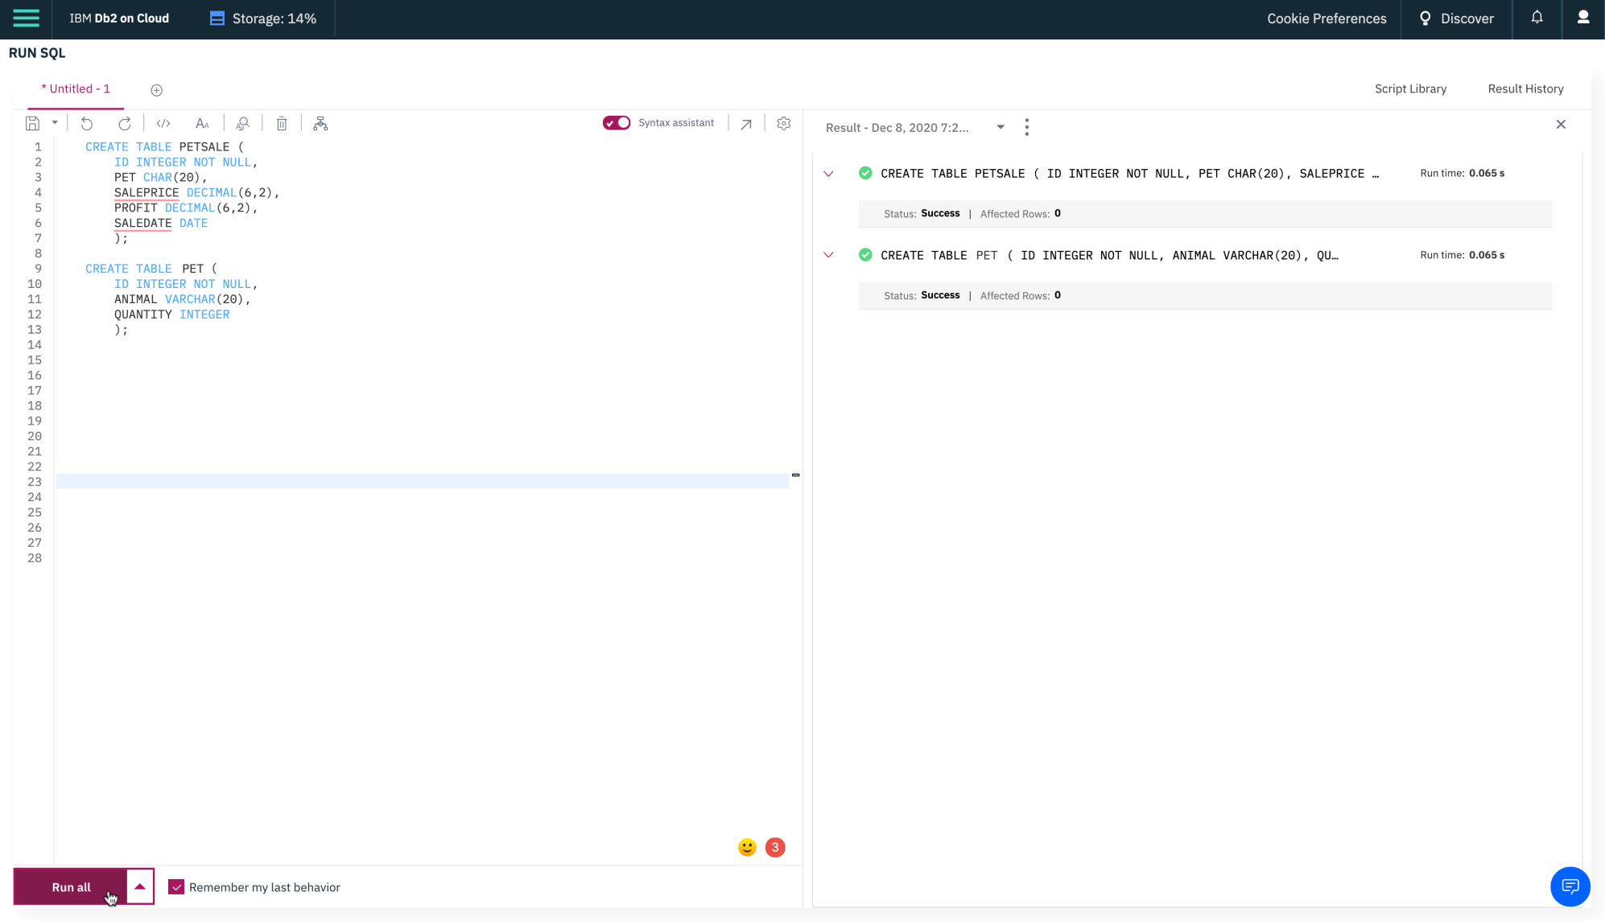

1. Now insert some records into the two newly created tables and show all the records of the two tables. Copy the code below and paste it to the textbox of the **Run SQL** page. Click **Run all**.
2. **INSERT** INTO PETSALE VALUES
3. (**1**,'Cat',450.09,100.47,'2018-05-29'),
4. (**2**,'Dog',666.66,150.76,'2018-06-01'),
5. (**3**,'Parrot',50.00,8.9,'2018-06-04'),
6. (**4**,'Hamster',60.60,12,'2018-06-11'),
7. (**5**,'Goldfish',48.48,3.5,'2018-06-14');
9. **INSERT** INTO PET VALUES
10. (**1**,'Cat',3),
11. (**2**,'Dog',4),
12. (**3**,'Hamster',2);
14. **SELECT** \* FROM PETSALE;
15. **SELECT** \* FROM PET;

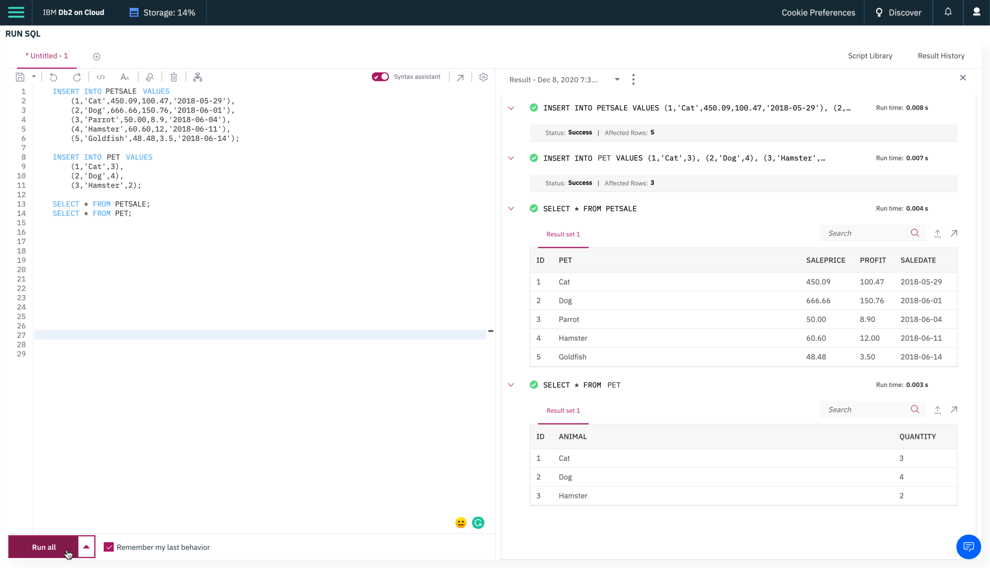

# Exercise 2: ALTER

In this exercise, you will use the ALTER statement to add, delete, or modify columns in two of the existing tables created in exercise 1.

## Task A: ALTER using ADD COLUMN

1. Add a new **QUANTITY** column to the **PETSALE** table and show the altered table. Copy the code below and paste it to the textbox of the **Run SQL** page. Click **Run all**.
2. **ALTER** **TABLE** PETSALE
3. **ADD** **COLUMN** QUANTITY INTEGER;
4. **SELECT** \* **FROM** PETSALE;

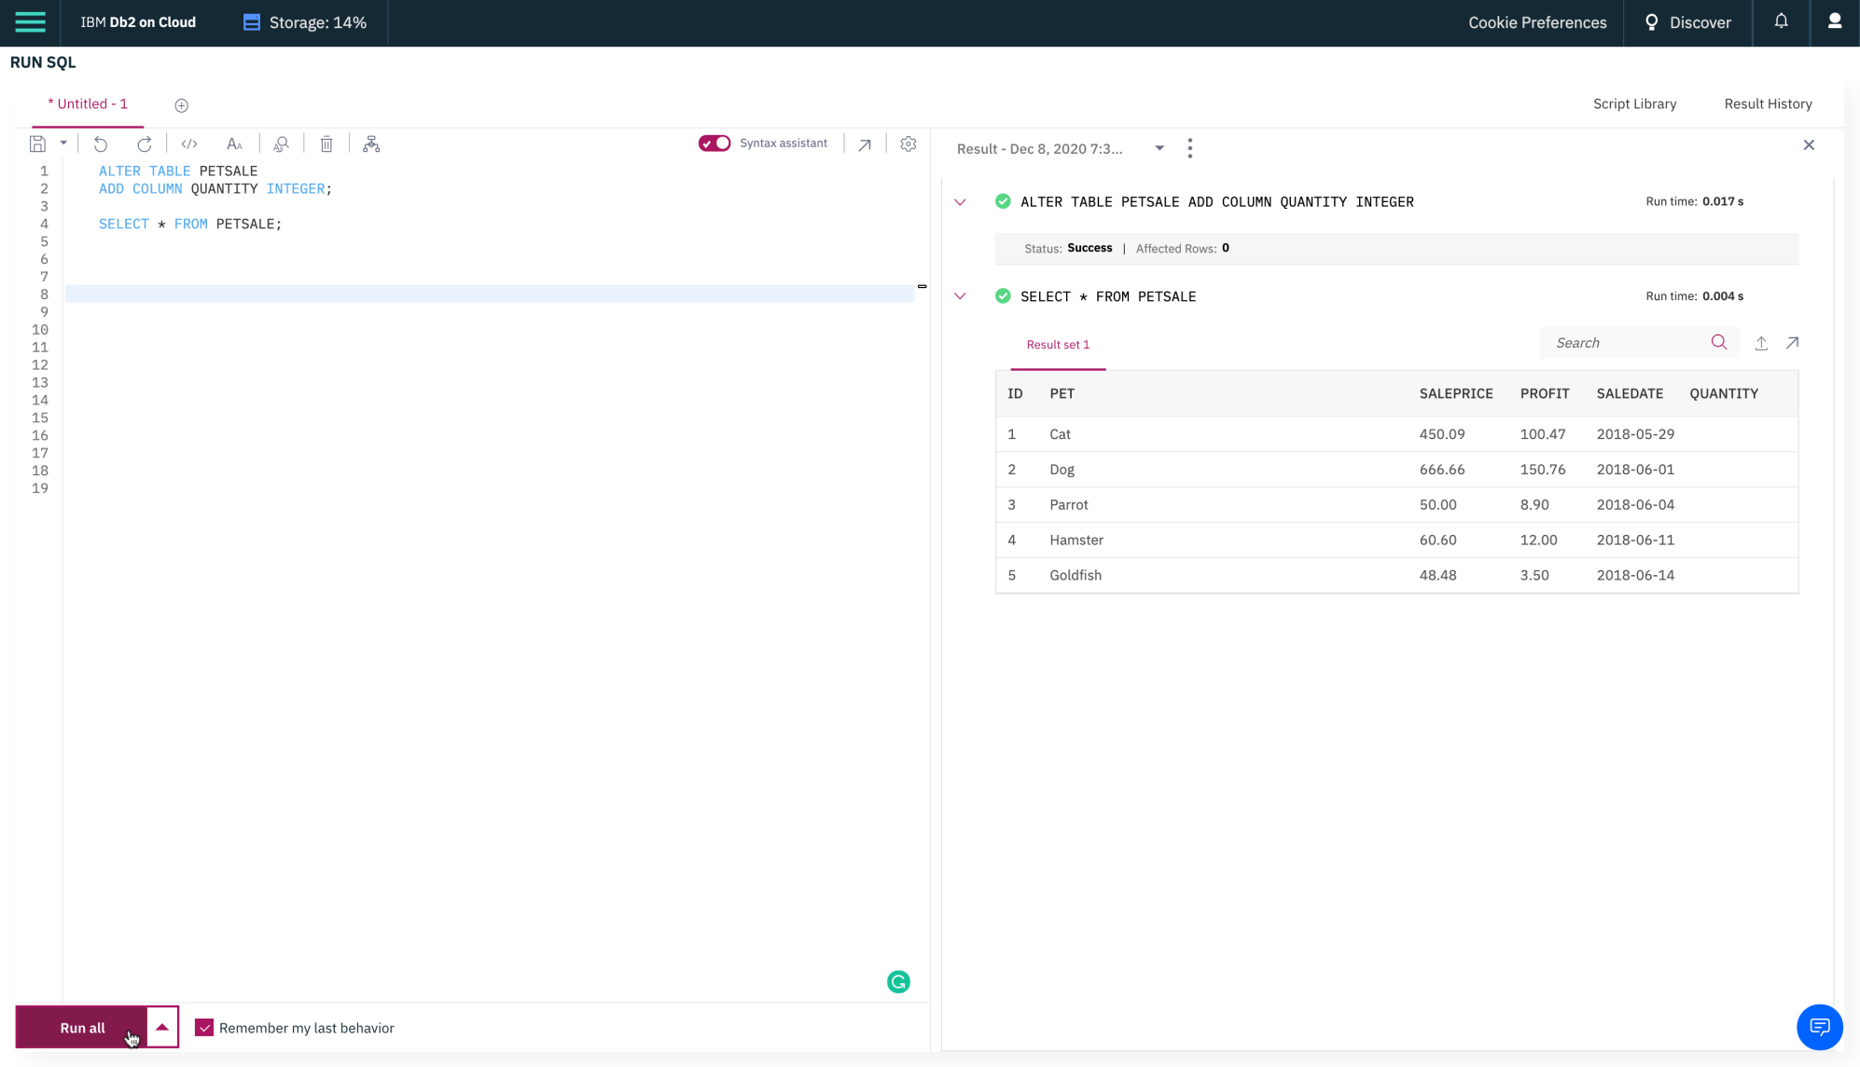

1. Now update the newly added **QUANTITY** column of the **PETSALE** table with some values and show all the records of the table. Copy the code below and paste it to the textbox of the **Run SQL** page. Click **Run all**.
2. **UPDATE** PETSALE **SET** QUANTITY = 9 **WHERE** **ID** = 1;
3. **UPDATE** PETSALE **SET** QUANTITY = 3 **WHERE** **ID** = 2;
4. **UPDATE** PETSALE **SET** QUANTITY = 2 **WHERE** **ID** = 3;
5. **UPDATE** PETSALE **SET** QUANTITY = 6 **WHERE** **ID** = 4;
6. **UPDATE** PETSALE **SET** QUANTITY = 24 **WHERE** **ID** = 5;
7. **SELECT** \* **FROM** PETSALE;

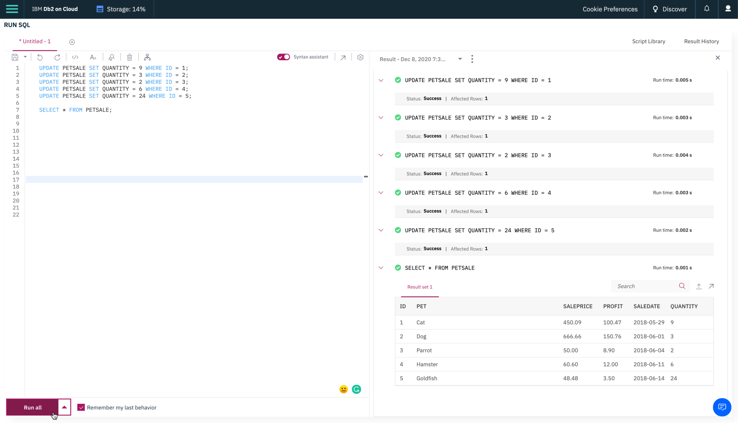

## Task B: ALTER using DROP COLUMN

1. Delete the **PROFIT** column from the **PETSALE** table and show the altered table. Copy the code below and paste it to the textbox of the **Run SQL** page. Click **Run all**.
2. **ALTER** **TABLE** PETSALE
3. **DROP** **COLUMN** PROFIT;
4. **SELECT** \* **FROM** PETSALE;

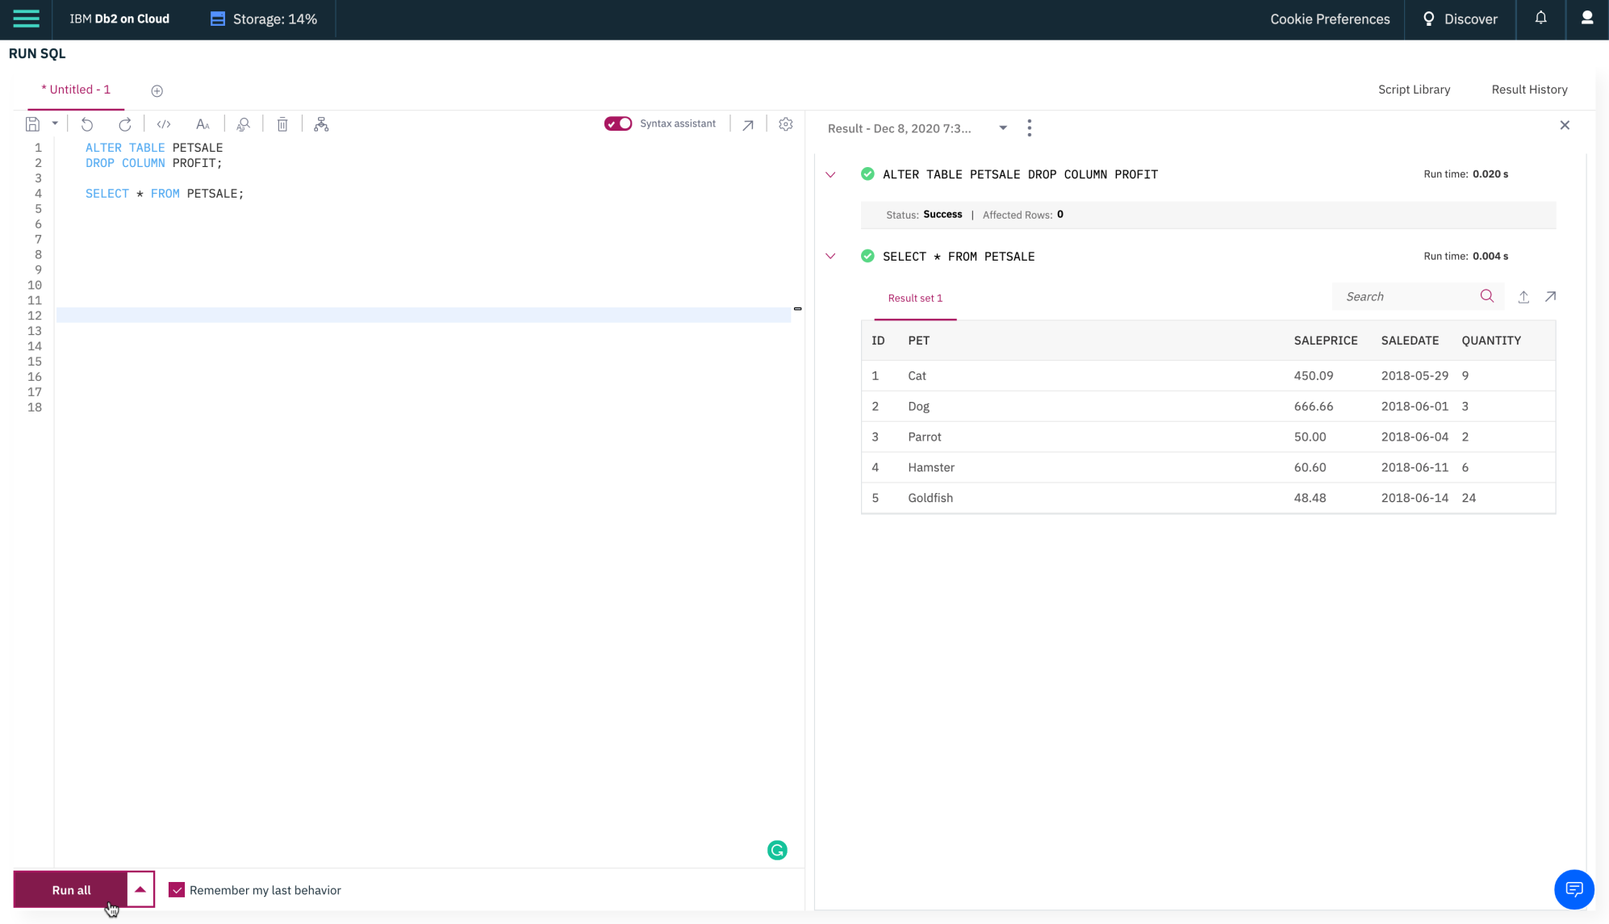

## Task C: ALTER using ALTER COLUMN

1. Change the data type to **VARCHAR(20)** type of the column **PET** of the table **PETSALE** and show the altered table. Copy the code below and paste it to the textbox of the **Run SQL** page. Click **Run all**.
2. **ALTER** **TABLE** PETSALE
3. **ALTER** **COLUMN** PET **SET** **DATA** **TYPE** VARCHAR(20);
4. **SELECT** \* **FROM** PETSALE;

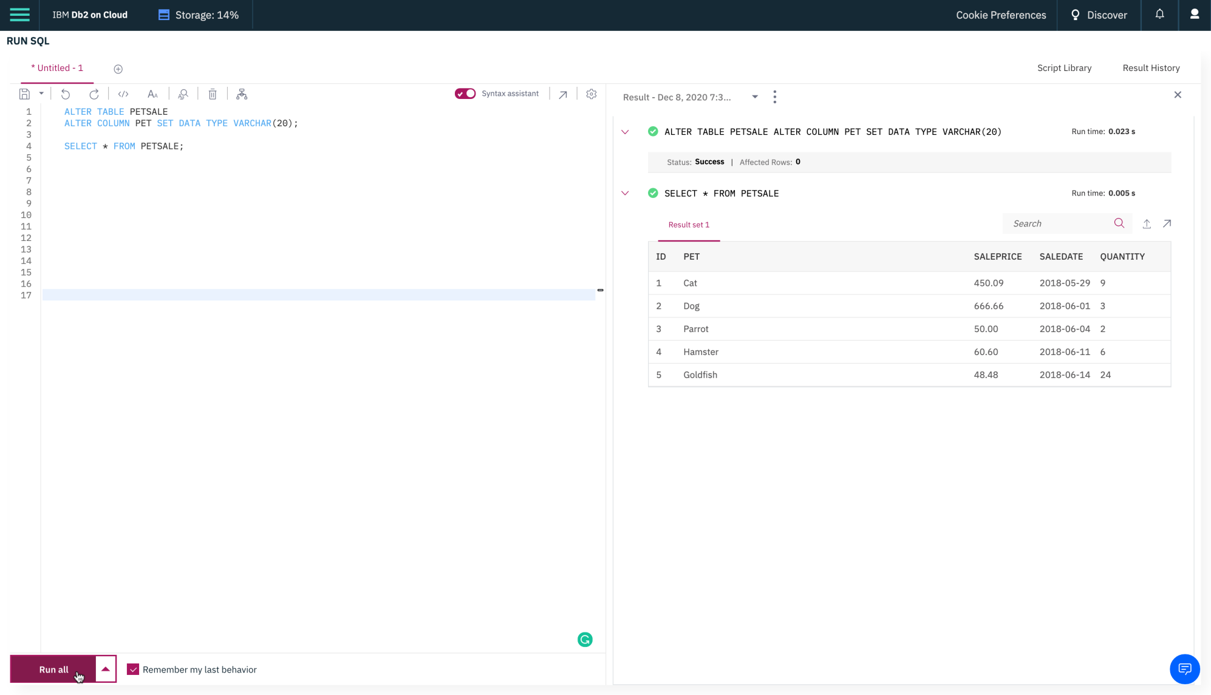

1. Now verify if the data type of the column **PET** of the table **PETSALE** changed to **VARCHAR(20)** type or not. Click on the 3 bar menu icon in the top left corner and click **Explore** > **Tables**. Find the **PETSALE** table from Schemas by clicking **Select All**. Click on the **PETSALE** table to open the Table Definition page of the table. Here, you can see all the current data type of the columns of the **PETSALE** table.

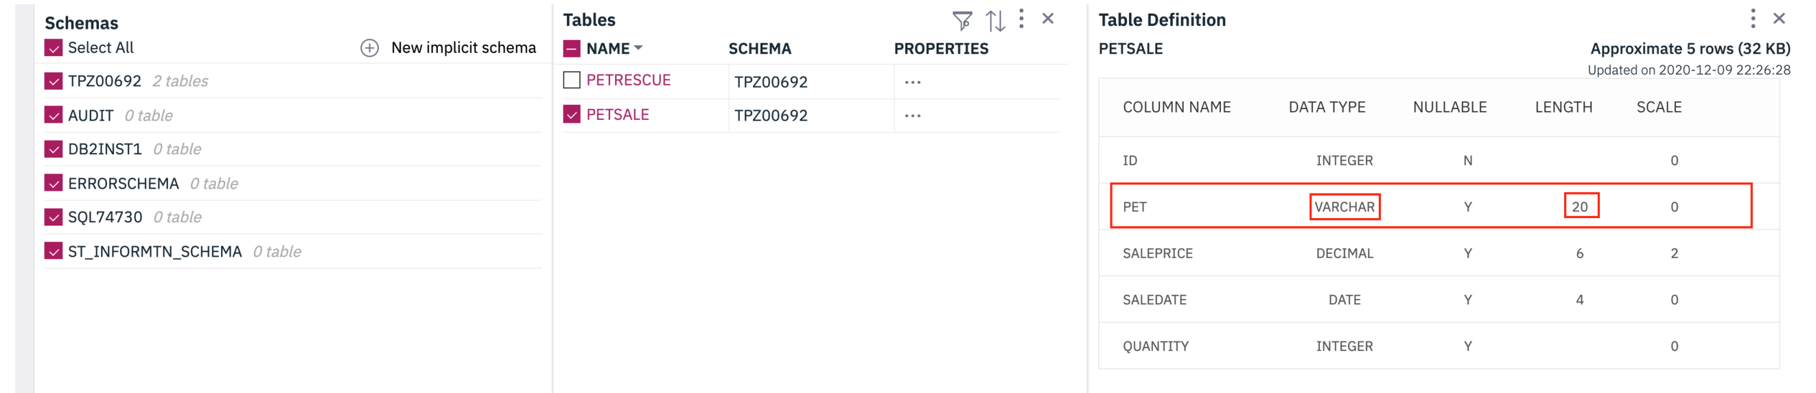

## Task D: ALTER using RENAME COLUMN

1. Rename the column **PET** to **ANIMAL** of the **PETSALE** table and show the altered table. Copy the code below and paste it to the textbox of the **Run SQL** page. Click **Run all**.
2. **ALTER** **TABLE** PETSALE
3. **RENAME** **COLUMN** PET **TO** ANIMAL;
4. **SELECT** \* **FROM** PETSALE;

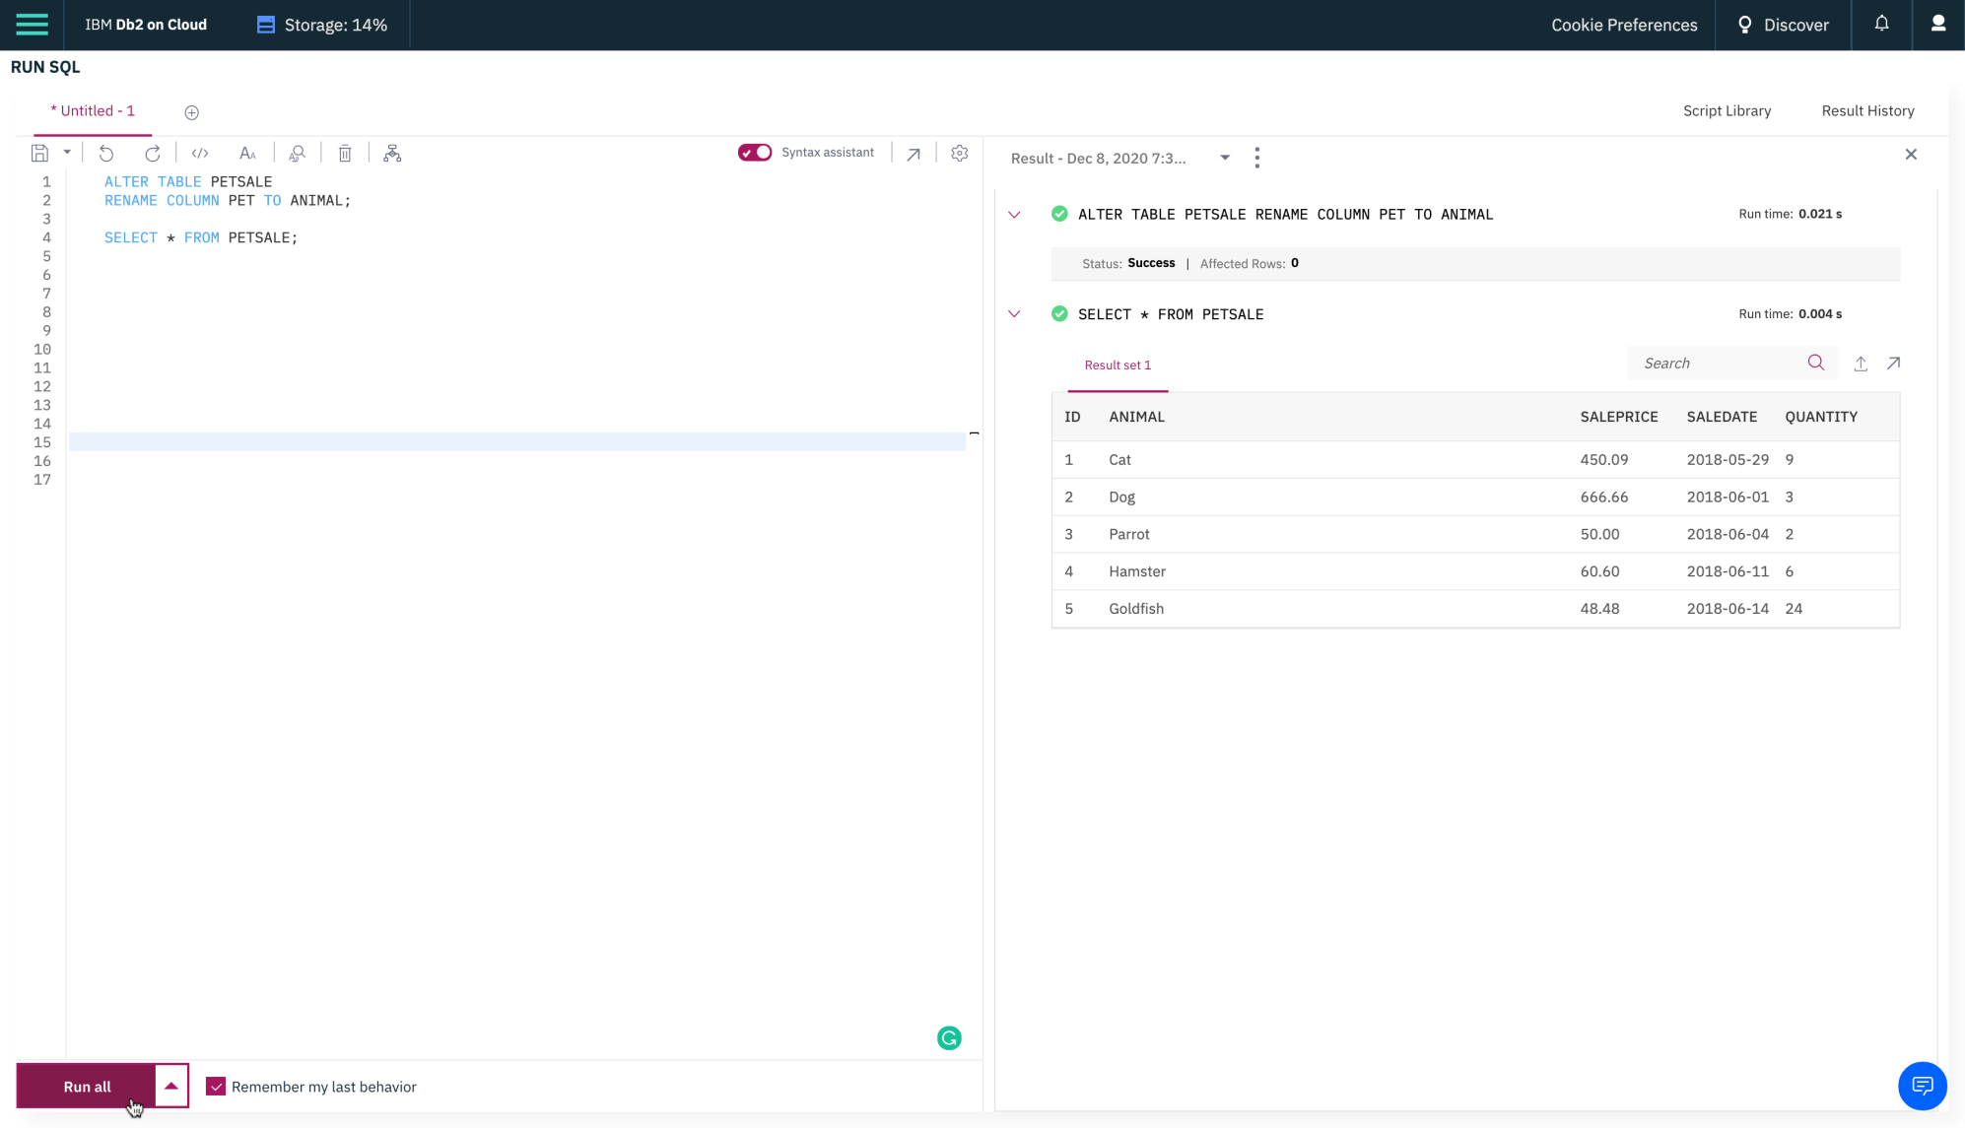

# Exercise 3: TRUNCATE

In this exercise, you will use the TRUNCATE statement to remove all rows from an existing table created in exercise 1 without deleting the table itself.

1. Remove all rows from the **PET** table and show the empty table. Copy the code below and paste it to the textbox of the **Run SQL** page. Click **Run all**.
2. **TRUNCATE** **TABLE** PET **IMMEDIATE**;
3. **SELECT** \* **FROM** PET;

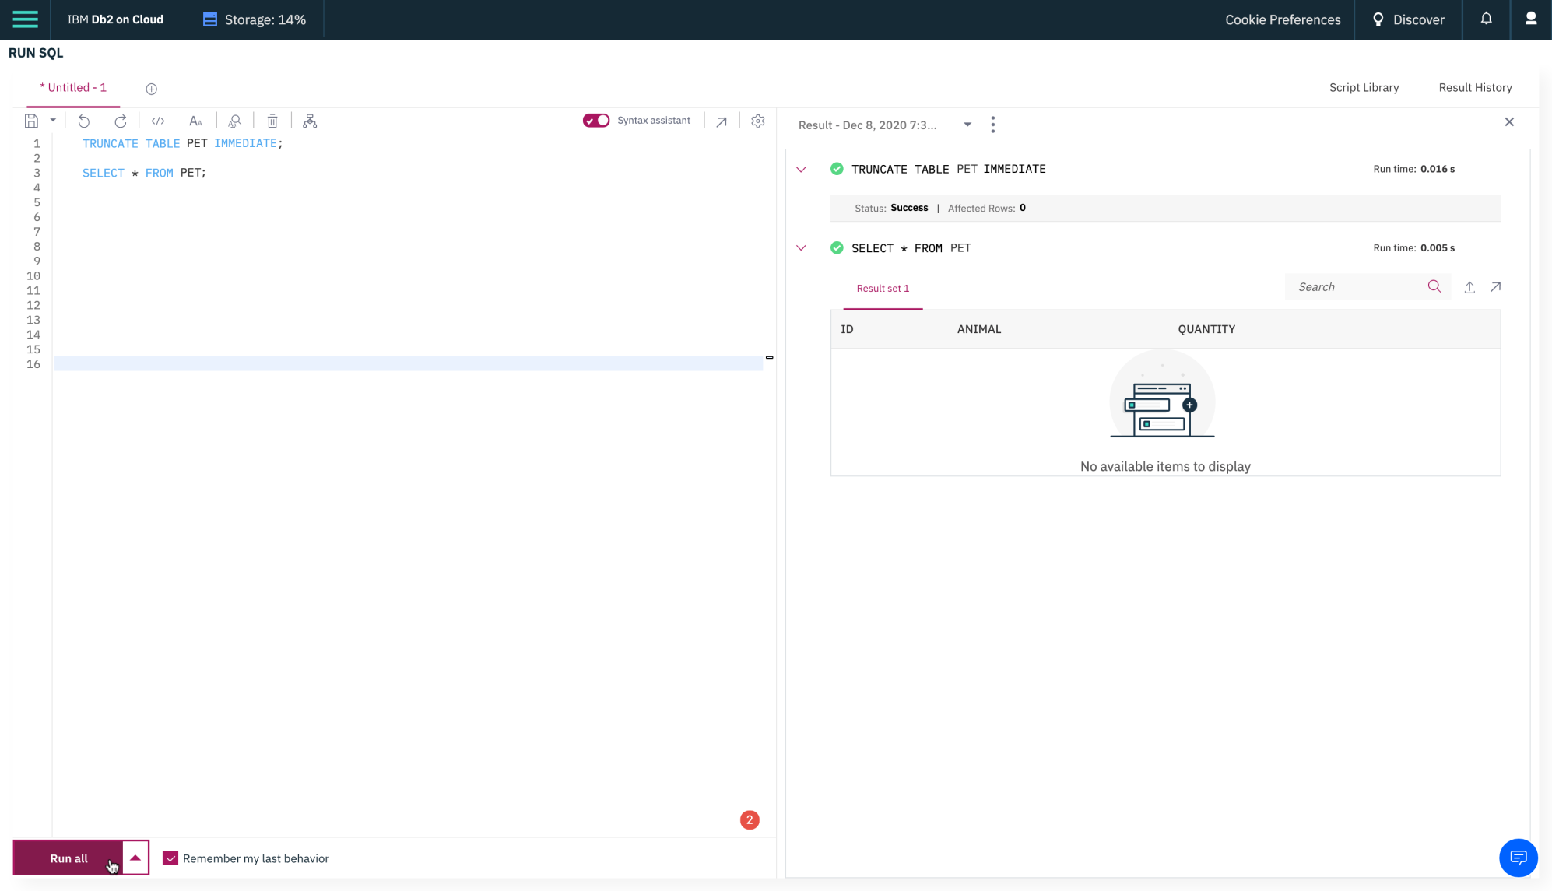

# Exercise 4: DROP

In this exercise, you will use the DROP statement to delete an existing table created in exercise 1.

1. Delete the **PET** table and verify if the table still exists or not (SELECT statement won't work if a table doesn't exist). Copy the code below and paste it to the textbox of the **Run SQL** page. Click **Run all**.
2. **DROP** **TABLE** PET;
3. **SELECT** \* **FROM** PET;

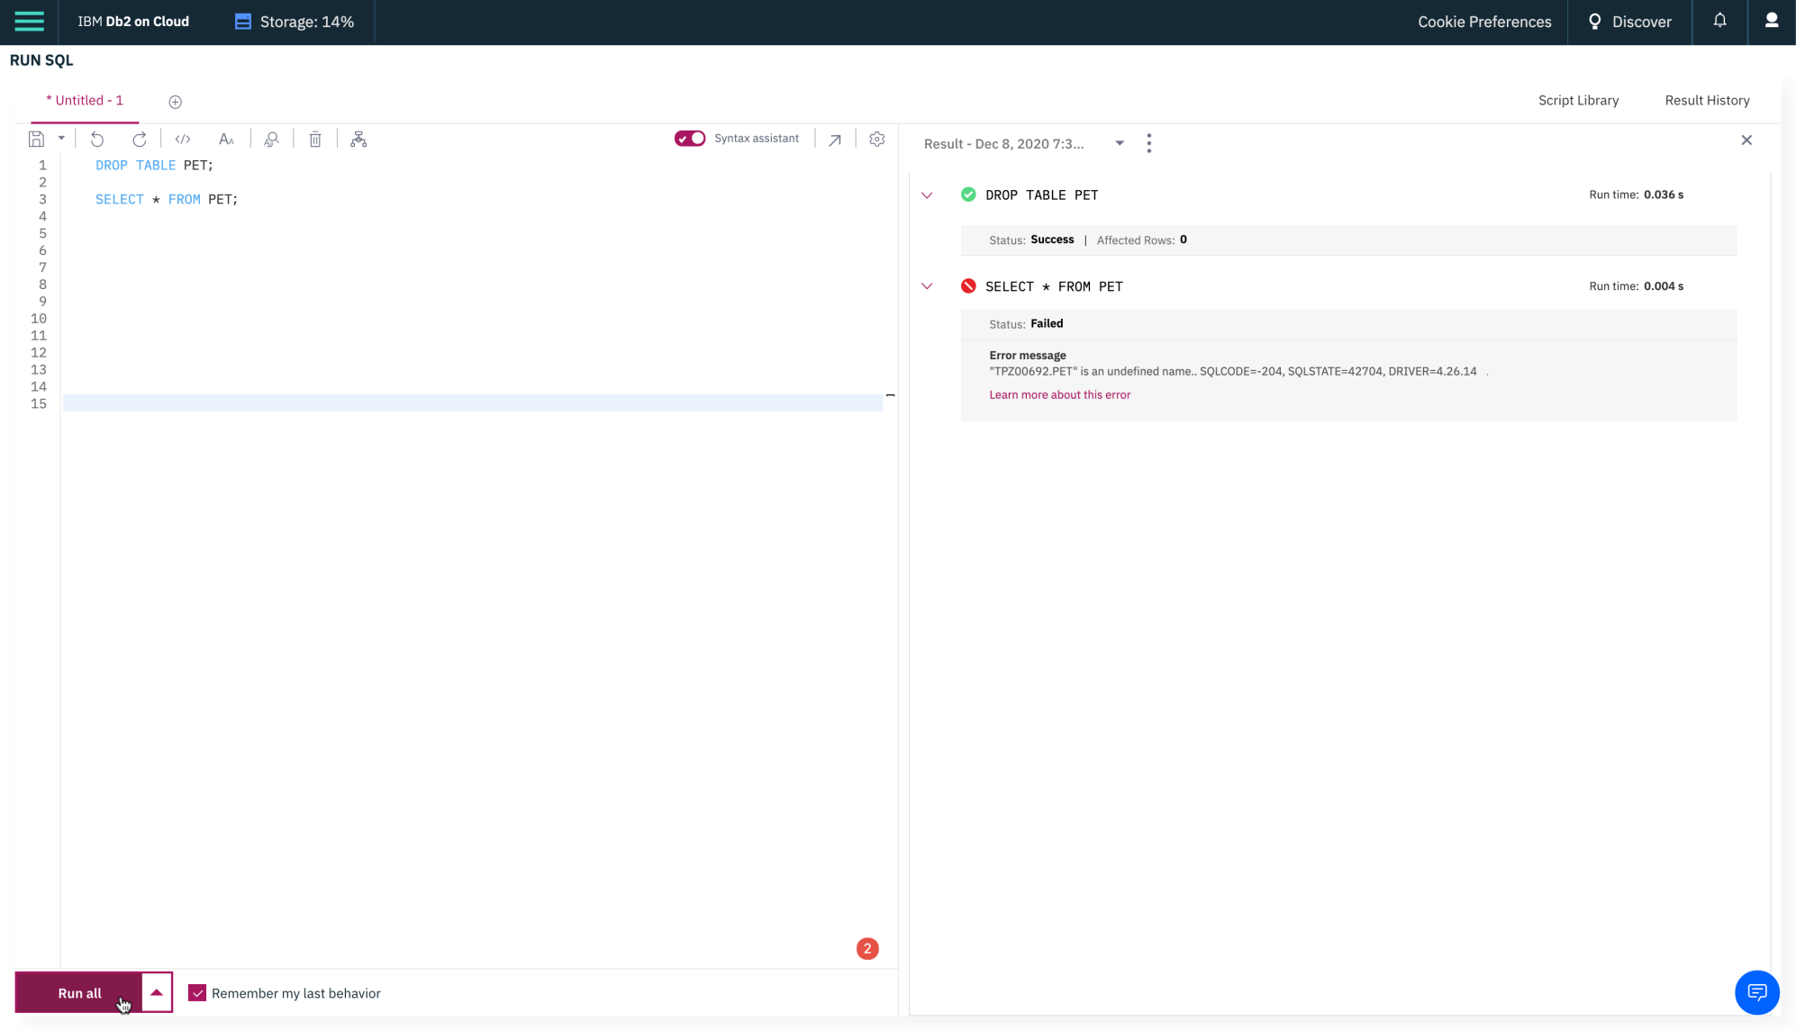

### Congratulations! You have completed this Lab. You are ready for the next topic.

## Author(s)

* [Sandip Saha Joy](https://www.linkedin.com/in/sandipsahajoy/?utm_medium=Exinfluencer&utm_source=Exinfluencer&utm_content=000026UJ&utm_term=10006555&utm_id=NA-SkillsNetwork-Channel-SkillsNetworkCoursesIBMDeveloperSkillsNetworkDB0201ENSkillsNetwork22-2022-01-01)

## Changelog

| **Date** | **Version** | **Changed by** | **Change Description** |
| --- | --- | --- | --- |
| 2020-12-24 | 1.1 | Steve Ryan | ID reviewed |
| 2020-12-07 | 1.0 | Sandip Saha Joy | Initial version created |

### © IBM Corporation 2020. All rights reserved.



# Hands-on Lab: Create Tables using SQL Scripts and Load Data into Tables

**Estimated time needed:** 30 minutes

In this lab, you will learn how to run SQL scripts to create several tables at once, as well as how to load data into tables from .csv files.

## Software Used in this Lab

In this lab, you will use [IBM Db2 Database](https://www.ibm.com/products/db2-database?utm_medium=Exinfluencer&utm_source=Exinfluencer&utm_content=000026UJ&utm_term=10006555&utm_id=NA-SkillsNetwork-Channel-SkillsNetworkCoursesIBMDeveloperSkillsNetworkDB0201ENSkillsNetwork22-2022-01-01). Db2 is a Relational Database Management System (RDBMS) from IBM, designed to store, analyze and retrieve the data efficiently.

To complete this lab you will utilize a Db2 database service on IBM Cloud. If you did not already complete this lab task earlier in this module, you will not yet have access to Db2 on IBM Cloud, and you will need to follow this lab first:

* [Hands-on Lab : Sign up for IBM Cloud, Create Db2 service instance and Get started with the Db2 console](https://cf-courses-data.s3.us.cloud-object-storage.appdomain.cloud/IBMDeveloperSkillsNetwork-DB0201EN-SkillsNetwork/labs/Labs_Coursera_V5/labs/Lab%20-%20Sign%20up%20for%20IBM%20Cloud%20-%20Create%20Db2%20service%20instance%20-%20Get%20started%20with%20the%20Db2%20console/instructional-labs.md.html)

## Database Used in this Lab

The database used in this lab is an internal database. You will be working on a sample HR database. This HR database schema consists of 5 tables called **EMPLOYEES**, **JOB\_HISTORY**, **JOBS**, **DEPARTMENTS** and **LOCATIONS**. Each table has a few rows of sample data. The following diagram shows the tables for the HR database:

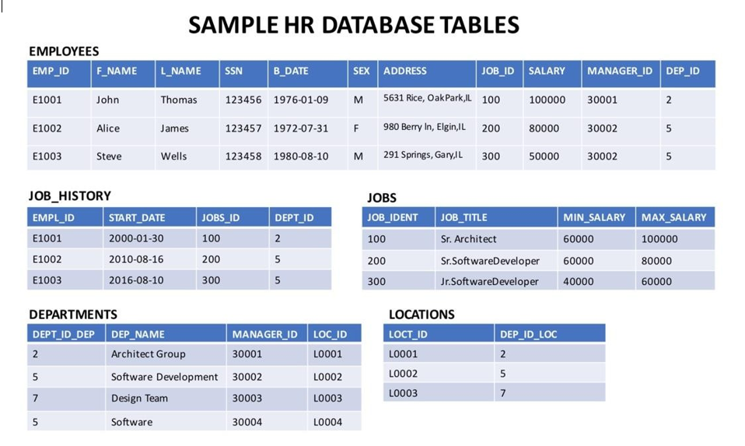

## Objectives

After completing this lab, you will be able to:

* Create tables using SQL scripts
* Load data into tables

### ****NOTE**** : Make sure that you are using the CSV file and datasets from the same instruction file.

## Exercise 1: Create tables using SQL scripts

In this exercise, you will learn how to execute a script containing the CREATE TABLE commands for all the tables rather than create each table manually by typing the DDL commands in the SQL editor.

1. Download the script file to your computer:
   * [HR\_Database\_Create\_Tables\_Script.sql](https://cf-courses-data.s3.us.cloud-object-storage.appdomain.cloud/IBMDeveloperSkillsNetwork-DB0201EN-SkillsNetwork/labs/Labs_Coursera_V5/datasets/HR_Database/HR_Database_Create_Tables_Script.sql)
2. Login to IBM Cloud and go to the [Resource List](https://cloud.ibm.com/resources?utm_medium=Exinfluencer&utm_source=Exinfluencer&utm_content=000026UJ&utm_term=10006555&utm_id=NA-SkillsNetwork-Channel-SkillsNetworkCoursesIBMDeveloperSkillsNetworkDB0201ENSkillsNetwork22-2022-01-01) where you can find the Db2 service instance that you created in a previous lab under **Services** section. Click on the Db2-xx service. Next, click on **Go to UI** button.

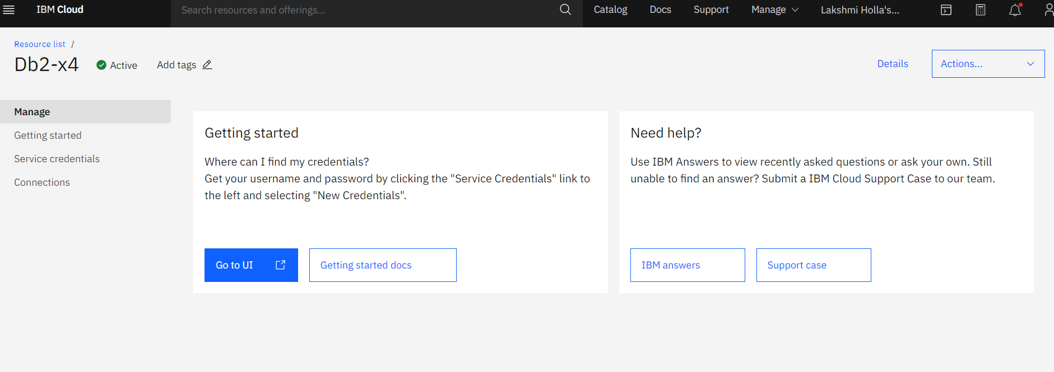

1. Click on Run SQL on the left corner and select the from file option.

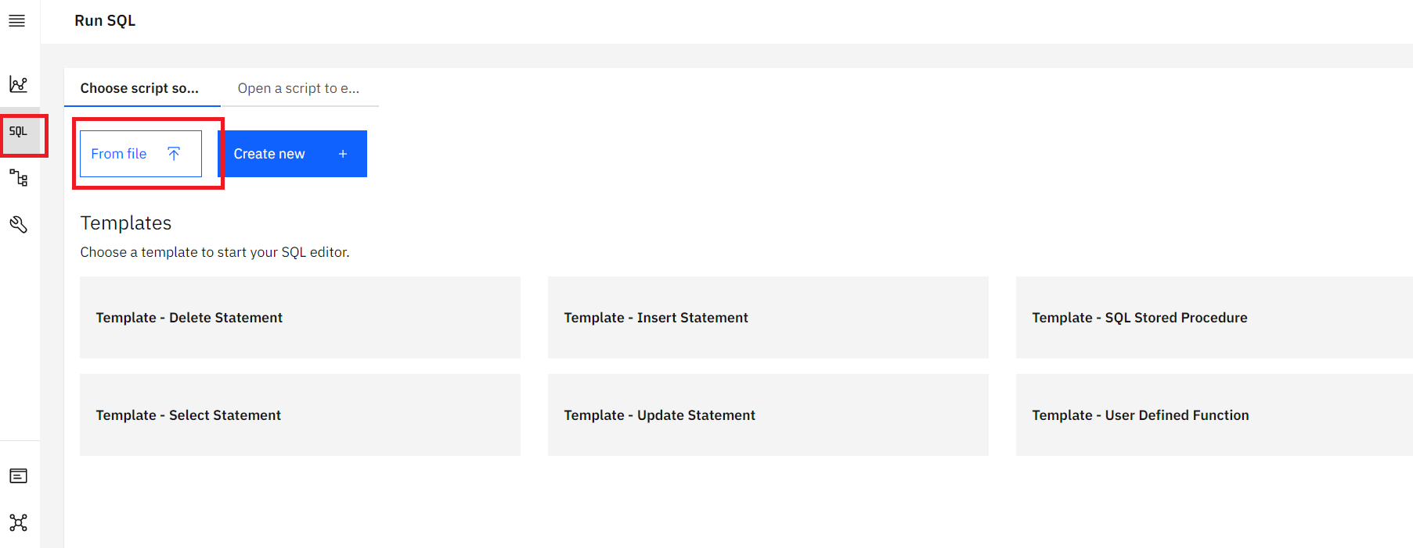

1. Locate the file **HR\_Database\_Create\_Tables\_Script.sql** that you downloaded to your computer earlier and open it.
2. Once the statements are in the SQL Editor tool , you can run the queries against the database by selecting the **Run All** button.

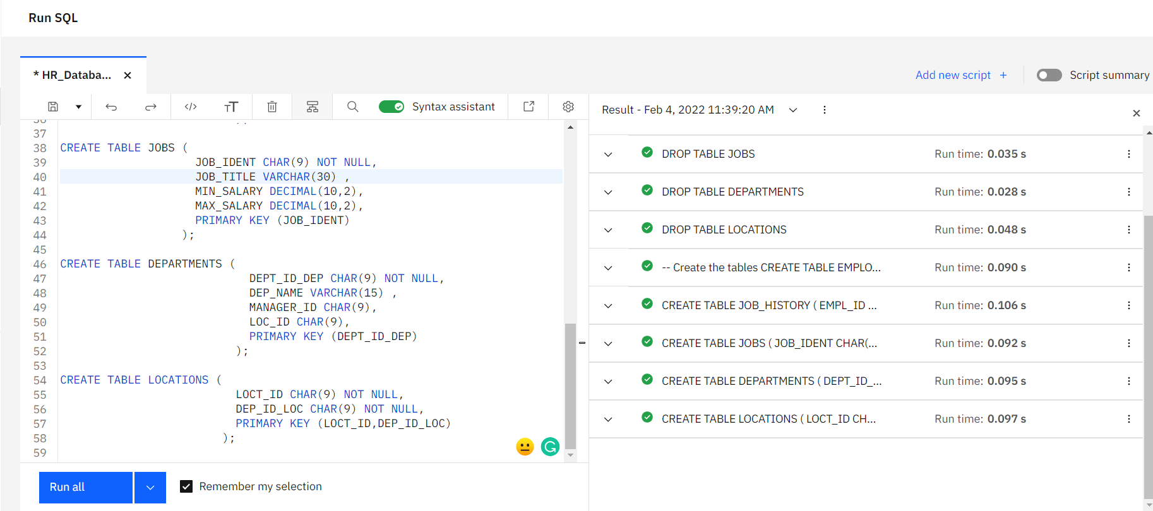

1. On the right side of the SQL editor window you will see a Result section. Clicking on a query in the Result section will show the execution details of the job like whether it ran successfully, or had any errors or warnings. Ensure your queries ran successfully and created all the tables.
   * **Note:** You may see several errors before the successful creation of the tables. These errors relate to the dropping (removal) of any pre-existing version of these tables. You can ignore these errors.

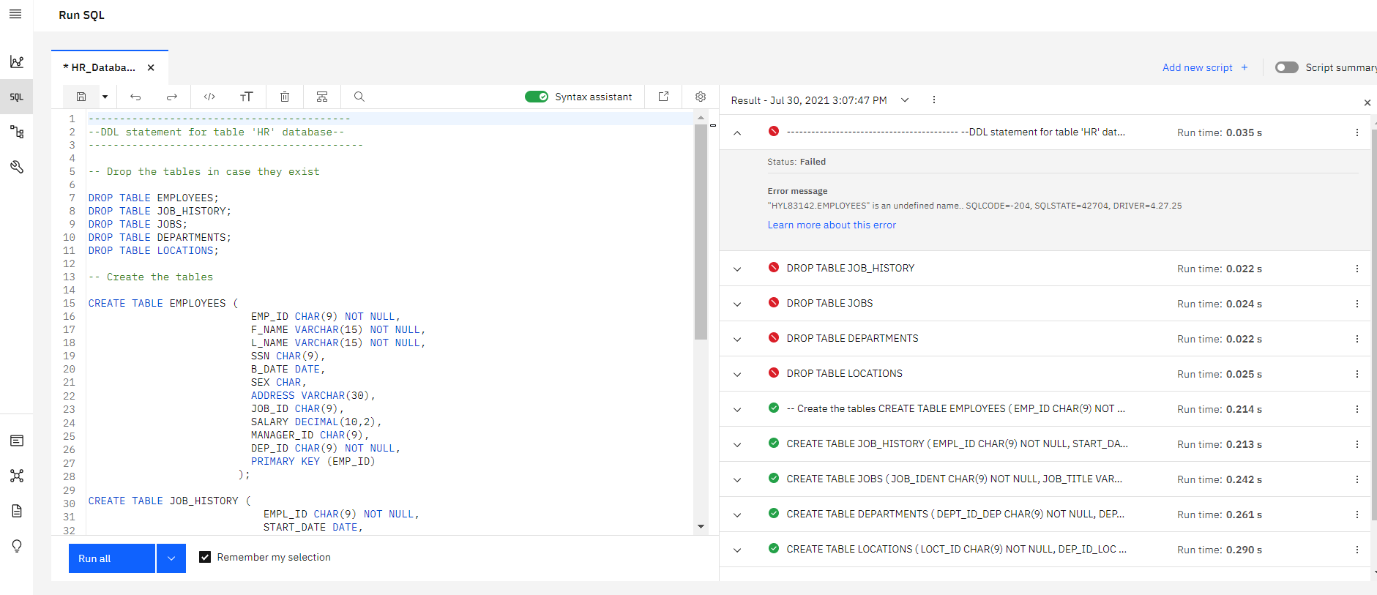

1. Now you can look at the tables you created. Click on the data icon and then click on Tables tab

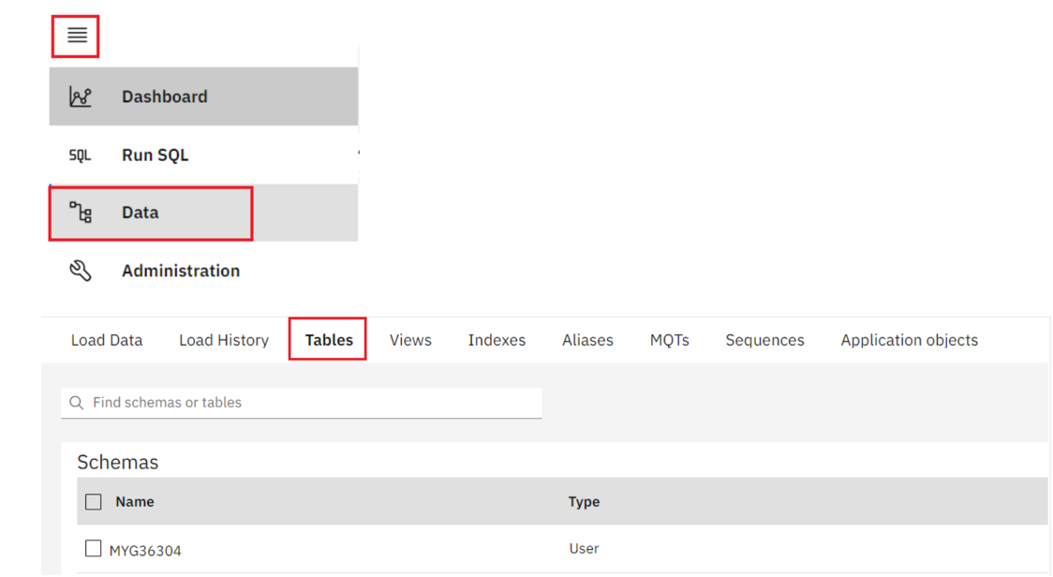

1. Select the Schema corresponding to your Db2 userid. It typically starts with 3 letters (not SQL) followed by 5 numbers (but will be different from the **MYG36304** example below). Then on the right side of the screen you should see the 5 newly created tables listed – DEPARTMENTS, EMPLOYEES, JOBS, JOB\_HISTORY and LOCATIONS (plus any other tables you may have created in previous labs e.g. PETSALE, PETRESCUE, etc.).

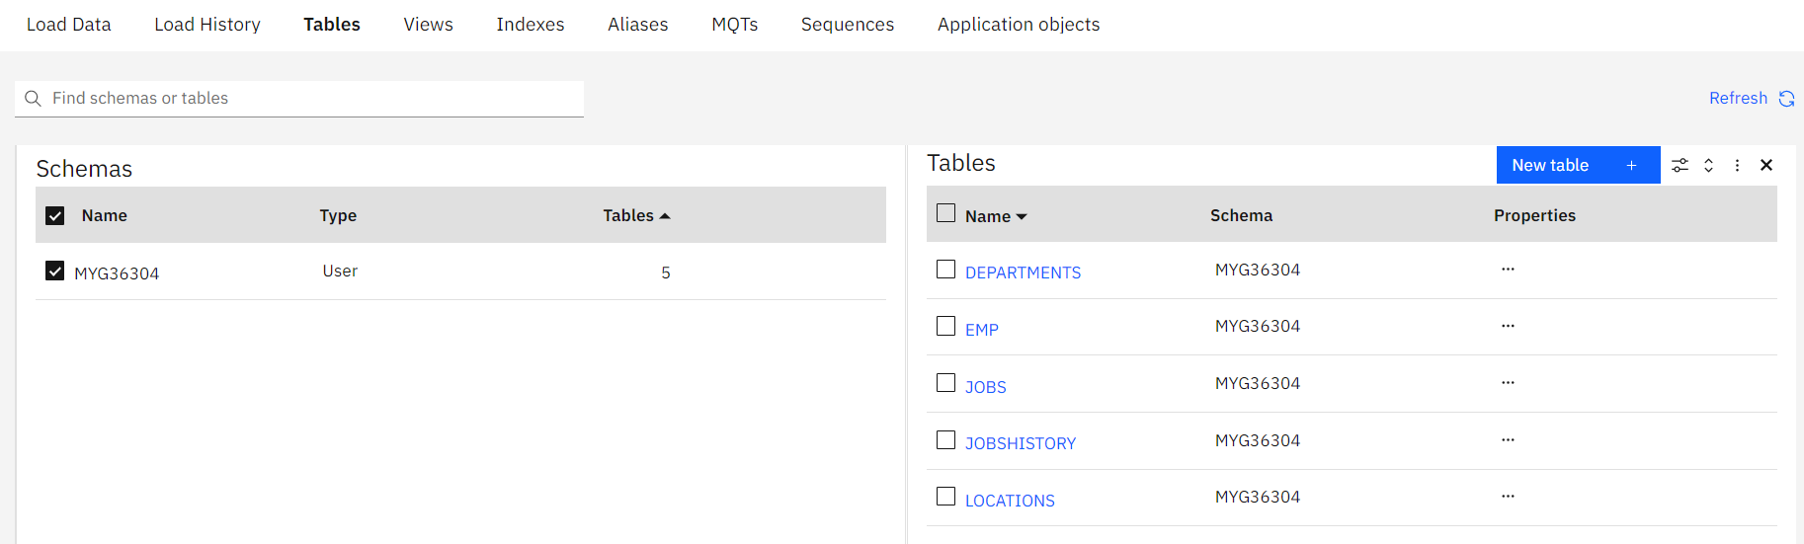

1. Click on any of the tables and you will see its Table Definition (that is, its list of columns, data types, etc).

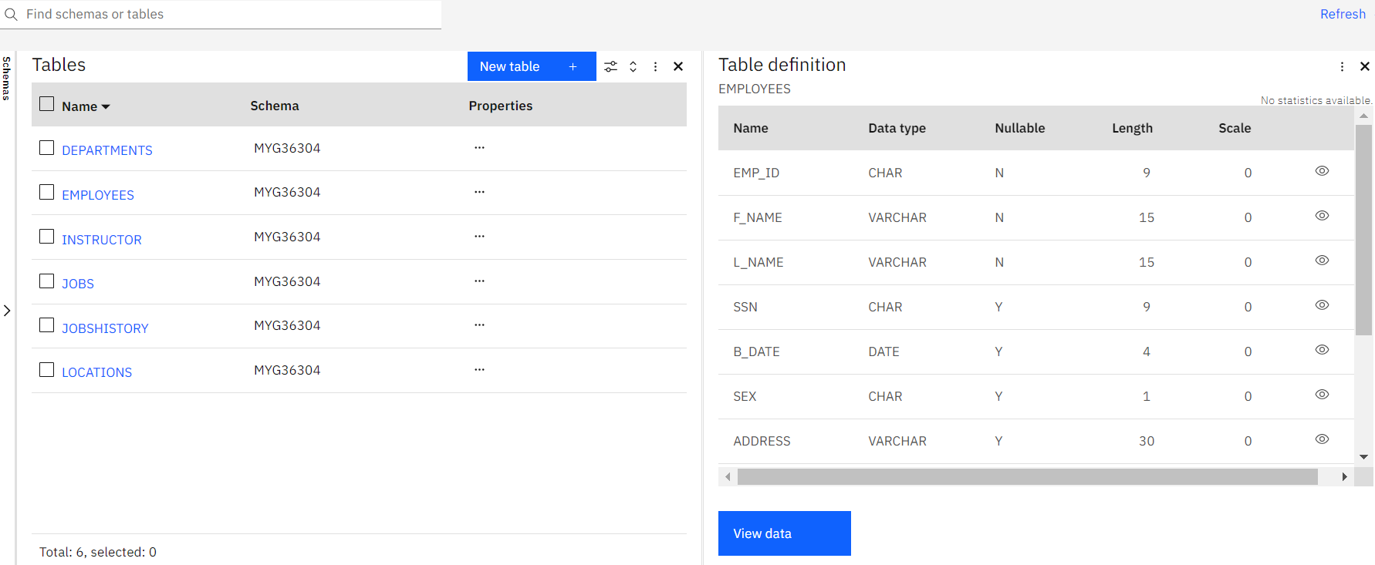

## Exercise 2: Load data into tables

In this exercise, you will learn how data can be loaded into Db2. You could manually insert each row into the table one by one, but that would take a long time. Instead, Db2 (and almost every other database) allows you to load data from .CSV files.

The steps below explain the process of loading data into the tables you created earlier in exercise 1.

1. Download the 5 .csv files below to your local computer:
   * [Departments.csv](https://cf-courses-data.s3.us.cloud-object-storage.appdomain.cloud/IBMDeveloperSkillsNetwork-DB0201EN-SkillsNetwork/labs/Labs_Coursera_V5/datasets/HR_Database/Departments.csv)
   * [Employees.csv](https://cf-courses-data.s3.us.cloud-object-storage.appdomain.cloud/IBMDeveloperSkillsNetwork-DB0201EN-SkillsNetwork/labs/Labs_Coursera_V5/datasets/HR_Database/Employees.csv)
   * [Jobs.csv](https://cf-courses-data.s3.us.cloud-object-storage.appdomain.cloud/IBMDeveloperSkillsNetwork-DB0201EN-SkillsNetwork/labs/Labs_Coursera_V5/datasets/HR_Database/Jobs.csv)
   * [Locations.csv](https://cf-courses-data.s3.us.cloud-object-storage.appdomain.cloud/IBMDeveloperSkillsNetwork-DB0201EN-SkillsNetwork/labs/Labs_Coursera_V5/datasets/HR_Database/Locations.csv)
   * [JobsHistory.csv](https://cf-courses-data.s3.us.cloud-object-storage.appdomain.cloud/IBMDeveloperSkillsNetwork-DB0201EN-SkillsNetwork/labs/Labs_Coursera_V5/datasets/HR_Database/JobsHistory.csv)

**Note**: For learners who are encountering issues with loading from .csv in Db2 using Firefox, they can download the .txt files and try with those:

* + [Departments.txt](https://cf-courses-data.s3.us.cloud-object-storage.appdomain.cloud/IBMDeveloperSkillsNetwork-DB0201EN-SkillsNetwork/labs/Module%202/data/Departments.txt)
  + [Employees.txt](https://cf-courses-data.s3.us.cloud-object-storage.appdomain.cloud/IBMDeveloperSkillsNetwork-DB0201EN-SkillsNetwork/labs/Module%202/data/Employees.txt)
  + [Jobs.txt](https://cf-courses-data.s3.us.cloud-object-storage.appdomain.cloud/IBMDeveloperSkillsNetwork-DB0201EN-SkillsNetwork/labs/Module%202/data/Jobs.txt)
  + [Locations.txt](https://cf-courses-data.s3.us.cloud-object-storage.appdomain.cloud/IBMDeveloperSkillsNetwork-DB0201EN-SkillsNetwork/labs/Module%202/data/Locations.txt)
  + [JobsHistory.txt](https://cf-courses-data.s3.us.cloud-object-storage.appdomain.cloud/IBMDeveloperSkillsNetwork-DB0201EN-SkillsNetwork/labs/Module%202/data/JobsHistory.txt)

1. In the Db2 Console, from the 3-bar menu icon in the top left corner, click **Load**, and then select **Load Data**.

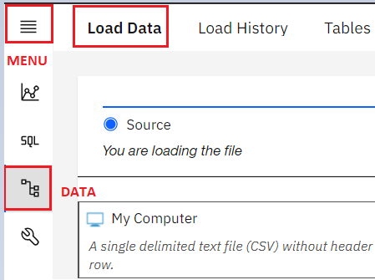

1. On the **Load Data** page that opens, ensure **My Computer** is selected as the source. Click on the **browse files** link.

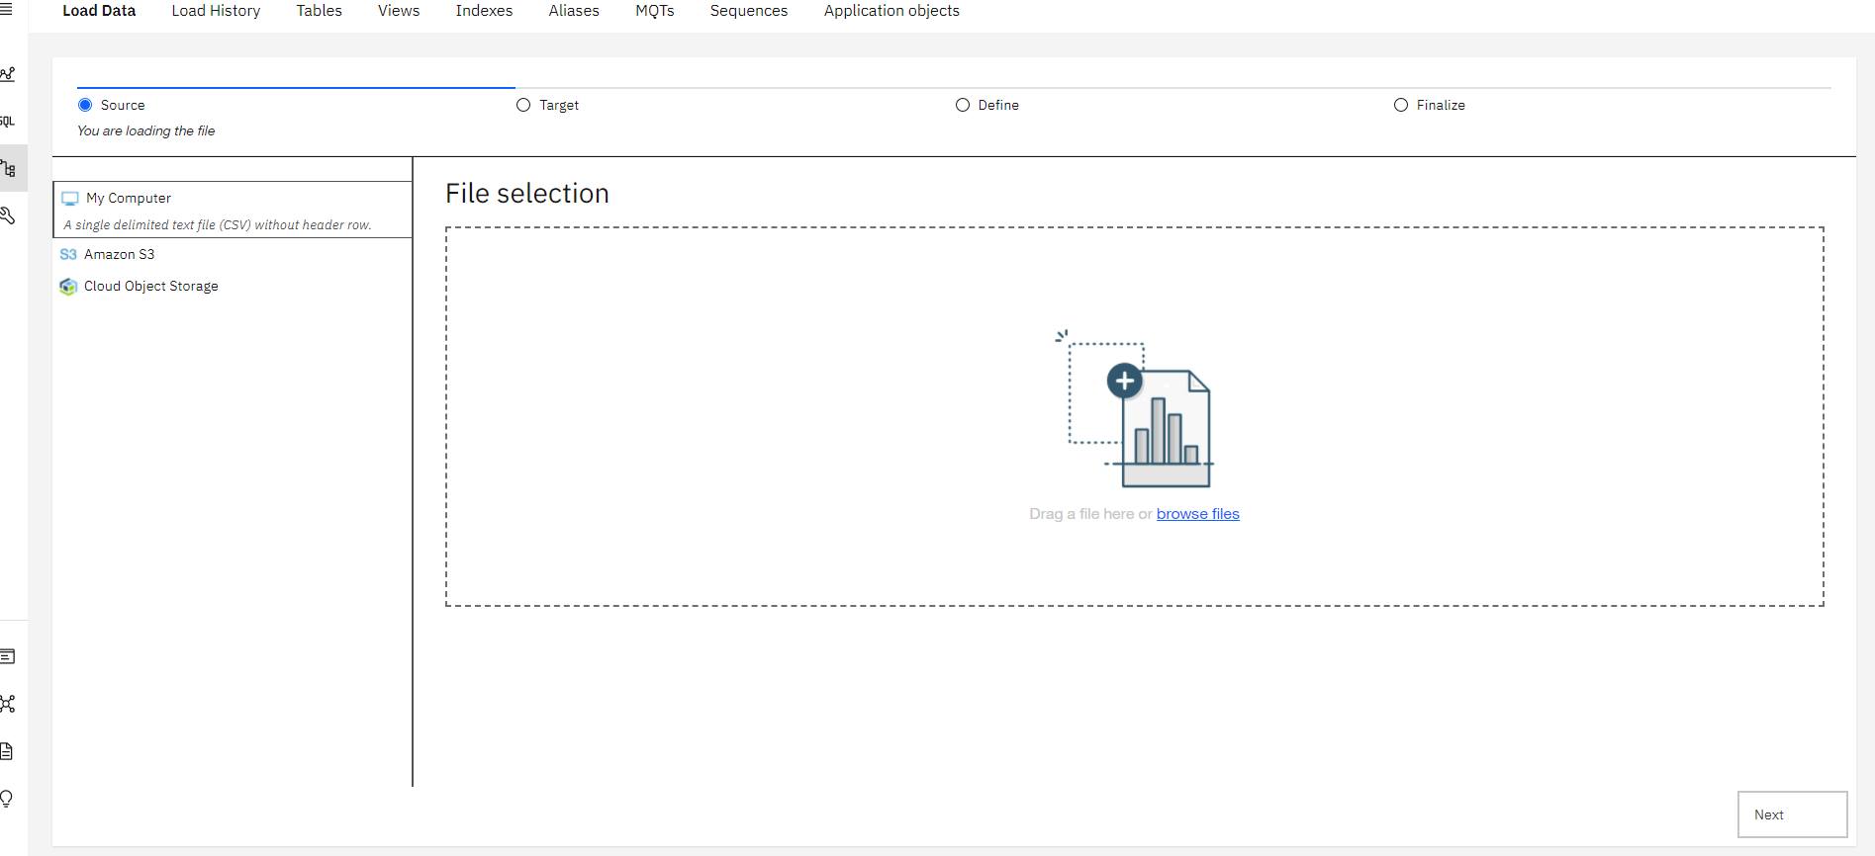

1. Choose the file **Employees.csv** that you downloaded to your computer and click **Open**.

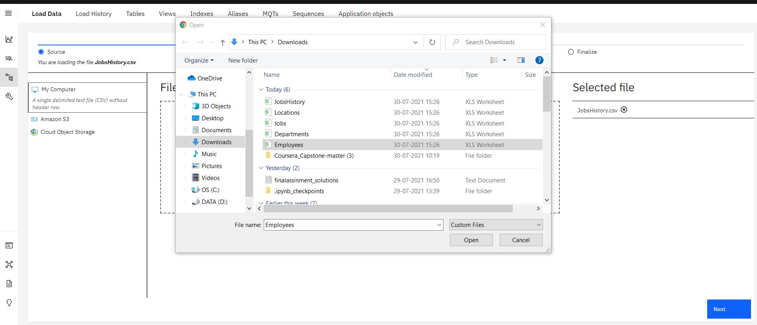

1. Once the File is selected, click **Next** in the bottom right corner.

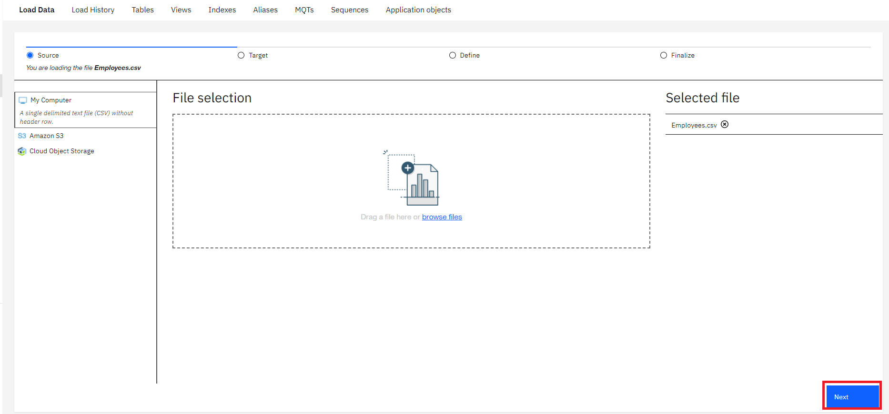

1. Select the schema for your Db2 Userid (the one where you created the tables earlier).It will show all the tables that have been created in this schema previously, including the Employees table. Select the **EMPLOYEES** table, and in the new Table Definition tab that appears, choose **Overwrite table with new data** (note the warning message), then click **Next**. Select the **Employees** table.
2. Since the source data files do not contain any rows with column labels, **turn off** the setting for **Header in first row**. Also, click on the down arrow next to **Date format** and choose **MM/DD/YYYY** since that is how the date is formatted in the source file.

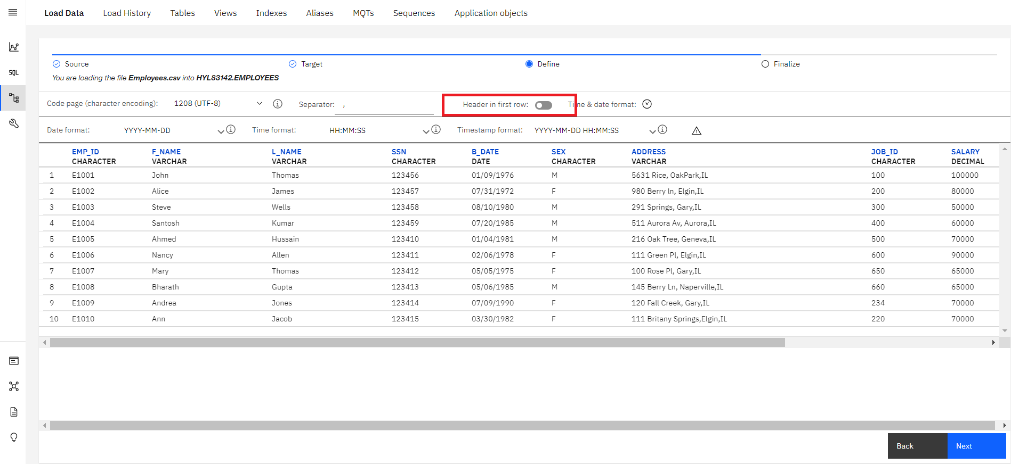

1. Click **Next**. Review the load settings and click **Begin Load** in the bottom right corner.

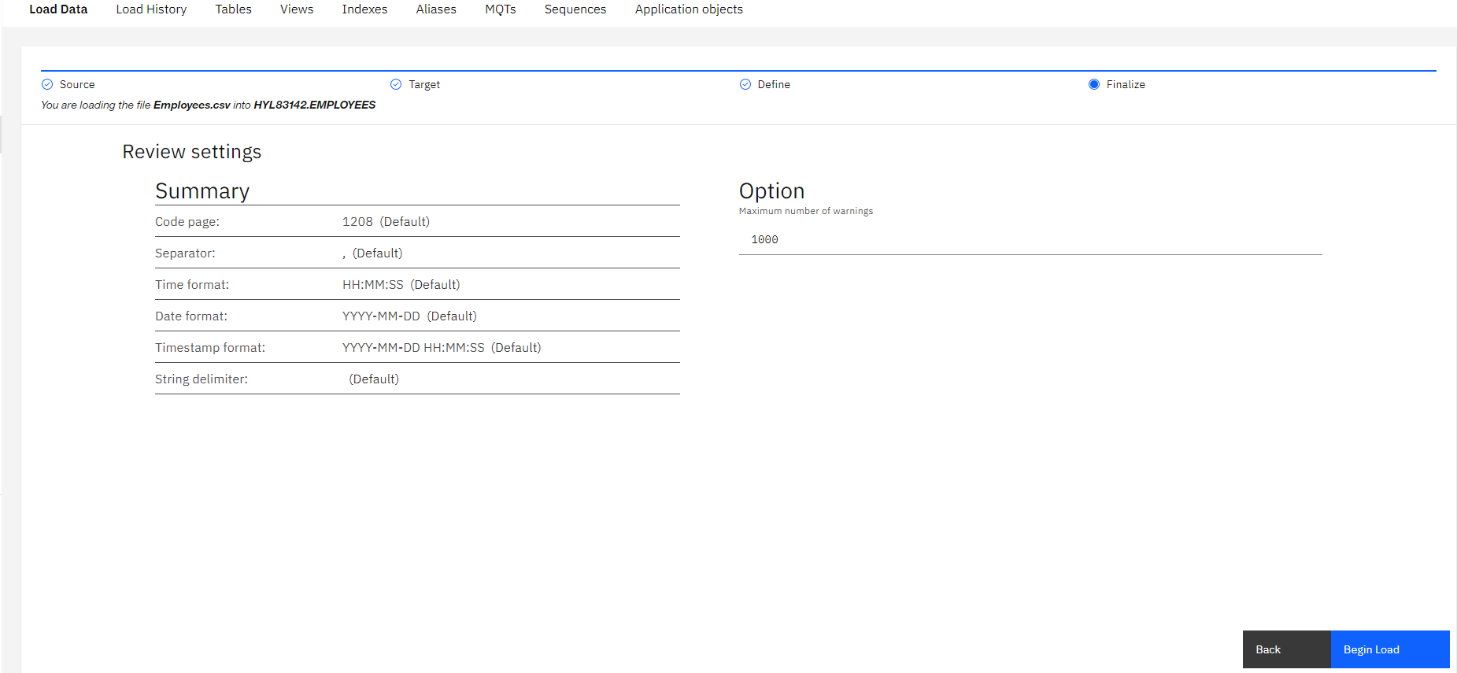

1. After loading has completed, you will notice that you were successful in loading all 10 rows of the Employees table. If there are any **Errors** or **Warnings**, you can see them on this screen.

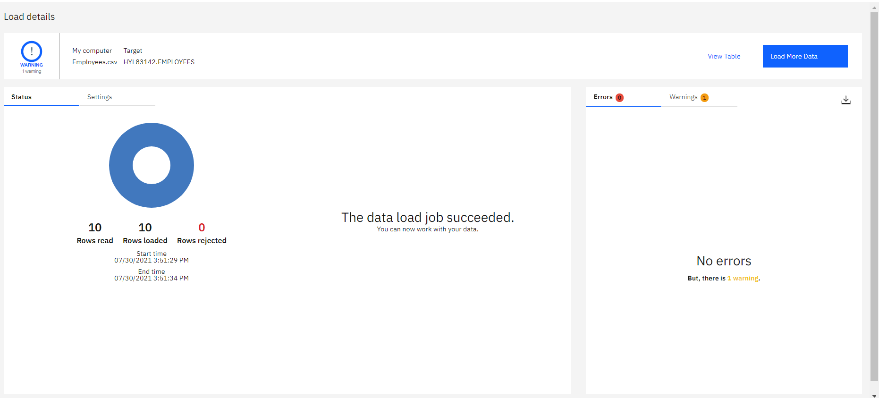

1. Click on the **Tables** tab and then select the **EMPLOYEES** table and then click on **View data**.

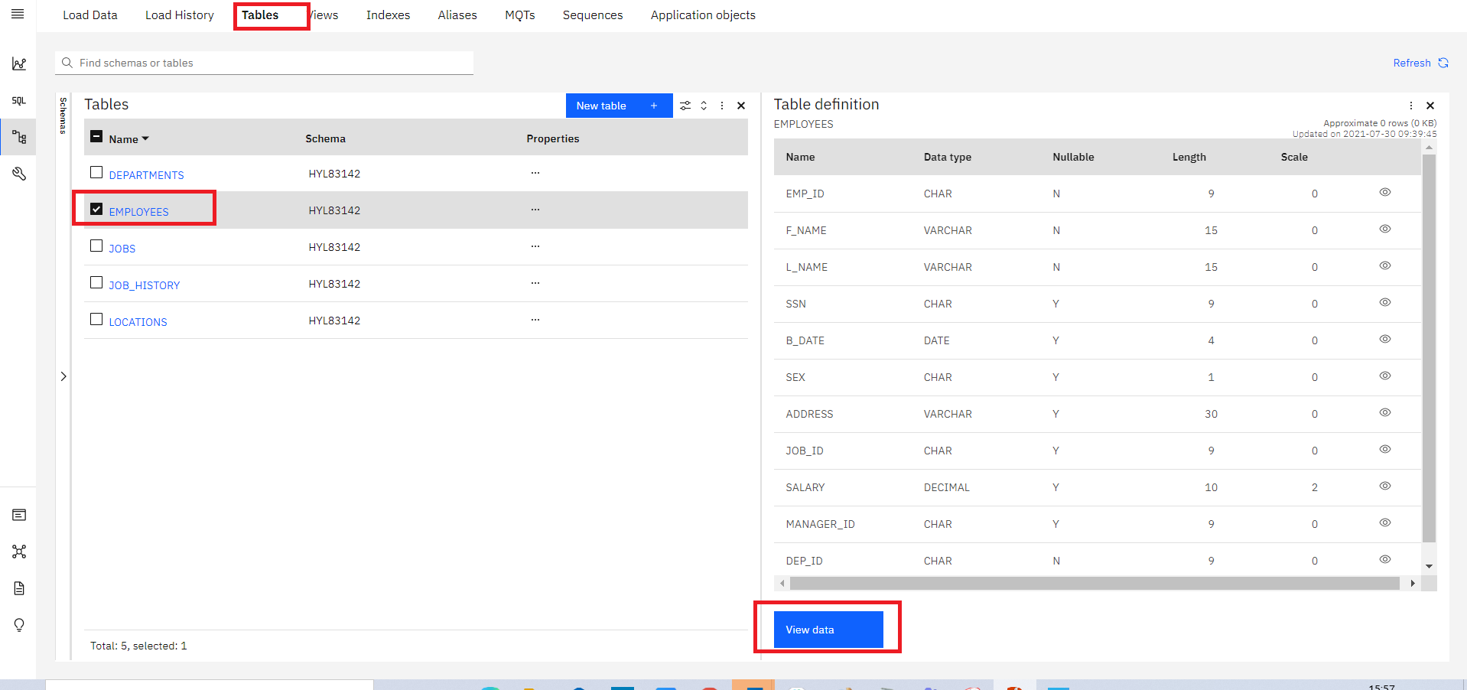

1. Now you can view the table data.

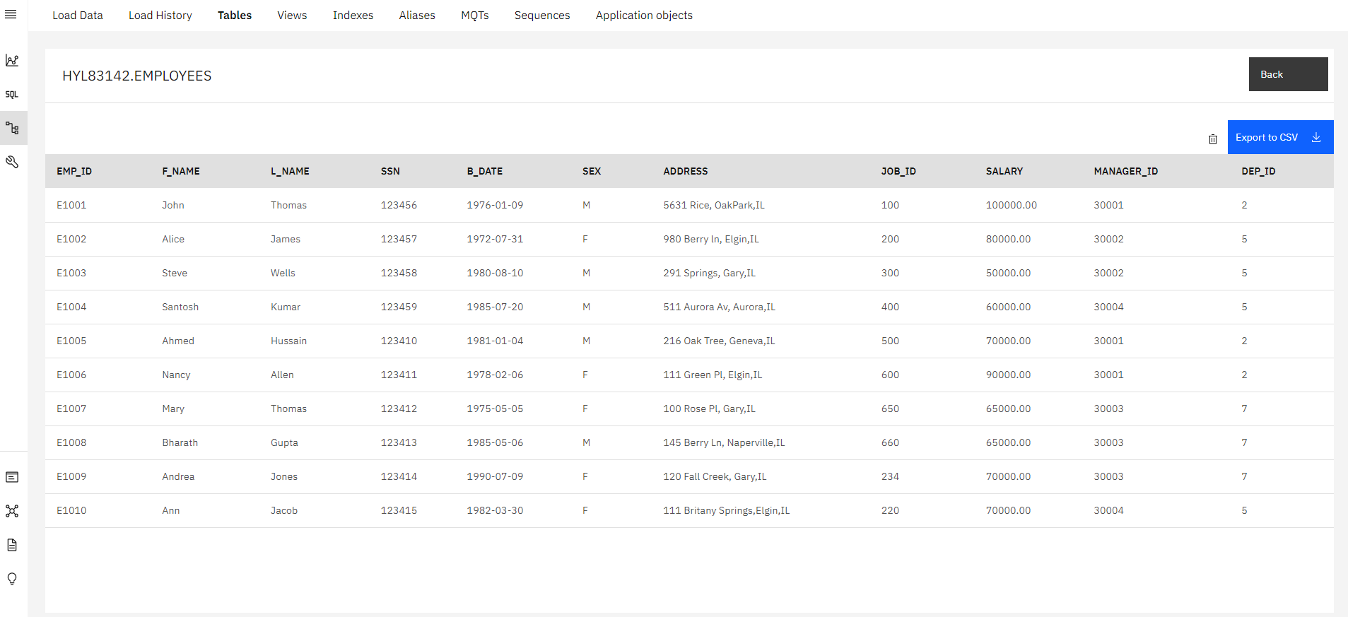

1. Now it's your turn to load data to the remaining 4 tables of the HR database – **LOCATIONS**, **JOB\_HISTORY**, **JOBS**, and **DEPARTMENTS** from the remaining source files.
2. Click **Load More Data** and then follow the steps from **Step 3** above again to load the remaining 4 tables.

**IMPORTANT** Make sure you perform the steps in **Step 7** for each of the 4 remaining file loads.

### Congratulations! You have completed this lab, and you are ready for the next topic.

# Author(s)

* [Rav Ahuja](https://www.linkedin.com/in/ravahuja/?utm_medium=Exinfluencer&utm_source=Exinfluencer&utm_content=000026UJ&utm_term=10006555&utm_id=NA-SkillsNetwork-Channel-SkillsNetworkCoursesIBMDeveloperSkillsNetworkDB0201ENSkillsNetwork22-2022-01-01)
* [Sandip Saha Joy](https://www.linkedin.com/in/sandipsahajoy/?utm_medium=Exinfluencer&utm_source=Exinfluencer&utm_content=000026UJ&utm_term=10006555&utm_id=NA-SkillsNetwork-Channel-SkillsNetworkCoursesIBMDeveloperSkillsNetworkDB0201ENSkillsNetwork22-2022-01-01)

## Changelog

| **Date** | **Version** | **Changed by** | **Change Description** |
| --- | --- | --- | --- |
| 2022-08-19 | 2.4 | D.M.Naidu | Upload .txt files |
| 2021-07-30 | 2.3 | Lakshmi Holla | Updated screenshot of DB2 |
| 2021-07-08 | 2.2 | Malika | Updated screenshot |
| 2020-12-23 | 2.1 | Steve Ryan | ID Review |
| 2020-12-08 | 2.0 | Sandip Saha Joy | Created revised version from DB0201EN |
| 2020 | 1.0 | Rav Ahuja | Created initial version |

### © IBM Corporation 2020. All rights reserved.

# Summary & Highlights

Congratulations! You have completed this lesson. At this point in the course, you know:

* A database is a repository of data that provides functionality for adding, modifying, and querying the data.
* SQL is a language used to query or retrieve data from a relational database.
* The Relational Model is the most used data model for databases because it allows for data independence.
* The primary key of a relational table uniquely identifies each tuple or row, preventing duplication of data and providing a way of defining relationships between tables.
* SQL statements fall into two different categories: Data Definition Language (DDL) statements and Data Manipulation Language (DML) statements.

## SQL Cheat Sheet: CREATE TABLE, ALTER, DROP, TRUNCATE



|  |  |  |  |
| --- | --- | --- | --- |
| **Command** | **Syntax** | **Description** | **Example** |
| CREATE TABLE | CREATE TABLE table\_name (col1 datatype *optional keyword*, col2 datatype *optional keyword*,col3 datatype *optional keyword*,..., coln datatype *optional keyword*) | CREATE TABLE statement is to create the table. Each column in the table is specified with its name, data type and an optional keyword which could be **PRIMARY KEY**, **NOT NULL**, etc., | CREATE TABLE employee ( employee\_id char(2) PRIMARY KEY, first\_name varchar(30) NOT NULL, mobile int); |
| ALTER TABLE - ADD COLUMN | ALTER TABLE table\_name ADD COLUMN column\_name\_1 datatype....ADD COLUMN column\_name\_n datatype; | ALTER TABLE statement is used to add the columns to a table. | ALTER TABLE employee ADD COLUMN income bigint; |
| ALTER TABLE - ALTER COLUMN | ALTER TABLE table\_name ALTER COLUMN column\_name\_1 SET DATA TYPE datatype; | ALTER TABLE ALTER COLUMN statement is used to modify the data type of columns. | ALTER TABLE employee ALTER COLUMN mobile SET DATA TYPE CHAR(20); |
| ALTER TABLE - DROP COLUMN | ALTER TABLE table\_name DROP COLUMN column\_name\_1 ; | ALTER TABLE DROP COLUMN statement is used to remove columns from a table. | ALTER TABLE employee DROP COLUMN mobile ; |
| ALTER TABLE - RENAME COLUMN | ALTER TABLE table\_name RENAME COLUMN current\_column\_name TO new\_column\_name; | ALTER TABLE RENAME COLUMN statement is used to rename the columns in a table. | ALTER TABLE employee RENAME COLUMN first\_name TO name ; |
| TRUNCATE TABLE | TRUNCATE TABLE table\_name IMMEDIATE; | TRUNCATE TABLE statement is used to delete all of the rows in a table. The IMMEDIATE specifies to process the statement immediately and that it cannot be undone. | TRUNCATE TABLE employee IMMEDIATE ; |
| DROP TABLE | DROP TABLE table\_name ; | Use the DROP TABLE statement to delete a table from a database. If you delete a table that contains data, by default the data will be deleted alongside the table. | DROP TABLE employee ; |

## Author(s)

[Himanshu Birla](https://www.linkedin.com/in/birlahimanshu/?utm_medium=Exinfluencer&utm_source=Exinfluencer&utm_content=000026UJ&utm_term=10006555&utm_id=NA-SkillsNetwork-Channel-SkillsNetworkCoursesIBMDeveloperSkillsNetworkDB0201ENSkillsNetwork20127838-2022-01-01)

## Changelog

| **Date** | **Version** | **Changed by** | **Change Description** |
| --- | --- | --- | --- |
| 2021-07-27 | 1.0 | Himanshu Birla | Initial Version |

# Using String Patterns and Ranges

0:00

Hello, and welcome to retrieving data with SELECT statements string patterns.

In this video, we will learn about

some advanced techniques in retrieving data from a relational database table.

At the end of this lesson,

you will be able to describe how to simplify a SELECT statement by using string patterns,

ranges or sets of values.

The main purpose of a database management system is not just to store the data,

but also facilitate retrieval of the data.

In its simplest form,

a SELECT statement is select star from table name.

Based on a simplified library database model and the table Book,

SELECT star from Book gives a result set of four rows.

All the data rows for all columns in the table Book are

displayed or you can retrieve a subset of columns for example,

just two columns from the table book such as Book\_ID and Title.

Or you can restrict the result set by using the WHERE clause.

For example, you can select the title of the book whose Book\_ID is B1.

But what if we don't know exactly what value to specify in the WHERE clause?

The WHERE clause always requires a predicate,

which is a condition that evaluates to true, false or unknown.

But what if we don't know exactly what value the predicate is?

For example, what if we can't remember the name of the author,

but we remember that their first name starts with R?

In a relational database,

we can use string patterns to search data rows that match this condition.

Let's look at some examples of using string patterns.

If we can't remember the name of the author,

but we remember that their name starts with R,

we use the WHERE clause with the like predicate.

The like predicate is used in a WHERE clause to search for a pattern in a column.

The percent sign is used to define missing letters.

The percent sign can be placed before the pattern,

after the pattern, or both before and after the pattern.

In this example, we use the percent sign after the pattern,

which is the letter R. The percent sign is called a wildcard character.

A wildcard character is used to substitute other characters.

So, if we can't remember the name of the author,

but we can remember that their first name starts with the letter R,

we add the like predicate to the WHERE clause.

For example, select first name from author,

where firstname like 'R%'.

This will return all rows in the author table

whose author's first name starts with the letter R. And here is the result set.

Two rows a return for authors Raul and Rav.

What if we wanted to retrieve the list of books whose number of pages is more than 290,

but less than 300.

We could write the SELECT statement like this,

specifying the WHERE clause as,

where pages is greater than or equal to 290,

and pages is less than or equal to 300.

But in a relational database,

we can use a range of numbers to specify the same condition.

Instead of using the comparison operators greater than or equal to,

we use the comparison operator 'between and.'

'Between and' compares two values.

The values in the range are inclusive.

In this case,we rewrite the query to specify the WHERE clause

as where pages between 290 and 300.

The result set is the same,

but the SELECT statement is easier and quicker to write.

In some cases, there are data values that cannot be grouped under ranges.

For example, if we want to know which countries the authors are from.

If we wanted to retrieve authors from Australia or Brazil,

we could write the SELECT statement with

the WHERE clause repeating the two country values.

However, what if we want to retrieve authors from Canada, India, and China?

The WHERE clause would become very long

repeatedly listing the required country conditions.

Instead, we can use the IN operator.

The IN operator allows us to specify a set of values in a WHERE clause.

This operator takes a list of expressions to compare against.

In this case the countries Australia or Brazil.

Now you can describe how to simplify a SELECT statement by using string patterns,

ranges, or sets of values.

Thanks for watching this video.

(Music)

# Sorting Result Sets

0:00

Hello, and welcome to sorting SELECT statement results sets.

In this video, we will learn about some advanced techniques in retrieving data from

a relational database table and sorting how the result set displays.

At the end of this lesson,

you will be able to describe how to sort the result set by either ascending or

descending order and explain how to indicate which column to use for the sorting order.

The main purpose of a database management system is not just to store the data,

but also facilitate retrieval of the data.

In its simplest form,

a select statement is select \* from table name.

Based on our simplified library database model, in the table book,

select \* from book gives a result set of four rows.

All the data rows for all columns in the table book are displayed.

We can choose to list the book titles only as shown in this example,

select title from book.

However, the order does not seem to be in any order.

Displaying the results set in

alphabetical order would make the result set more convenient.

To do this, we use the "order by" clause.

To display the result set in alphabetical order,

we add the order by clause to the select statement.

The order by clause is used in a query to sort the result set by a specified column.

In this example, we have used order by on the column title to sort the result set.

By default, the result set is sorted in ascending order.

In this example, the result set is sorted in alphabetical order by book title.

To sort in descending order, use the key word" desc."

The result set is now sorted according to the column specified,

which is title, and is sorted in descending order.

Notice the order of the first three rows.

The first three words of the title are the same,

so the sorting starts from the point where the characters differ.

Another way of specifying the sort column is to indicate the column sequence number.

In this example, select title, pages from book

order by two, indicates the column sequence number in the query for the sorting order.

Instead of specifying the column name pages,

the number two is used.

In the select statement, the second column specified in the column list is pages,

so the sort order is based on the values in the pages column.

In this case, the pages column indicates the number of pages in the book.

As you can see, the result set is in ascending order by number of pages.

Now you can describe how to sort the result set by either ascending or

descending order, and explain how to indicate which column to use for the sorting order.

Thanks for watching this video.

# Grouping Result Sets

Notes

[**Discuss**](https://www.coursera.org/learn/sql-data-science/discussions/weeks/3)

0:00

Hello and welcome to Grouping Select Statement Result Sets.

In this video, we will learn about some advanced techniques

in retrieving data from a relational database table,

and sorting, and grouping how the results set displays.

At the end of this lesson,

you will be able to explain how to eliminate duplicates from

a result set and describe how to further restrict a result set.

At times, a select statement result set can contain duplicate values.

Based on our simplified library database model,

in the author table example,

the country column lists the two-letter country code of the author's country.

If we select just the country column,

we get a list of all of the countries.

For example, select country from author order by 1.

The order by clause sorts the result set.

This result set lists the countries the authors belong to,

sorted alphabetically by country.

In this case, the result set displays 20 rows,

one row for each of the 20 authors.

But some of the authors come from the same country,

so the result set contains duplicates.

However, all we need is a list of countries the authors come from.

So in this case, duplicates do not make sense.

To eliminate duplicates, we use the keyword distinct.

Using the keyword "distinct" reduces the result set to just six rows.

But what if we wanted to also know how many authors come from the same country?

So now we know that the 20 authors come from six different countries.

But we might want to also know how many authors come from the same country.

To display the result set listing

the country and number of authors that come from that country,

we add the "group by" clause to the select statement.

The "group by" clause groups a result into

subsets that has matching values for one or more columns.

In this example, countries are grouped and then counted using the count function.

Notice the column heading for the second column and the result set.

The numeric value "2" displays as

a column name because the column name is not directly available in the table.

The second column in the result set was calculated by the count function.

Instead of using the column named "2,"

we can assign a column name to the result set.

We do this using the "as" keyword.

In this example, we change the derived column name

"2" to column name "Count" using the "as count" keyword.

This helps clarify the meaning of the result set.

Now that we have the count of authors from different countries,

we can further restrict the number of rows by passing some conditions.

For example, we can check if there are more than four authors from the same country.

To set a condition to a "group by" clause,

we use the keyword "having".

The "having" clause is used in combination with the "group by" clause.

It is very important to note that the "where" clause is for the entire result set,

but the "having" clause works only with the "group by" clause.

To check if there are more than four authors from the same country,

we add the following to the select statement,

having count country greater than four.

Only countries that have five or more authors

from that country are listed in the result set.

In this example, those countries are China with six authors and India,

also with six authors.

Now you can explain how to eliminate duplicates from

a result set and describe how to further restrict a result set.

Thanks for watching this video.



# Hands-on Lab : String Patterns, Sorting and Grouping

**Estimated time needed:** 35 minutes

In this lab, you will go through some SQL practice problems that will provide hands-on experience with string patterns, sorting result sets and grouping result sets.

## Software Used in this Lab

In this lab, you will use an [IBM Db2 Database](https://www.ibm.com/products/db2-database?utm_medium=Exinfluencer&utm_source=Exinfluencer&utm_content=000026UJ&utm_term=10006555&utm_id=NA-SkillsNetwork-Channel-SkillsNetworkCoursesIBMDeveloperSkillsNetworkDB0201ENSkillsNetwork22-2022-01-01). Db2 is a Relational Database Management System (RDBMS) from IBM, designed to store, analyze and retrieve data efficiently.

To complete this lab you will utilize a Db2 database service on IBM Cloud. If you did not already complete this lab task earlier in this module, you will not yet have access to Db2 on IBM Cloud, and you will need to follow the lab below first:

* [Hands-on Lab : Sign up for IBM Cloud, Create Db2 service instance and Get started with the Db2 console](https://cf-courses-data.s3.us.cloud-object-storage.appdomain.cloud/IBMDeveloperSkillsNetwork-DB0201EN-SkillsNetwork/labs/Labs_Coursera_V5/labs/Lab%20-%20Sign%20up%20for%20IBM%20Cloud%20-%20Create%20Db2%20service%20instance%20-%20Get%20started%20with%20the%20Db2%20console/instructional-labs.md.html)

## Database Used in this Lab

The database used in this lab is an internal database. You will be working on a sample HR database. This HR database schema consists of 5 tables called **EMPLOYEES**, **JOB\_HISTORY**, **JOBS**, **DEPARTMENTS** and **LOCATIONS**. Each table has a few rows of sample data. The following diagram shows the tables for the HR database:



**NOTE:** This lab requires you to have all 5 of these tables of the HR database populated with sample data on Db2. If you didn't complete the earlier lab in this module, you won't have the tables above populated with sample data on Db2, so you will need to go through the lab below first:

* [Hands-on Lab : Create tables using SQL scripts and Load data into tables](https://cf-courses-data.s3.us.cloud-object-storage.appdomain.cloud/IBMDeveloperSkillsNetwork-DB0201EN-SkillsNetwork/labs/Labs_Coursera_V5/labs/Lab%20-%20Create%20tables%20using%20SQL%20scripts%20and%20Load%20data%20into%20tables/instructional-labs.md.html)

## Objectives

After completing this lab, you will be able to:

* Simplify a SELECT statement by using string patterns, ranges, or sets of values
* Sort the result set in either ascending or descending order and identify which column to use for the sorting order
* Eliminate duplicates from a result set and further restrict a result set

### ****NOTE**** : Make sure that you are using the CSV file and datasets from the same instruction file.

## Instructions

When you approach the exercises in this lab, follow the instructions to run the queries on Db2:

* Go to the [Resource List](https://cloud.ibm.com/resources?utm_medium=Exinfluencer&utm_source=Exinfluencer&utm_content=000026UJ&utm_term=10006555&utm_id=NA-SkillsNetwork-Channel-SkillsNetworkCoursesIBMDeveloperSkillsNetworkDB0201ENSkillsNetwork22-2022-01-01) of IBM Cloud by logging in where you can find the Db2 service instance that you created in a previous lab under **Services** section. Click on the **Db2-xx service**. Next, open the Db2 Console by clicking on **Open Console** button. Click on the 3-bar menu icon in the top left corner and go to the **Run SQL** page. The Run SQL tool enables you to run SQL statements.
  + If needed, follow [Hands-on Lab : Sign up for IBM Cloud, Create Db2 service instance and Get started with the Db2 console](https://cf-courses-data.s3.us.cloud-object-storage.appdomain.cloud/IBMDeveloperSkillsNetwork-DB0201EN-SkillsNetwork/labs/Labs_Coursera_V5/labs/Lab%20-%20Sign%20up%20for%20IBM%20Cloud%20-%20Create%20Db2%20service%20instance%20-%20Get%20started%20with%20the%20Db2%20console/instructional-labs.md.html)

# Exercise 1: String Patterns

In this exercise, you will go through some SQL problems on String Patterns.

1. Problem:

Retrieve all employees whose address is in Elgin,IL.

Hint

Solution

Output

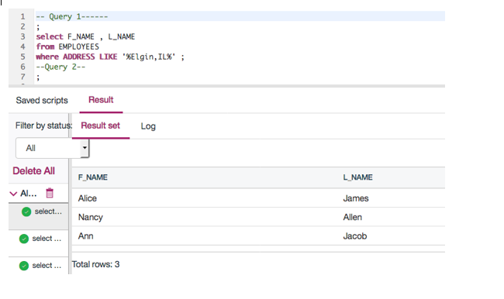

1. Problem:

Retrieve all employees who were born during the 1970's.

Hint

Solution

Output

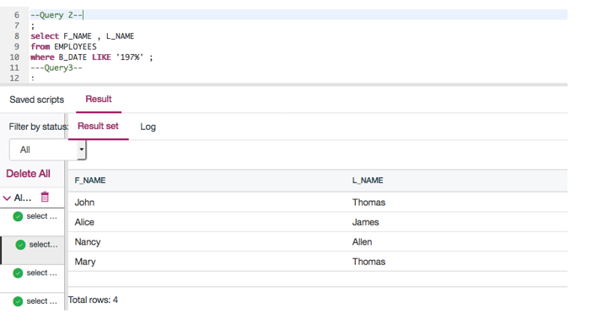

1. Problem:

Retrieve all employees in department 5 whose salary is between 60000 and 70000.

Hint

Solution

Output

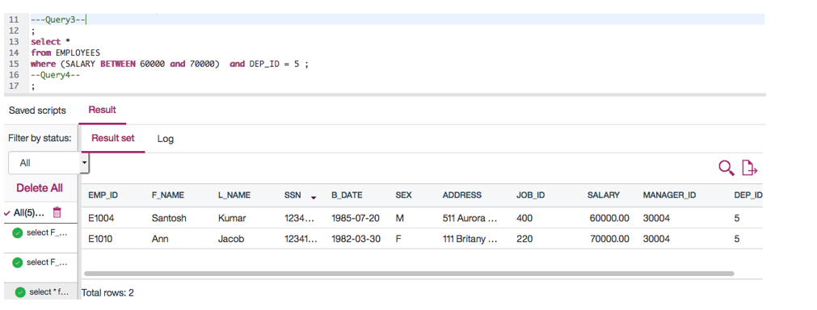

# Exercise 2: Sorting

In this exercise, you will go through some SQL problems on Sorting.

1. Problem:

Retrieve a list of employees ordered by department ID.

Hint

Solution

Output

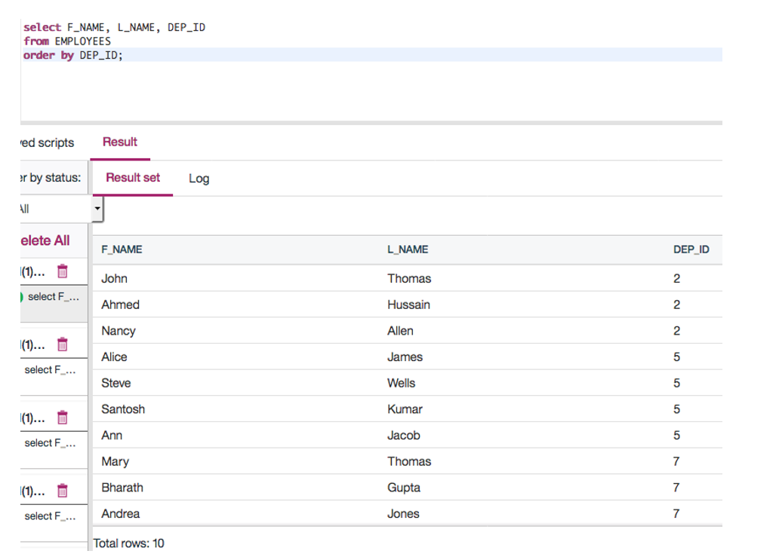

1. Problem:

Retrieve a list of employees ordered in descending order by department ID and within each department ordered alphabetically in descending order by last name.

Hint

Solution

Output

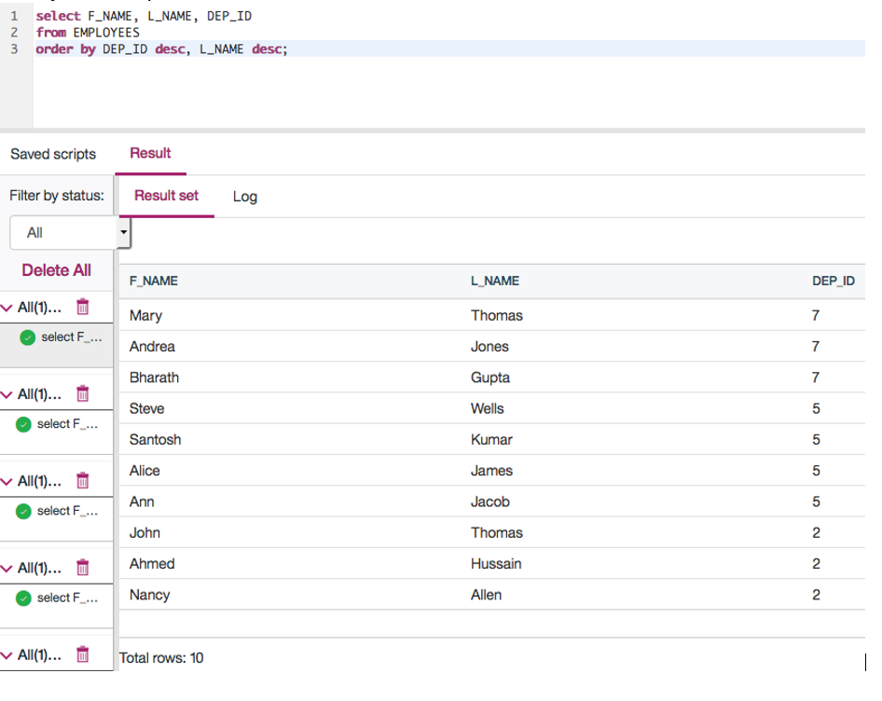

1. (Optional) Problem:

In SQL problem 2 (Exercise 2 Problem 2), use department name instead of department ID. Retrieve a list of employees ordered by department name, and within each department ordered alphabetically in descending order by last name.

Hint

Solution

Output

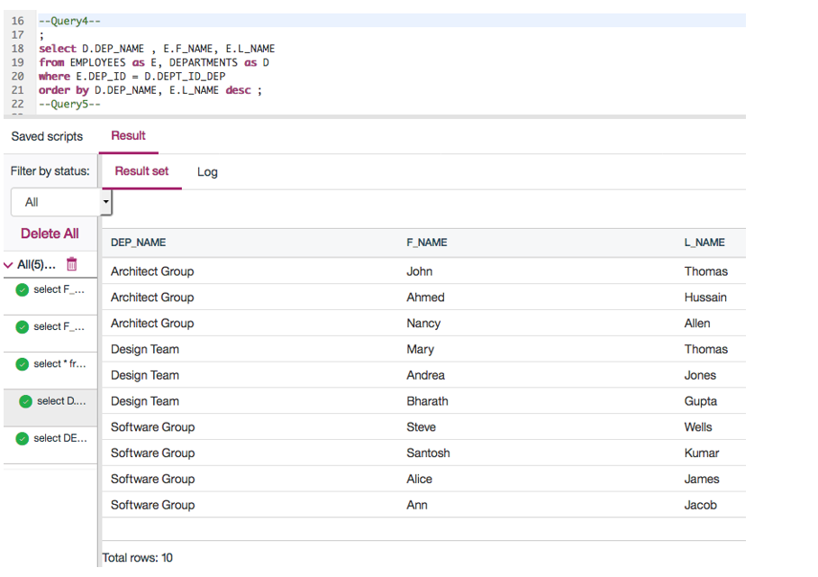

# Exercise 3: Grouping

In this exercise, you will go through some SQL problems on Grouping.

**NOTE:** The SQL problems in this exercise involve usage of SQL Aggregate functions AVG and COUNT. COUNT has been covered earlier. AVG is a function that can be used to calculate the Average or Mean of all values of a specified column in the result set. For example, to retrieve the average salary for all employees in the EMPLOYEES table, issue the query: SELECT AVG(SALARY) FROM EMPLOYEES;. You will learn more about AVG and other aggregate functions later in the lecture **Built-in Database Functions**.

1. Problem:

For each department ID retrieve the number of employees in the department.

Hint

Solution

Output

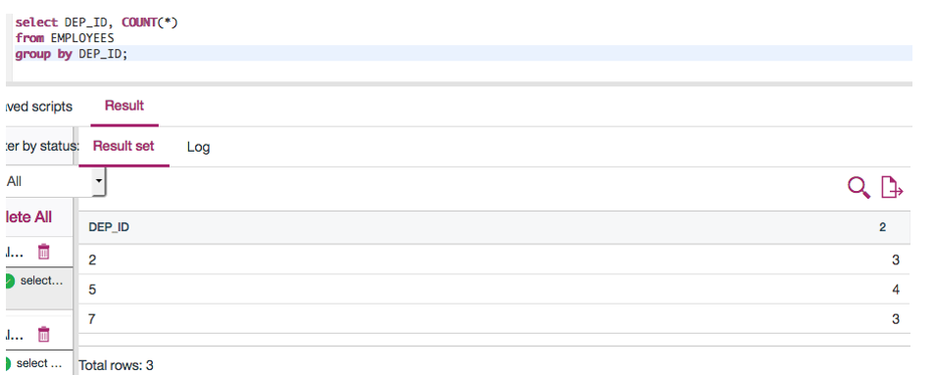

1. Problem:

For each department retrieve the number of employees in the department, and the average employee salary in the department..

Hint

Solution

Output

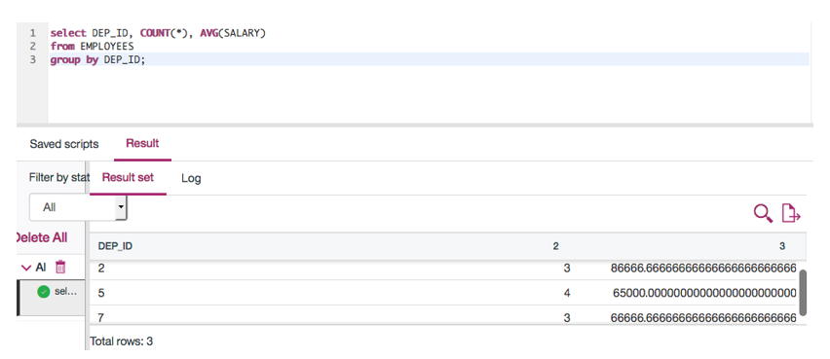

1. Problem:

Label the computed columns in the result set of SQL problem 2 (Exercise 3 Problem 2) as NUM\_EMPLOYEES and AVG\_SALARY.

Hint

Solution

Output

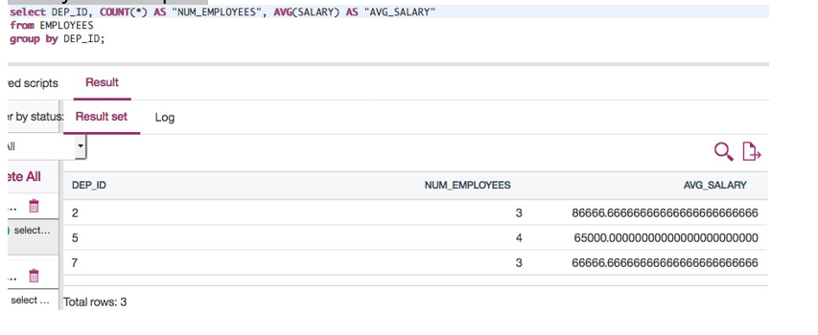

1. Problem:

In SQL problem 3 (Exercise 3 Problem 3), order the result set by Average Salary..

Hint

Solution

Output

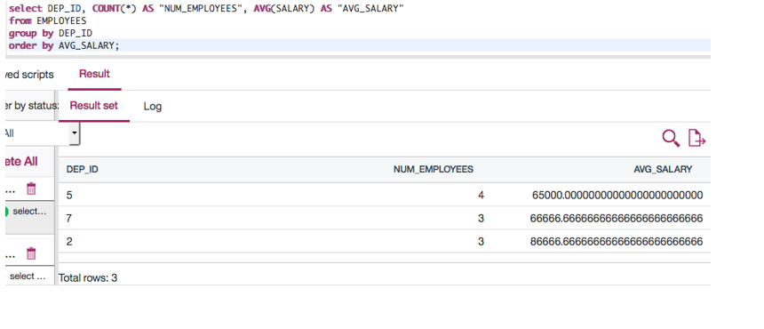

1. Problem:

In SQL problem 4 (Exercise 3 Problem 4), limit the result to departments with fewer than 4 employees.

Hint

Solution

Output

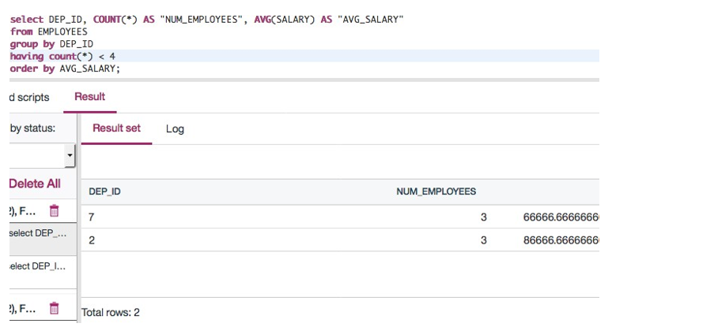

# Solution Script

If you would like to run all the solution queries of the SQL problems of this lab with a script, download the script below. Upload the script to the Db2 console and run. Follow [Hands-on Lab : Create tables using SQL scripts and Load data into tables](https://cf-courses-data.s3.us.cloud-object-storage.appdomain.cloud/IBMDeveloperSkillsNetwork-DB0201EN-SkillsNetwork/labs/Labs_Coursera_V5/labs/Lab%20-%20Create%20tables%20using%20SQL%20scripts%20and%20Load%20data%20into%20tables/instructional-labs.md.html) on how to upload a script to Db2 console and run it.

* [StringPattern-Sorting-Grouping\_Solution\_Script.sql](https://cf-courses-data.s3.us.cloud-object-storage.appdomain.cloud/IBMDeveloperSkillsNetwork-DB0201EN-SkillsNetwork/labs/Labs_Coursera_V5/labs/Lab%20-%20String%20Patterns%20-%20Sorting%20-%20Grouping/StringPattern-Sorting-Grouping_Solution_Script.sql)

### Congratulations! You have completed this lab, and you are ready for the next topic.

# Author(s)

* [Rav Ahuja](https://www.linkedin.com/in/ravahuja/?utm_medium=Exinfluencer&utm_source=Exinfluencer&utm_content=000026UJ&utm_term=10006555&utm_id=NA-SkillsNetwork-Channel-SkillsNetworkCoursesIBMDeveloperSkillsNetworkDB0201ENSkillsNetwork22-2022-01-01)
* [Sandip Saha Joy](https://www.linkedin.com/in/sandipsahajoy/?utm_medium=Exinfluencer&utm_source=Exinfluencer&utm_content=000026UJ&utm_term=10006555&utm_id=NA-SkillsNetwork-Channel-SkillsNetworkCoursesIBMDeveloperSkillsNetworkDB0201ENSkillsNetwork22-2022-01-01)

## Changelog

| **Date** | **Version** | **Changed by** | **Change Description** |
| --- | --- | --- | --- |
| 2020-12-24 | 2.1 | Steve Ryan | ID Reviewed |
| 2020-12-08 | 2.0 | Sandip Saha Joy | Created revised version from DB0201EN |
| 2020 | 1.0 | Rav Ahuja | Created initial version |

### © IBM Corporation 2020. All rights reserved.

# Summary & Highlights

Congratulations! You have completed this lesson. At this point in the course, you know:

* You can use the WHERE clause to refine your query results.
* You can use the wildcard character (%) as a substitute for unknown characters in a pattern.
* You can use BETWEEN ... AND ... to specify a range of numbers.
* You can sort query results into ascending or descending order, using the ORDER BY clause to specify the column to sort on.
* You can group query results by using the GROUP BY clause.

## SQL Cheat Sheet: Intermediate - LIKE, ORDER BY, GROUP BY



|  |  |  |  |
| --- | --- | --- | --- |
| **Command** | **Syntax** | **Description** | **Example** |
| LIKE | SELECT column1, column2, ... FROM table\_name WHERE columnN LIKE pattern; | LIKE operator is used in a WHERE clause to search for a specified pattern in a column. There are two wildcards often used in conjunction with the LIKE operator which are percent sign(%) and underscore sign (\_). | SELECT f\_name , l\_name FROM employees WHERE address LIKE '%Elgin,IL%'; |
| BETWEEN | SELECT column\_name(s) FROM table\_name WHERE column\_name BETWEEN value1 AND value2; | The BETWEEN operator selects values within a given range. The values can be numbers, text, or dates. The BETWEEN operator is inclusive: begin and end values are included. | SELECT \* FROM employees WHERE salary BETWEEN 40000 AND 80000; |
| ORDER BY | SELECT column1, column2, ... FROM table\_name ORDER BY column1, column2, ... ASC|DESC; | ORDER BY keyword is used to sort the result-set in ascending or descending order. The default is ascending. | SELECT f\_name, l\_name, dep\_id FROM employees ORDER BY dep\_id DESC, l\_name; |
| GROUP BY | SELECT column\_name(s) FROM table\_name WHERE condition GROUP BY column\_name(s) ORDER BY column\_name(s); | GROUP BY clause is used in collaboration with the SELECT statement to arrange identical data into groups. | SELECT dep\_id, COUNT(\*) FROM employees GROUP BY dep\_id; |

## Author(s)

[Lakshmi Holla](https://www.linkedin.com/in/lakshmi-holla-b39062149/?utm_medium=Exinfluencer&utm_source=Exinfluencer&utm_content=000026UJ&utm_term=10006555&utm_id=NA-SkillsNetwork-Channel-SkillsNetworkCoursesIBMDeveloperSkillsNetworkDB0201ENSkillsNetwork22-2022-01-01)

## Changelog

| **Date** | **Version** | **Changed by** | **Change Description** |
| --- | --- | --- | --- |
| 2021-07-28 | 1.0 | Lakshmi Holla | Initial Version |

# Built-in Database Functions

0:00

(Music)

Hello and welcome. In this Video,

we'll go over SQL functions built into the database.

Play video starting at ::14 and follow transcript0:14

So let's get started.

While it is very much possible to first fetch data from a database and

then perform operations on it from your applications and notebooks,

most databases come with Built-in Functions.

These functions can be included in SQL statements, allowing you to perform operations on

data right within the database itself.

Using database functions can significantly reduce

the amount of data that needs to be retrieved from the database.

That is, reduces network traffic and use of bandwidth.

When working with large data sets, it may be faster to use built in functions,

rather than first retrieving the data into your application and then

executing functions on the retrieved data.

Note that it is also possible to create your own functions,

that is User-Defined Functions in the database; but that is a more advanced topic.

For the examples in this lesson, let's consider this PETRESCUE table in a database for a pet

rescue organization.

It records rescue transaction details and includes the columns: ID,

animal, quantity, cost, and rescue date.

For the purposes of this lesson, we have populated it with

several rows of data, as shown here.

What are aggregate or column functions?

An aggregate function takes a collection of like values,

such as all of the values in a column, as input, and returns a single value or null.

Examples of aggregate functions include: sum, minimum, maximum, average, etc.

Let's look at some examples based on the PETRESCUE table.

The SUM function is used to add up all the values in a column.

To use the function, you write the column name within parenthesis,

after the function name.

For example, to add up all the values in the COST column,

select SUM (COST) from PETRESCUE.

When you use an aggregate function, the column in the result set

by default is given a number.

It is possible to explicitly name the resulting column.

For example, let's say we want to call the output column in

the previous query, as SUM\_OF\_COST.

select SUM(COST) as SUM\_OF\_COST from PETRESCUE.

Note the use of 'as' in this example.

MINimum, as the name implies, is used to get the lowest value.

Similarly, MAXimum is used to get the highest value.

For example, to get the maximum quantity of any animal rescue in

a single transaction, select MAX(QUANTITY) from PETRESCUE.

Aggregate functions can also be applied on a subset of data instead of an entire column.

For example, to get the minimum quantity of the ID column

for dogs.

select MIN(ID) from PETRESCUE where animal equals dog.

The Average (AVG) function is used to return the average or the mean value.

For example, to specify the average value of cost,

as: select AVG(COST) from PETRESCUE.

Note that we can perform mathematical operations between columns,

and then apply aggregate functions on them.

For example, to calculate the average cost per dog:

select AVG(COST divided by QUANTITY) from PETRESCUE where ANIMAL equals

Dog.

In this case, the cost is for multiple units; so we first divide

the cost by the quantity of the rescue.

Now let's look at the Scalar and String functions.

Scalar functions perform operations on individual values.

For example, to round up or down every value in the cost column

to the nearest integer, select ROUND (COST) from PETRESCUE.

There is a class of scalar functions called string functions,

that can be used for operations on strings.

That is char and varchar values.

For example, to retrieve the length of each value in animal column,

select LENGTH (ANIMAL) from PETRESCUE.

Uppercase and lowercase functions can be used to

return uppercase or lowercase values of strings.

For example, to retrieve animal values in uppercase:

select UPPERCASE (ANIMAL) from PETRESCUE.

Scalar functions can be used in the where clause.

For example, to get lowercase values of the animal column for cat,

select star from PETRESCUE where LOWERCASE(ANIMAL) equals cat.

This type of statement is useful for matching values in the where clause,

if you're not sure whether the values are stored in upper,

lower or mixed case in the table.

You can also have one function operate on the output of another function.

For example, to get unique cases for the animal column in

uppercase: select DISTINCT (UPPERCASE(ANIMAL)) from PETRESCUE.

In this video, we looked at some built-in SQL aggregate functions, such as

sum, minimum, maximum, and average We also looked at scalar and

string functions, such as round, lowercase, and uppercase.

Thank you for watching.

(Music)

# Date and Time Built-in Functions

Notes

[**Discuss**](https://www.coursera.org/learn/sql-data-science/discussions/weeks/3)

0:00

(Music)

Hello and welcome. In this video,

we'll go over date and time SQL functions built into

the database. So let's get started.

Most databases contain special data types

for dates and times.

Db2 contains date, time, and timestamp types.

In Db2, date has eight digits:

for year, month, and day.

Time has six digits:

hours, minutes, and seconds.

Timestamp has 20 digits: year,

month, day, hour, minute, seconds,

and microseconds where double X represents month

and six Zs or Zs represents microseconds.

Functions exist to extract the day,

month, day of month,

day of week, day of year,

week, hour, minute, and second.

Let us look at some examples of

queries for date and time functions.

The day function can be used to

extract the day portion from a date.

For example, to get the day portion

for each rescue date involving cat,

select

DAY (RESCUEDATE) from PETRESCUE where ANIMAL equals cat.

Date and time functions can be used in the where clause.

For example, to get the number

of rescues during the month of May,

that is, from Month 5,

select COUNT star from PETRESCUE

where MONTH (RESCUEDATE) equals 05.

You can also perform date or time arithmetic.

For example, to find out what

date it is three days

after each rescue date,

maybe you

want to know this

because the rescue needs to be

processed within three days.

select (RESCUEDATE plus three DAYS) from PETRESCUE.

Special registers current time

and current date are also available.

For example, to find how many days

have passed since each rescue date till now-

(CURRENT\_DATE minus RESCUEDATE) from PETRESCUE.

The result will be in years, months, days.

In this video, we looked at different types of

built in SQL functions for working

with dates and times.

Thanks for watching.

(Music)



# Hands-on Lab: Built-in functions - Aggregate, Scalar, String, Date and Time Functions

Now let’s practice using sub-queries and working with multiple tables. Use the PETRESCUE-CREATE.sql file provided to create the table and execute the queries in the last two videos.

| **ID** | **ANIMAL** | **QUANTITY** | **COST** | **RESCUEDATE** |
| --- | --- | --- | --- | --- |
| 1 | Cat | 9 | 450.09 | 5/29/2018 |
| 2 | Dog | 3 | 666.66 | 6/1/2018 |
| 3 | Dog | 1 | 100 | 6/4/2018 |
| 4 | Parrot | 2 | 50 | 6/4/2018 |
| 5 | Dog | 1 | 75.75 | 6/10/2018 |
| 6 | Hamster | 6 | 60.6 | 6/11/2018 |
| 7 | Cat | 1 | 44.44 | 6/11/2018 |
| 8 | Goldfish | 24 | 48.48 | 6/14/2018 |
| 9 | Dog | 2 | 222.22 | 6/15/2018 |

# Objectives

After completing this lab, you will be able to:

1. Compose and run sub-queries with multiple tables
2. Check query results and view log files

Compose and run the following queries. Check that the results are what you expect and remember to view the logs in the Results section for errors and warnings.

**Note:** The solutions are provided at the end of this lab, but please try to compose the queries on your own before checking the solutions.

### ****NOTE**** : Make sure that you are using the CSV file and datasets from the same instruction file.

# Exercise 1: Create the Pet Rescue table

Rather than create the table manually by typing the DDL commands in the SQL editor, you will execute a script containing the create table command.

1. Download the script file [PETRESCUE-CREATE.sql](https://cf-courses-data.s3.us.cloud-object-storage.appdomain.cloud/IBMDeveloperSkillsNetwork-DB0201EN-SkillsNetwork/labs/Labs_Coursera_V5/datasets/PETSALE_PETRESCUE/PETRESCUE-CREATE.sql)

**Note**: To download, just right-click on the link above and click on **Save As..** or **Save Link As...** depending on your browser. Save the file as a .sql file and not HTML.

1. Login to IBM Cloud and go to the Resources Dashboard: [https://cloud.ibm.com/resources](https://cloud.ibm.com/resources?utm_medium=Exinfluencer&utm_source=Exinfluencer&utm_content=000026UJ&utm_term=10006555&utm_id=NA-SkillsNetwork-Channel-SkillsNetworkCoursesIBMDeveloperSkillsNetworkDB0201ENSkillsNetwork22-2022-01-01) where you can find the Db2 service that you created in a previous Lab. Click on the **Db2-xx** service. Next, open the Db2 Console by clicking on **Open Console** button. Go to the **Run SQL** page. The Run SQL tool enables you to run DDL and SQL statements.
2. Click on the **+** (Add New Script) icon.
3. Click on **From File**.
4. Locate the file **PETRESCUE-CREATE.sql** that you downloaded to your computer earlier and open it.
5. Once the statements are in the SQL Editor tool, you can run the queries against the database by selecting the **Run all** button.
6. On the right side of the SQL editor window you will see a **Result** section. Clicking on a query in the Result section will show the execution details of the job - whether it ran successfully or had any errors or warnings. Ensure your queries ran successfully and created all the tables.
7. Now you can look at the tables you created. Navigate to the three-bar menu icon, select **Explore**, then click on **Tables**.
8. Select the Schema corresponding to your Db2 userid. Then on the right side of the screen you should see the newly created **PETRESCUE** table listed (plus any other tables you may have created in previous labs e.g. INSTRUCTOR, TEST, etc.).
9. Click on any of the tables and you will see its SCHEMA definition (that is list of columns, their data types, and so on). You can also click **View Data** to view the content of the table.

# Exercise 2: Aggregate Functions

**Query A1:** Enter a function that calculates the total cost of all animal rescues in the PETRESCUE table.

**Query A2:** Enter a function that displays the total cost of all animal rescues in the PETRESCUE table in a column called SUM\_OF\_COST.

**Query A3:** Enter a function that displays the maximum quantity of animals rescued.

**Query A4:** Enter a function that displays the average cost of animals rescued.

**Query A5:** Enter a function that displays the average cost of rescuing a dog.

# Exercise 3: Scalar and String Functions

**Query B1:** Enter a function that displays the rounded cost of each rescue.

**Query B2:** Enter a function that displays the length of each animal name.

**Query B3:** Enter a function that displays the animal name in each rescue in uppercase.

**Query B4:** Enter a function that displays the animal name in each rescue in uppercase without duplications.

**Query B5:** Enter a query that displays all the columns from the PETRESCUE table, where the animal(s) rescued are cats. Use **cat** in lower case in the query.

# Exercise 4: Date and Time Functions

**Query C1:** Enter a function that displays the day of the month when cats have been rescued.

**Query C2:** Enter a function that displays the number of rescues on the 5th month.

**Query C3:** Enter a function that displays the number of rescues on the 14th day of the month.

**Query C4:** Animals rescued should see the vet within three days of arrivals. Enter a function that displays the third day from each rescue.

**Query C5:** Enter a function that displays the length of time the animals have been rescued; the difference between today’s date and the rescue date.

# Lab Solutions

# Exercise 2 Solutions: Aggregate Functions

**Query A1:** Enter a function that calculates the total cost of all animal rescues in the PETRESCUE table.

select SUM(COST) from PETRESCUE;

**Query A2:** Enter a function that displays the total cost of all animal rescues in the PETRESCUE table in a column called SUM\_OF\_COST.

select SUM(COST) AS SUM\_OF\_COST from PETRESCUE;

**Query A3:** Enter a function that displays the maximum quantity of animals rescued.

select MAX(QUANTITY) from PETRESCUE;

**Query A4:** Enter a function that displays the average cost of animals rescued.

select AVG(COST) from PETRESCUE;

**Query A5:** Enter a function that displays the average cost of rescuing a dog.

Hint - Bear the cost of rescuing one dog on one day, which is different from another day. So you will have to use an average of averages.

select AVG(COST/QUANTITY) from PETRESCUE where ANIMAL = 'Dog';

# Exercise 3 Solutions: Scalar and String Functions

**Query B1:** Enter a function that displays the rounded cost of each rescue.

select ROUND(COST) from PETRESCUE;

**Query B2:** Enter a function that displays the length of each animal name.

select LENGTH(ANIMAL) from PETRESCUE;

**Query B3:** Enter a function that displays the animal name in each rescue in uppercase.

select UCASE(ANIMAL) from PETRESCUE;

**Query B4:** Enter a function that displays the animal name in each rescue in uppercase without duplications.

select DISTINCT(UCASE(ANIMAL)) from PETRESCUE;

**Query B5:** Enter a query that displays all the columns from the PETRESCUE table, where the animal(s) rescued are cats. Use **cat** in lower case in the query.

select \* from PETRESCUE where LCASE(ANIMAL) = 'cat';

# Exercise 4 Solutions: Date and Time Functions

**Query C1:** Enter a function that displays the day of the month when cats have been rescued.

select DAY(RESCUEDATE) from PETRESCUE where ANIMAL = 'Cat';

**Query C2:** Enter a function that displays the number of rescues on the 5th month.

select SUM(QUANTITY) from PETRESCUE where MONTH(RESCUEDATE)='05';

**Query C3:** Enter a function that displays the number of rescues on the 14th day of the month.

select SUM(QUANTITY) from PETRESCUE where DAY(RESCUEDATE)='14';

**Query C4:** Animals rescued should see the vet within three days of arrivals. Enter a function that displays the third day from each rescue.

select (RESCUEDATE + 3 DAYS) from PETRESCUE;

**Query C5:** Enter a function that displays the length of time the animals have been rescued; the difference between today’s date and the recue date.

select (CURRENT DATE - RESCUEDATE) from PETRESCUE;

# Summary

You can now compose and run queries, check results and view the logs. You will use these skills in later labs.

# Author(s)

#### Rav Ahuja

# Changelog

| **Date** | **Version** | **Changed by** | **Change Description** |
| --- | --- | --- | --- |
| 2021-07-15 | 1.4 | Malika | Added hint to A5 solution |
| 2020-06-29 | 1.3 | Rose Malcolm | Added new Ex.1 to create table form sql file. Renumbered remaining exercises and solutions. |
| 2020-06-26 | 1.2 | Steve Hord | Replace quotes |
| 2020-06-25 | 1.1 | Steve Hord | Revise Objectives section |
| 05-Jun-20 | 1.0 | Rose Malcolm | Initial version created |

### © IBM Corporation 2020. All rights reserved.

# Sub-Queries and Nested Selects

Notes

[**Discuss**](https://www.coursera.org/learn/sql-data-science/discussions/weeks/3)

0:05

Hello and welcome.

In this video you'll learn how to write

sub-queries or nested selects statements.

Sub-queries or sub selects are like regular queries

but placed within parentheses

and nested inside another query.

This allows you to form

more powerful queries than

would have been otherwise possible.

An example of a nested query is shown.

In this example, the sub-query is

inside the where clause of another query.

Consider the employees table from the previous video.

The first few rows of data are shown here.

The table contains several columns,

including an employee ID,

first name, last name, salary, etc.

We will now go over some examples involving this table.

Let's consider a scenario which may

necessitate the use of sub-queries.

Let's say, we want to retrieve the list of employees

who earn more than the average salary.

To do so, you could try this code.

Select \* from employees,

where salary > AVG(salary).

However, running this query will

result in an error like the one shown.

Indicating an invalid use of the aggregate function.

One of the limitations of built in

aggregate functions, like the average function,

is that they cannot always be

evaluated in the WHERE clause.

So to evaluate a function

like average in the WHERE clause,

we can make use of

a sub-select expression like the one shown here.

Select EMP\_ID, F\_NAME, L\_NAME,

SALARY from employees where SALARY

< ( select AVG (SALARY) from employees).

Notice that the average function is

evaluated in the first part of the sub-query.

Allowing us to circumvent the limitation of

evaluating it directly in the WHERE clause.

The sub-select doesn't just

have to go in the WHERE clause.

It can also go in other parts of

the query, such as in the list of columns to be selected.

Such sub-queries are called column expressions.

Now, let's look at a scenario where

we might want to use a column expression.

Say we wanted to compare the salary of

each employee with the average salary.

We could try a query like select EMP\_ID,

SALARY, AVG(SALARY) AS AVG\_SALARY from employees.

Running this query will result in an error

indicating that no group by clause is specified.

We can circumvent this error by using

the average function in

a sub-query placed in the list of the columns.

For example, select EMP\_ID, SALARY,

(select AVG(SALARY) from employees

) AS AVG\_SALARY from employees.

Another option is to make

the sub-query be part of the FROM clause.

Sub-queries like these are sometimes

called derived tables or table expressions.

Because the outer query uses the results

of the sub-query as a data source.

Let's look at an example to create

a table expression that

contains nonsensitive employee information.

Select \* from (select EMP\_ID,

F\_NAME, L\_NAME, DEP\_ID from employees) AS EMP4ALL.

The derived table in a sub-query does not

include sensitive fields like date of birth or salary.

This example is a trivial one, and

we could just as easily have

included the columns in the outer query.

However, such derived tables can prove to be powerful in

more complex situations such as when

working with multiple tables and doing joins.

In this video, you have seen how

sub-queries and nested queries can be

used to form richer queries and how they can

overcome some of the limitations of aggregate functions.

You also learned to use sub-queries in the WHERE clause,

in the list of columns and in the FROM clause.

Thanks for watching this video



# Hands-on Lab : Sub-queries and Nested SELECTs

**Estimated time needed:** 20 minutes

In this lab, you will run through some SQL practice problems that will provide hands-on experience with nested SQL SELECT statements (also known as Sub-queries).

**How does a typical Nested SELECT statement syntax look?**

SELECT column\_name [, column\_name ]

FROM table1 [, table2 ]

WHERE column\_name OPERATOR

(SELECT column\_name [, column\_name ]

FROM table1 [, table2 ]

WHERE condition);

## Software Used in this Lab

In this lab, you will use an [IBM Db2 Database](https://www.ibm.com/products/db2-database?utm_medium=Exinfluencer&utm_source=Exinfluencer&utm_content=000026UJ&utm_term=10006555&utm_id=NA-SkillsNetwork-Channel-SkillsNetworkCoursesIBMDeveloperSkillsNetworkDB0201ENSkillsNetwork22-2022-01-01). Db2 is a Relational Database Management System (RDBMS) from IBM, designed to store, analyze and retrieve data efficiently.

To complete this lab you will utilize a Db2 database service on IBM Cloud. If you did not already complete this lab task earlier in this module, you will not yet have access to Db2 on IBM Cloud, and you will need to follow the lab below first:

* [Hands-on Lab : Sign up for IBM Cloud, Create Db2 service instance and Get started with the Db2 console](https://cf-courses-data.s3.us.cloud-object-storage.appdomain.cloud/IBMDeveloperSkillsNetwork-DB0201EN-SkillsNetwork/labs/Labs_Coursera_V5/labs/Lab%20-%20Sign%20up%20for%20IBM%20Cloud%20-%20Create%20Db2%20service%20instance%20-%20Get%20started%20with%20the%20Db2%20console/instructional-labs.md.html)

## Database Used in this Lab

The database used in this lab is an internal database. You will be working on a sample HR database. This HR database schema consists of 5 tables called **EMPLOYEES**, **JOB\_HISTORY**, **JOBS**, **DEPARTMENTS** and **LOCATIONS**. Each table has a few rows of sample data. The following diagram shows the tables for the HR database:



**NOTE:** This lab requires you to have all 5 of these tables of the HR database populated with sample data on Db2. If you didn't complete the earlier lab in this module, you won't have the tables above populated with sample data on Db2, so you will need to go through the lab below first:

* [Hands-on Lab : Create tables using SQL scripts and Load data into tables](https://cf-courses-data.s3.us.cloud-object-storage.appdomain.cloud/IBMDeveloperSkillsNetwork-DB0201EN-SkillsNetwork/labs/Labs_Coursera_V5/labs/Lab%20-%20Create%20tables%20using%20SQL%20scripts%20and%20Load%20data%20into%20tables/instructional-labs.md.html)

## Objectives

After completing this lab you will be able to:

* Write SQL queries that demonstrate the necessity of using sub-queries
* Compose sub-queries in the where clause
* Build Column Expressions (i.e. sub-query in place of a column)
* Write Table Expressions (i.e. sub-query in place of a table)

### ****NOTE**** : Make sure that you are using the CSV file and datasets from the same instruction file.

## Instructions

When you approach the exercises in this lab, follow the instructions to run the queries on Db2:

* Go to the [Resource List](https://cloud.ibm.com/resources?utm_medium=Exinfluencer&utm_source=Exinfluencer&utm_content=000026UJ&utm_term=10006555&utm_id=NA-SkillsNetwork-Channel-SkillsNetworkCoursesIBMDeveloperSkillsNetworkDB0201ENSkillsNetwork22-2022-01-01) of IBM Cloud by logging in where you can find the Db2 service instance that you created in a previous lab under **Services** section. Click on the **Db2-xx service**. Next, open the Db2 Console by clicking on **Open Console** button. Click on the 3-bar menu icon in the top left corner and go to the **Run SQL** page. The Run SQL tool enables you to run SQL statements.
  + If needed, follow [Hands-on Lab : Sign up for IBM Cloud, Create Db2 service instance and Get started with the Db2 console](https://cf-courses-data.s3.us.cloud-object-storage.appdomain.cloud/IBMDeveloperSkillsNetwork-DB0201EN-SkillsNetwork/labs/Labs_Coursera_V5/labs/Lab%20-%20Sign%20up%20for%20IBM%20Cloud%20-%20Create%20Db2%20service%20instance%20-%20Get%20started%20with%20the%20Db2%20console/instructional-labs.md.html)

# Exercise:

1. Problem:

Execute a failing query (i.e. one which gives an error) to retrieve all employees records whose salary is lower than the average salary.

Hint

Solution

Output

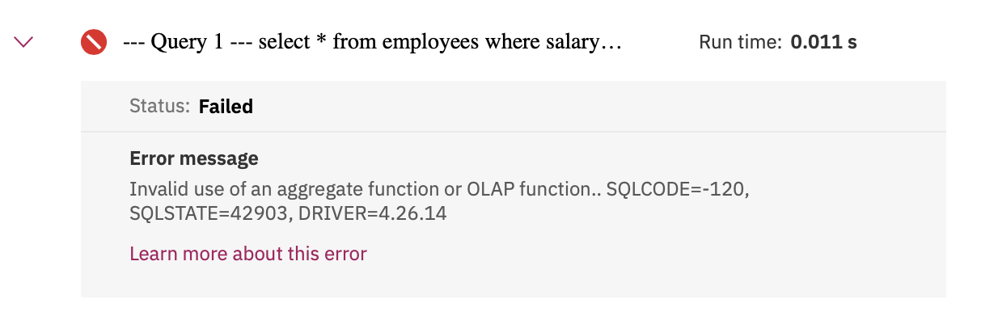

1. Problem:

Execute a working query using a sub-select to retrieve all employees records whose salary is lower than the average salary.

Hint

Solution

Output

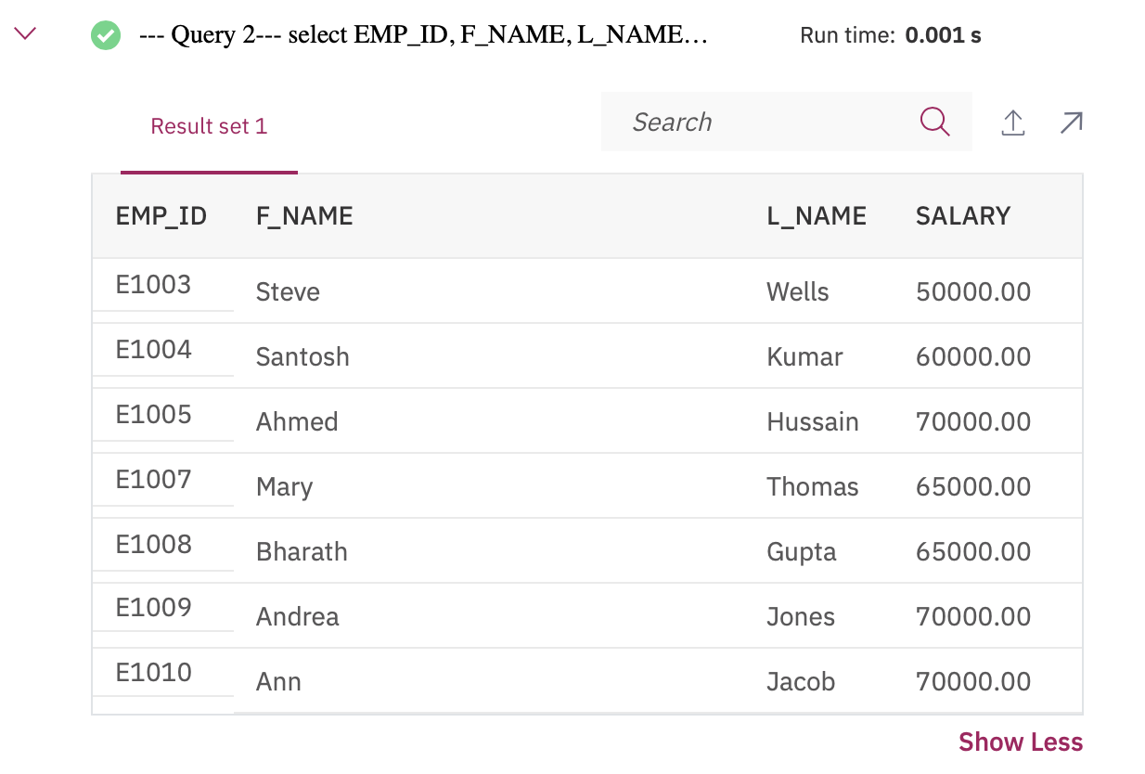

1. Problem:

Execute a failing query (i.e. one which gives an error) to retrieve all employees records with EMP\_ID, SALARY and maximum salary as MAX\_SALARY in every row.

Hint

Solution

Output

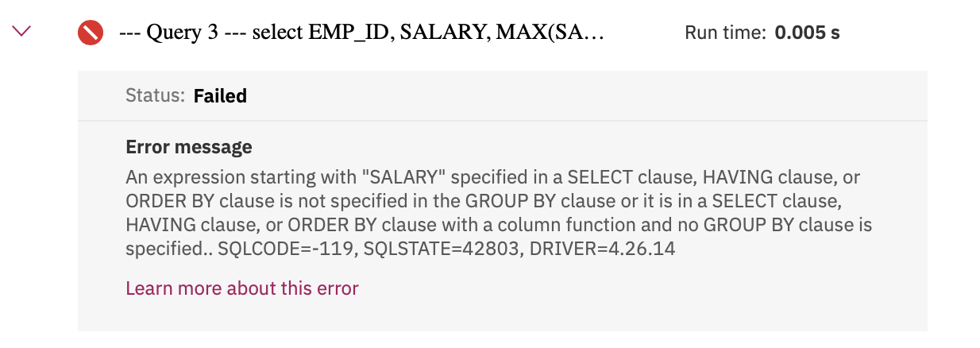

1. Problem:

Execute a Column Expression that retrieves all employees records with EMP\_ID, SALARY and maximum salary as MAX\_SALARY in every row.

Hint

Solution

Output

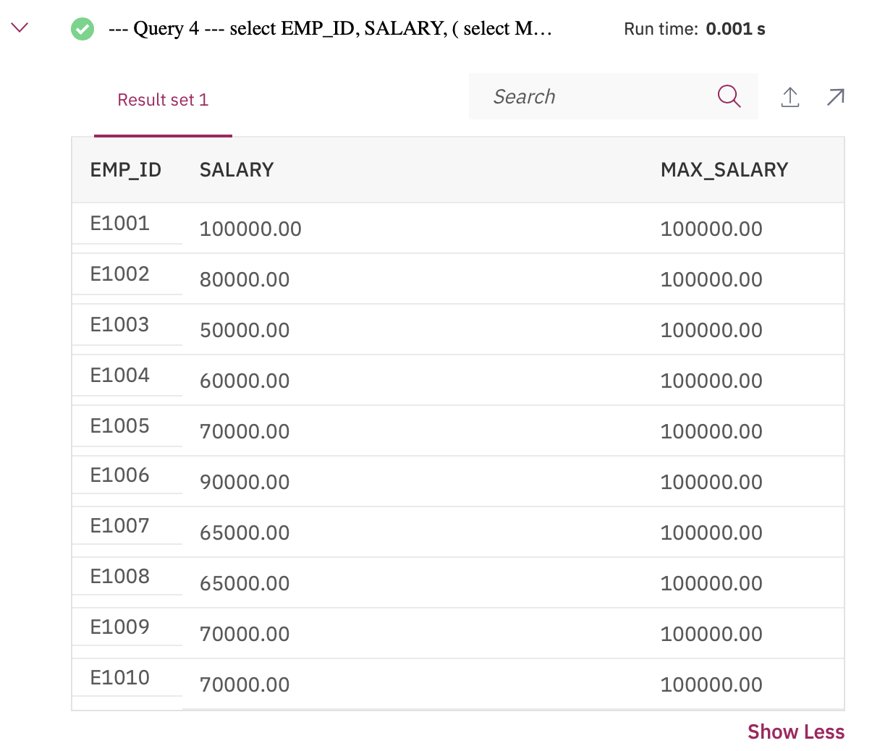

1. Problem:

Execute a Table Expression for the EMPLOYEES table that excludes columns with sensitive employee data (i.e. does not include columns: SSN, B\_DATE, SEX, ADDRESS, SALARY).

Hint

Solution

Output

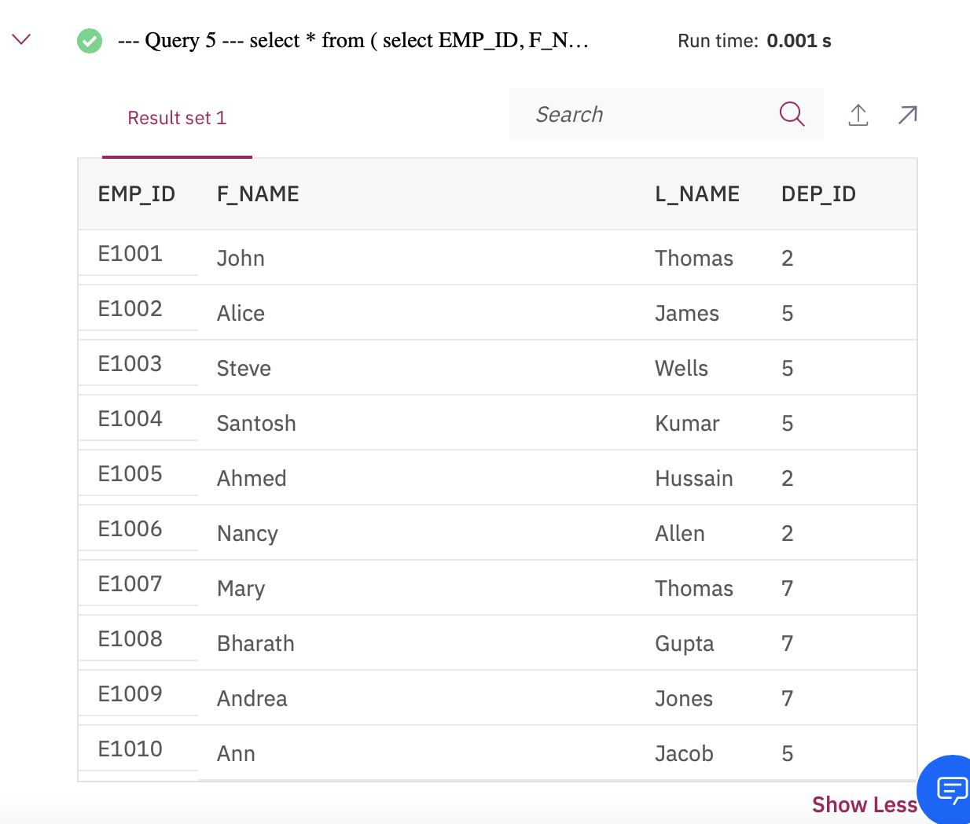

# Solution Script

If you would like to run all the solution queries of the SQL problems in this lab with a script, download the script below. Upload the script to the Db2 console and run it. Follow [Hands-on Lab : Create tables using SQL scripts and Load data into tables](https://cf-courses-data.s3.us.cloud-object-storage.appdomain.cloud/IBMDeveloperSkillsNetwork-DB0201EN-SkillsNetwork/labs/Labs_Coursera_V5/labs/Lab%20-%20Create%20tables%20using%20SQL%20scripts%20and%20Load%20data%20into%20tables/instructional-labs.md.html) on how to upload a script to Db2 console and run it.

* [SubQueries\_Solution\_Script.sql](https://cf-courses-data.s3.us.cloud-object-storage.appdomain.cloud/IBMDeveloperSkillsNetwork-DB0201EN-SkillsNetwork/labs/Labs_Coursera_V5/labs/Lab%20-%20Sub-queries%20and%20Nested%20SELECTs%20/SubQueries_Solution_Script.sql)

### Congratulations! You have completed this lab, and you are ready for the next topic.

# Author(s)

* [Rav Ahuja](https://www.linkedin.com/in/ravahuja/?utm_medium=Exinfluencer&utm_source=Exinfluencer&utm_content=000026UJ&utm_term=10006555&utm_id=NA-SkillsNetwork-Channel-SkillsNetworkCoursesIBMDeveloperSkillsNetworkDB0201ENSkillsNetwork22-2022-01-01)
* [Sandip Saha Joy](https://www.linkedin.com/in/sandipsahajoy/?utm_medium=Exinfluencer&utm_source=Exinfluencer&utm_content=000026UJ&utm_term=10006555&utm_id=NA-SkillsNetwork-Channel-SkillsNetworkCoursesIBMDeveloperSkillsNetworkDB0201ENSkillsNetwork22-2022-01-01)

# Other Contributor(s)

## Changelog

| **Date** | **Version** | **Changed by** | **Change Description** |
| --- | --- | --- | --- |
| 2020-12-25 | 2.1 | Steve Ryan | ID Reviewed |
| 2020-12-10 | 2.0 | Sandip Saha Joy | Created revised version from DB0201EN |
| 2020 | 1.0 | Rav Ahuja | Created initial version |

### © IBM Corporation 2020. All rights reserved.

# Working with Multiple Tables

## Transcript



Help Us Translate

### Interactive Transcript - Enable basic transcript mode by pressing the escape key

You may navigate through the transcript using tab. To save a note for a section of text press CTRL + S. To expand your selection you may use CTRL + arrow key. You may contract your selection using shift + CTRL + arrow key. For screen readers that are incompatible with using arrow keys for shortcuts, you can replace them with the H J K L keys. Some screen readers may require using CTRL in conjunction with the alt key

Play video starting at ::5 and follow transcript0:05

Hello and welcome.

In this video,

you will learn how to write queries

that access more than one table.

There are several ways to access

multiple tables in the same query.

Namely, using Sub-queries, Implicit JOIN,

and JOIN operators, such as INNER JOIN and OUTER JOIN.

In this video, we'll examine the first two options.

The third option is covered in

more detail in other videos.

Let's consider the employees and

departments tables from a previous video.

The employees table contains

several columns for categories,

such as employee ID,

first name, last name,

and salary to name a few.

The Departments table contains a department ID,

department name, Manager ID, and location ID.

Some sample data from these tables is shown here.

We will utilize these tables

for the examples in this video.

In a previous video,

we learned how to use sub-queries.

Now, let's use sub-queries to work with multiple tables.

If we want to retrieve only the employee records from

the employees table for which

a department ID exists in the departments table,

we can use a sub-query as follows.

Select star from employees,

where department\_ID IN,

select department\_ID\_department from departments.

Here the outer query accesses

the employees table and the sub-query

on the departments table is used for

filtering the result set of the outer query.

Let's say we want to retrieve

only the list of employees from a specific location.

We do not have any location information

in the employees table,

but the departments table has

a column called location ID.

Therefore, we can use a sub-query from

the Departments table as input to

the employee table query as follows.

Select star from employees, where department\_ID IN,

select department\_ID\_department from departments,

where location ID equals L0002.

Now, let's retrieve the department ID and

department name for employees who earn more than $70,000.

To do so, we will need a sub-query on

the employees table to satisfy the salary criteria,

and then feed it as input to an outer query on

the departments table in order to

get the matching department info.

Select department\_ID\_department department\_name

from departments, where department\_ID\_department IN, select

department\_ID from employees where

salary is greater than 70,000.

We can also access multiple tables by

specifying them in the FROM clause of the query.

Consider the example, select

star from employees, departments.

Here we specify two tables in the FROM clause.

This results in a table join,

but note we are not explicitly using the join operator.

The resulting join in this example is called a

full join or Cartesian join,

because every row in the first table

is joined with every row in the second table.

If you examine the results set,

you will see more rows than in both tables individually.

We can use additional operands to limit the result set.

Let's look at an example where we limit the result

set to only rows with matching department IDs.

Select star from employees, departments, where employees

department\_ID equals departments,

department\_ID\_department.

Notice that in the WHERE clause,

we prefix the name of

the column with the name of the table.

This is to fully qualify the column name,

since it's possible that different tables could

have some column names that are exactly the same.

Since the table names can sometimes be long,

we can use shorter aliases for table names as shown here.

Select star from employees E, departments D,

where E department\_ID equals D department\_ID\_department.

Here, we define the alias E for

employees table and D for departments table,

and then use these aliases in the WHERE clause.

If we wanted to see

the department name for each employee,

we would enter the code as follows:

Select

Employee\_ID, Department\_Name

from employees E, departments D,

where E department\_ID equals D

department\_ID\_department.

Similar to before, the column names in the select clause

can also be prefixed by aliases as shown in the query.

Select E. Employee\_ID, D. Department\_ID\_department,

from employees E. Departments D where

E.Department\_ID equals D. Department\_ID\_department.

In this lesson, we have shown

you how to work with multiple tables

using sub-queries and

implicit joins. Thanks for watching.



# Hands-on Lab: Working with Multiple Tables

**Estimated time needed:** 30 minutes

In this lab, you will through some SQL practice problems that will provide hands-on experience with SQL queries that access multiple tables. You will be:

* Accessing Multiple Tables with Sub-Queries
* Accessing Multiple Tables with Implicit Joins

**How does an Implicit version of CROSS JOIN (also known as Cartesian Join) statement syntax look?**

**SELECT** column\_name(s)

**FROM** table1, table2;

**How does an Implicit version of INNER JOIN statement syntax look?**

**SELECT** column\_name(s)

**FROM** table1, table2

**WHERE** table1.column\_name = table2.column\_name;

## Software Used in this Lab

In this lab, you will use [IBM Db2 Database](https://www.ibm.com/products/db2-database?utm_medium=Exinfluencer&utm_source=Exinfluencer&utm_content=000026UJ&utm_term=10006555&utm_id=NA-SkillsNetwork-Channel-SkillsNetworkCoursesIBMDeveloperSkillsNetworkDB0201ENSkillsNetwork22-2022-01-01). Db2 is a Relational Database Management System (RDBMS) from IBM, designed to store, analyze and retrieve the data efficiently.

To complete this lab you will utilize a Db2 database service on IBM Cloud. If you did not already complete this lab task earlier in this module, you will not yet have access to Db2 on IBM Cloud, and you will need to follow the lab below first:

* [Hands-on Lab : Sign up for IBM Cloud, Create Db2 service instance and Get started with the Db2 console](https://cf-courses-data.s3.us.cloud-object-storage.appdomain.cloud/IBMDeveloperSkillsNetwork-DB0201EN-SkillsNetwork/labs/Labs_Coursera_V5/labs/Lab%20-%20Sign%20up%20for%20IBM%20Cloud%20-%20Create%20Db2%20service%20instance%20-%20Get%20started%20with%20the%20Db2%20console/instructional-labs.md.html)

## Database Used in this Lab

The database used in this lab is an internal database. You will be working on a sample HR database. This HR database schema consists of 5 tables called **EMPLOYEES**, **JOB\_HISTORY**, **JOBS**, **DEPARTMENTS** and **LOCATIONS**. Each table has a few rows of sample data. The following diagram shows the tables for the HR database:



**NOTE:** This lab requires you to have all 5 of these tables of the HR database populated with sample data on Db2. If you didn't complete the earlier lab in this module, you won't have the tables above populated with sample data on Db2, so you will need to go through the lab below first:

* [Hands-on Lab : Create tables using SQL scripts and Load data into tables](https://cf-courses-data.s3.us.cloud-object-storage.appdomain.cloud/IBMDeveloperSkillsNetwork-DB0201EN-SkillsNetwork/labs/Labs_Coursera_V5/labs/Lab%20-%20Create%20tables%20using%20SQL%20scripts%20and%20Load%20data%20into%20tables/instructional-labs.md.html)

## Objectives

After completing this lab you will be able to:

* Write SQL queries that access more than one table
* Compose queries that access multiple tables using a nested statement in the WHERE clause
* Build queries with multiple tables in the FROM clause
* Write Implicit Join queries with join criteria specified in the WHERE clause
* Specify aliases for table names and qualify column names with table aliases

### ****NOTE**** : Make sure that you are using the CSV file and datasets from the same instruction file.

## Instructions

When you approach the exercises in this lab, follow the instructions to run the queries on Db2:

* Go to the [Resource List](https://cloud.ibm.com/resources?utm_medium=Exinfluencer&utm_source=Exinfluencer&utm_content=000026UJ&utm_term=10006555&utm_id=NA-SkillsNetwork-Channel-SkillsNetworkCoursesIBMDeveloperSkillsNetworkDB0201ENSkillsNetwork22-2022-01-01) of IBM Cloud by logging in where you can find the Db2 service instance that you created in a previous lab under **Services** section. Click on the **Db2-xx service**. Next, open the Db2 Console by clicking on **Open Console** button. Click on the 3-bar menu icon in the top left corner and go to the **Run SQL** page. The Run SQL tool enables you to run SQL statements.
  + If needed, follow [Hands-on Lab : Sign up for IBM Cloud, Create Db2 service instance and Get started with the Db2 console](https://cf-courses-data.s3.us.cloud-object-storage.appdomain.cloud/IBMDeveloperSkillsNetwork-DB0201EN-SkillsNetwork/labs/Labs_Coursera_V5/labs/Lab%20-%20Sign%20up%20for%20IBM%20Cloud%20-%20Create%20Db2%20service%20instance%20-%20Get%20started%20with%20the%20Db2%20console/instructional-labs.md.html)

# Exercise 1: Accessing Multiple Tables with Sub-Queries

1. Problem:

Retrieve only the EMPLOYEES records that correspond to jobs in the JOBS table.

Solution

Output

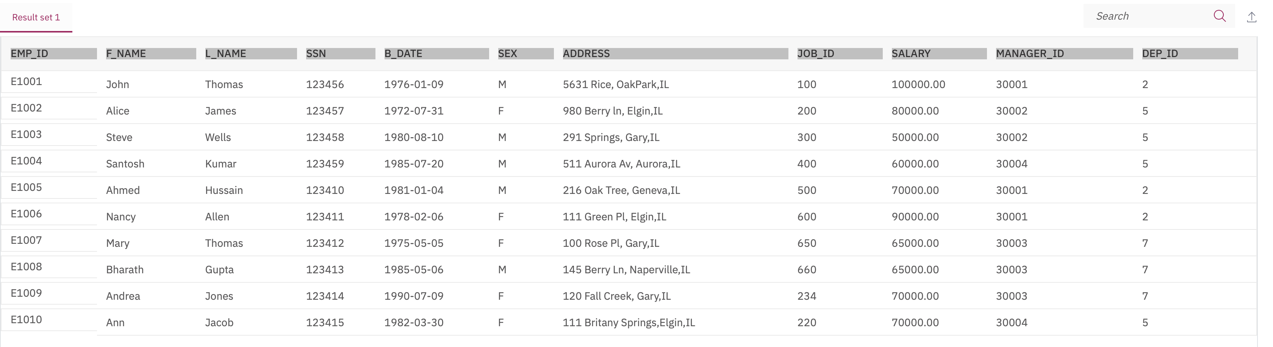

1. Problem:

Retrieve only the list of employees whose JOB\_TITLE is Jr. Designer.

Solution

Output

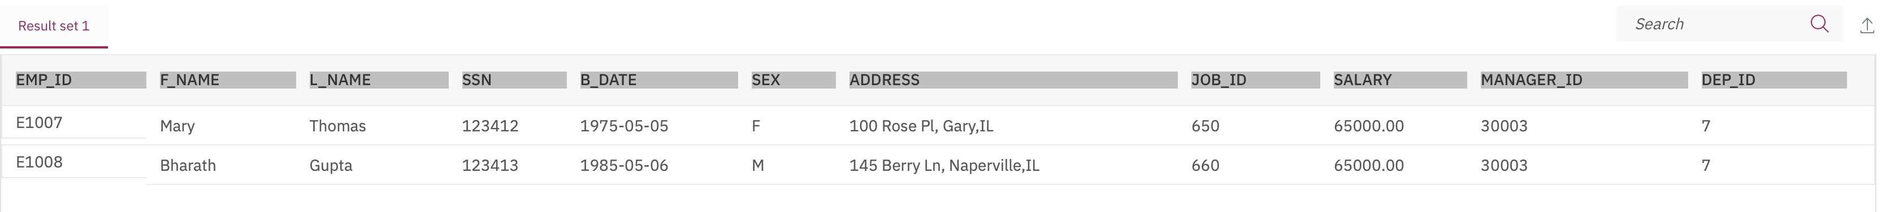

1. Problem:

Retrieve JOB information and who earn more than $70,000.

Solution

Output

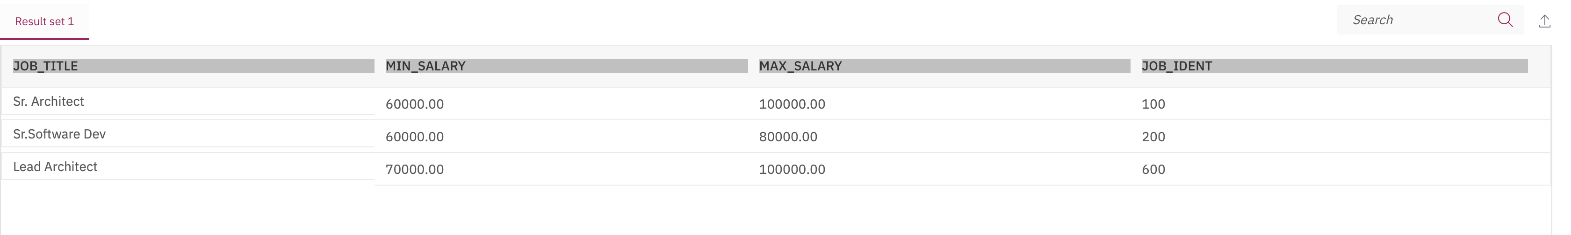

1. Problem:

Retrieve JOB information and whose birth year is after 1976.

Solution

Output

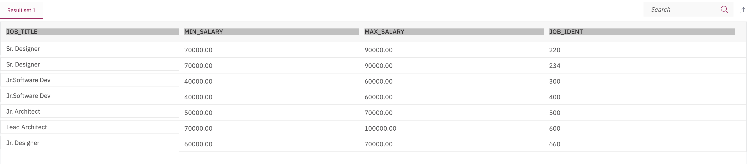

1. Problem:

Retrieve JOB information for female employees whose birth year is after 1976.

Solution

Output

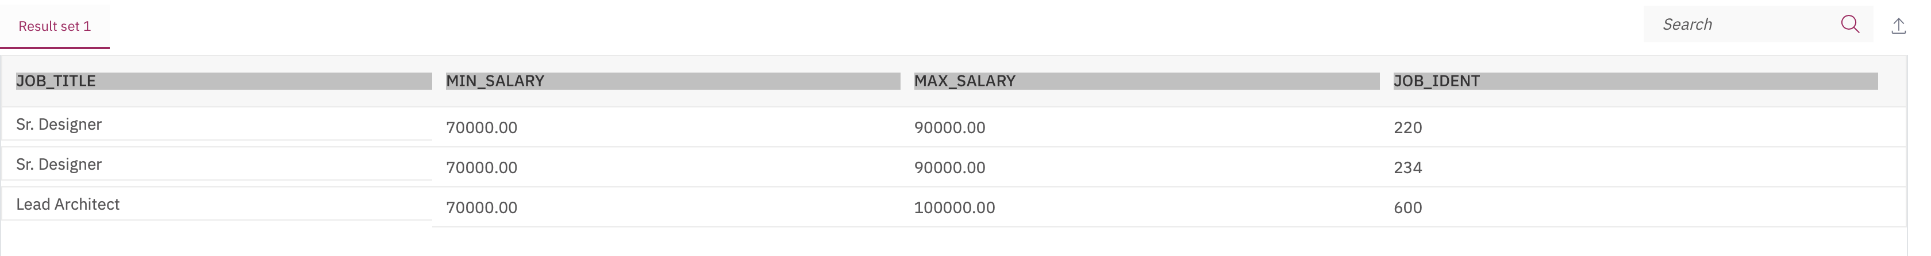

# Exercise 2: Accessing Multiple Tables with Implicit Joins

1. Problem:

Perform an implicit cartesian/cross join between EMPLOYEES and JOBS tables.

Solution

Output

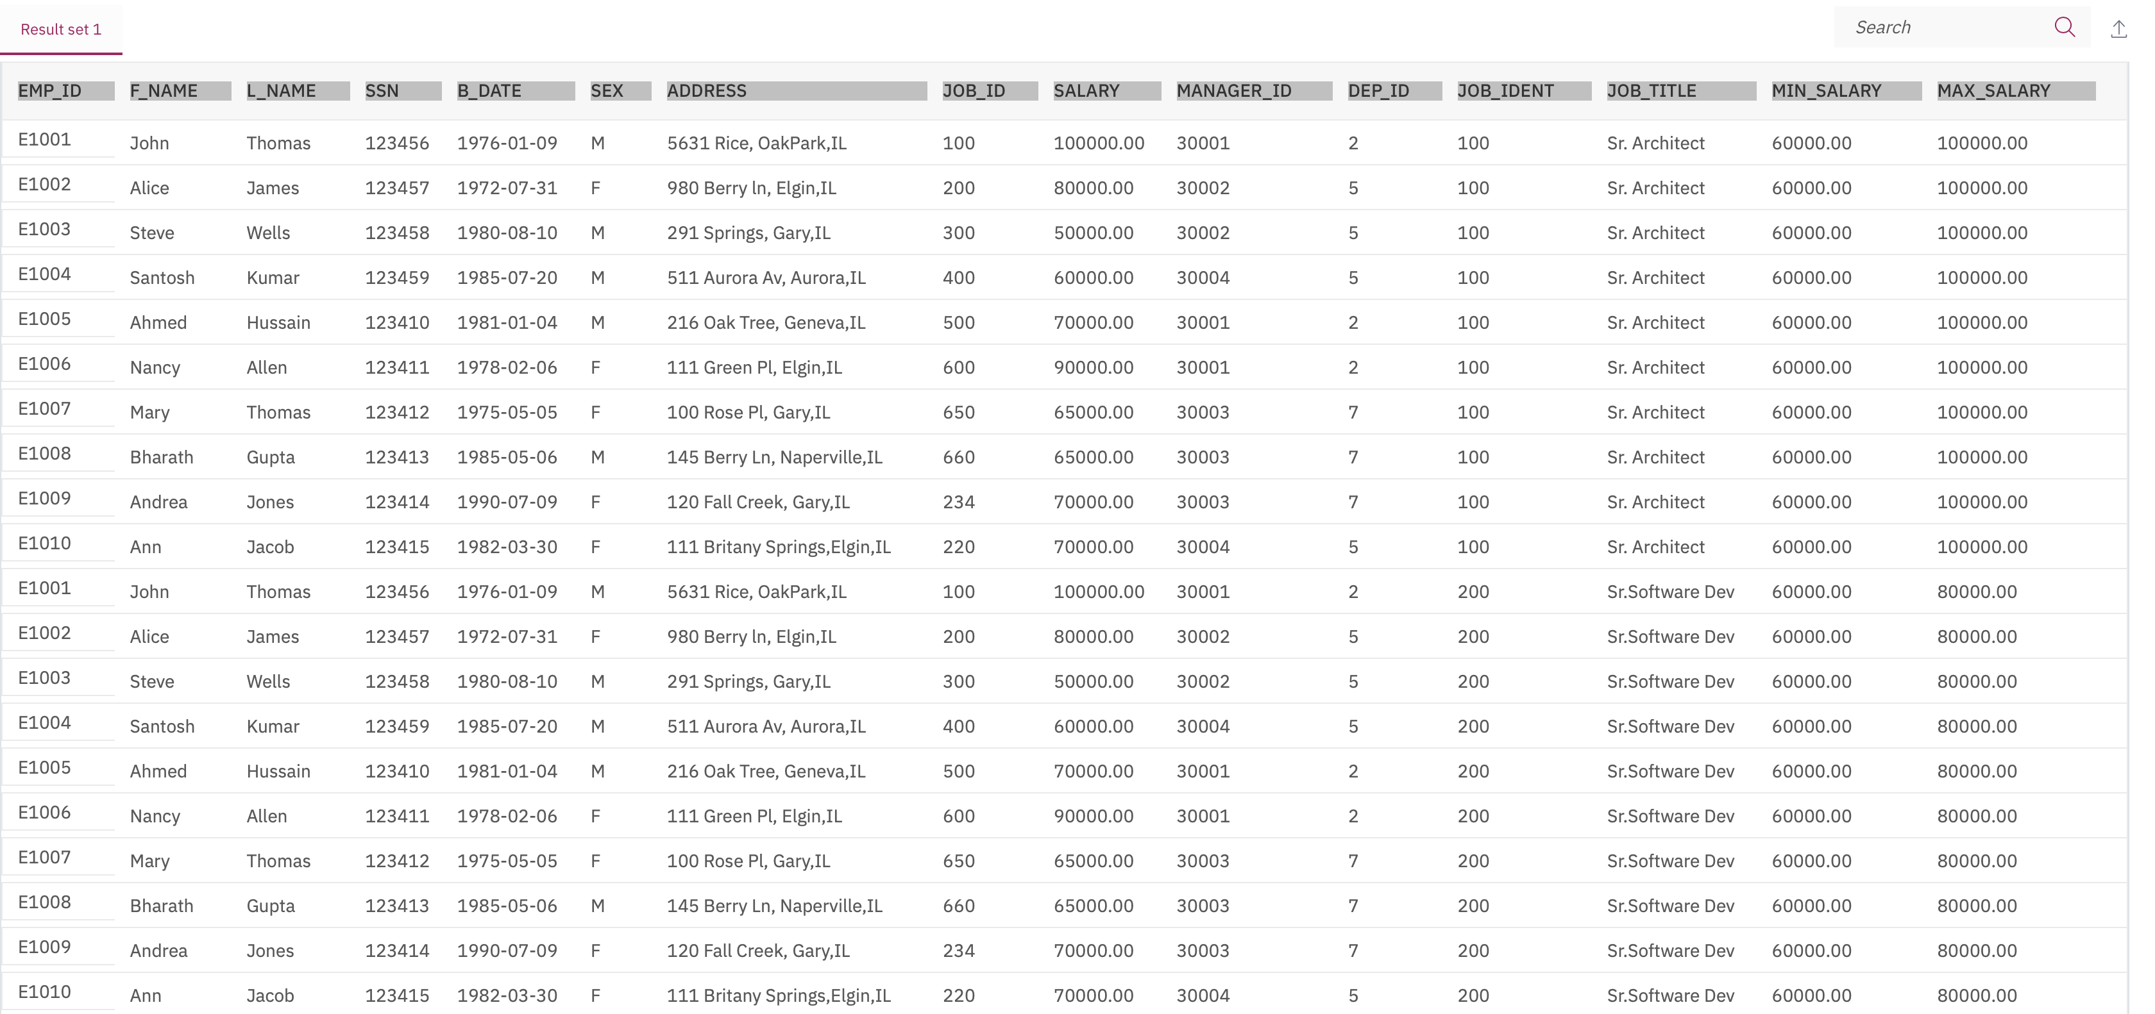

1. Problem:

Retrieve only the EMPLOYEES records that correspond to jobs in the JOBS table.

Solution

Output

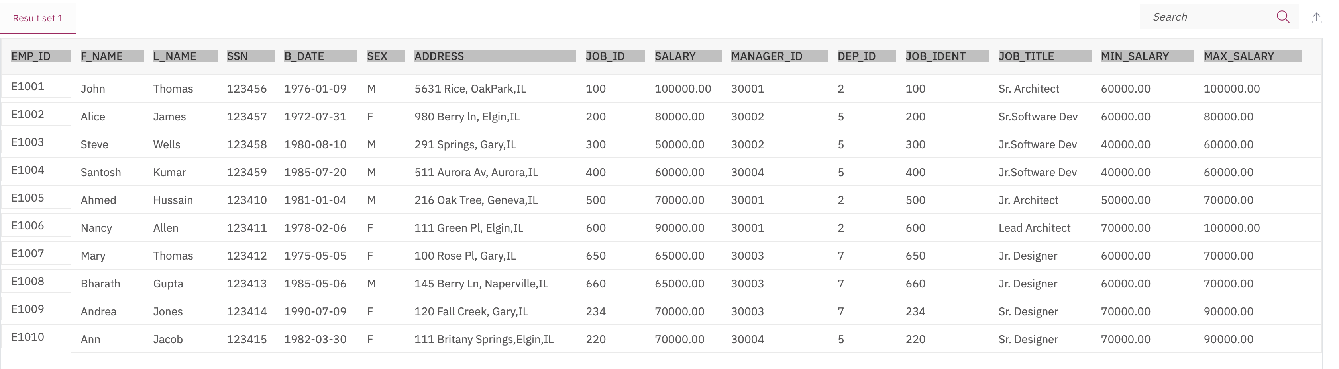

1. Problem:

Redo the previous query, using shorter aliases for table names.

Solution

Output



1. Problem:

Redo the previous query, but retrieve only the Employee ID, Employee Name and Job Title.

Solution

Output

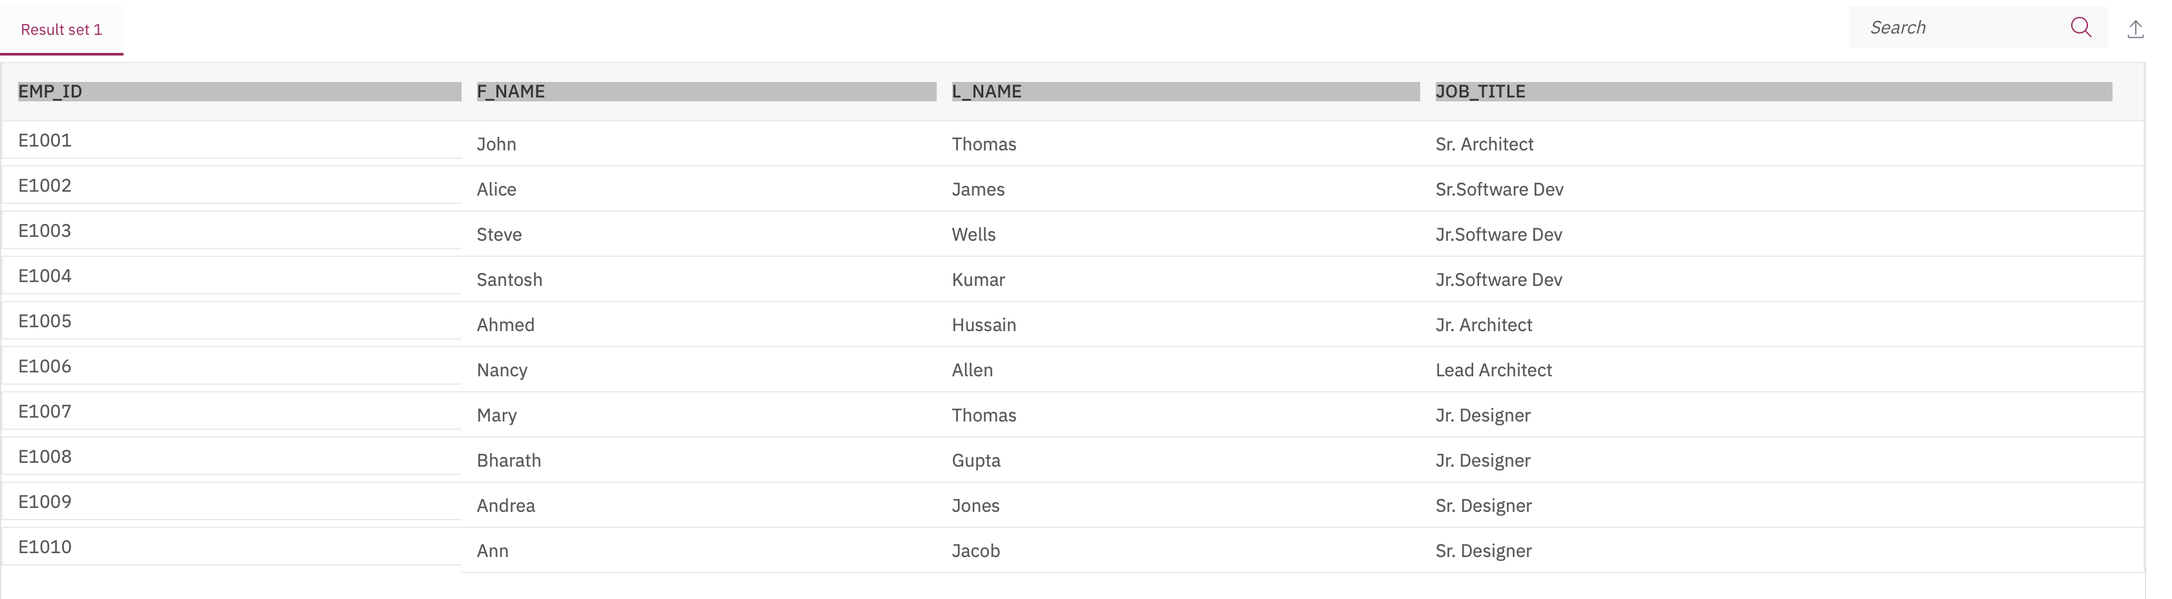

1. Problem:

Redo the previous query, but specify the fully qualified column names with aliases in the SELECT clause.

Solution

Output

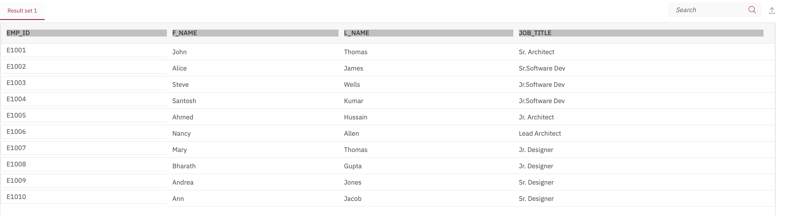

# Solution Script

If you would like to run all the solution queries of the SQL problems of this lab with a script, download the script below. Upload the script to the Db2 console and run. Follow [Hands-on Lab : Create tables using SQL scripts and Load data into tables](https://cf-courses-data.s3.us.cloud-object-storage.appdomain.cloud/IBMDeveloperSkillsNetwork-DB0201EN-SkillsNetwork/labs/Labs_Coursera_V5/labs/Lab%20-%20Create%20tables%20using%20SQL%20scripts%20and%20Load%20data%20into%20tables/instructional-labs.md.html) on how to upload a script to Db2 console and run it.

* [MultipleTables\_Solution\_Script.sql](https://cf-courses-data.s3.us.cloud-object-storage.appdomain.cloud/IBMDeveloperSkillsNetwork-DB0201EN-SkillsNetwork/labs/Labs_Coursera_V5/labs/Lab%20-%20Working%20with%20Multiple%20Tables%20%20/MultipleTables_Solution_Script.sql)

### Congratulations! You have completed this lab, and you are ready for the next topic.

# Author(s)

* [Rav Ahuja](https://www.linkedin.com/in/ravahuja/?utm_medium=Exinfluencer&utm_source=Exinfluencer&utm_content=000026UJ&utm_term=10006555&utm_id=NA-SkillsNetwork-Channel-SkillsNetworkCoursesIBMDeveloperSkillsNetworkDB0201ENSkillsNetwork22-2022-01-01)
* [Sandip Saha Joy](https://www.linkedin.com/in/sandipsahajoy/?utm_medium=Exinfluencer&utm_source=Exinfluencer&utm_content=000026UJ&utm_term=10006555&utm_id=NA-SkillsNetwork-Channel-SkillsNetworkCoursesIBMDeveloperSkillsNetworkDB0201ENSkillsNetwork22-2022-01-01)

## Changelog

| **Date** | **Version** | **Changed by** | **Change Description** |
| --- | --- | --- | --- |
| 2022-01-20 | 2.2 | Malika | Updated Exercise 1 problem statement 3,4 and 5 |
| 2020-12-25 | 2.1 | Steve Ryan | ID Reviewed |
| 2020-12-10 | 2.0 | Sandip Saha Joy | Created revised version from DB0201EN |
| 2020 | 1.0 | Rav Ahuja | Created initial version |

### © IBM Corporation 2020. All rights reserved.

# Summary & Highlights

Congratulations! You have completed this lesson. At this point in the course, you know:

* Most databases come with built-in functions that you can use in SQL statements to perform operations on data within the database itself.
* When you work with large datasets, you may save time by using built-in functions rather than first retrieving the data into your application and then executing functions on the retrieved data.
* You can use sub-queries to form more powerful queries than otherwise.
* You can use a sub-select expression to evaluate some built-in aggregate functions like the average function.
* Derived tables or table expressions are sub-queries where the outer query uses the results of the sub-query as a data source.

# How to Access Databases Using Python

0:00

Hello, in this video you will learn how to access databases using Python.

Databases are powerful tools for data scientists.

After completing this module,

you'll be able to explain the basic concepts

related to using Python to connect to databases.

Then you'll create tables,

load data and query data using SQL from Jupyter Notebooks,

and finally, analyze the data.

In the lab assignments,

you will learn how to create an instance in the Cloud,

connect to a database,

query data from the database using SQL, and analyze the data using Python.

You will be able to explain the basic concepts related

to connecting a Python application to a database.

Describe SQL APIs as well as list some of

the proprietary APIs used by popular SQL-based DBMS systems.

Let's quickly review some of the benefits of using Python,

a popular scripting language for connecting to databases.

The Python ecosystem is very rich and provides easy to use tools for data science.

Some of the most popular packages are NumPy,

pandas, matplotlib, and SciPy.

Python is easy to learn and has a simple syntax.

Due to its open source nature,

Python has been ported to many platforms.

All your python programs can work on any of

these platforms without requiring any changes at all.

If you are careful and avoid any system dependent features,

Python supports relational database systems.

Writing Python code to access databases is made

easier by the presence of the Python database API.

Commonly referred to as the DB API,

and detailed documentation related to Python is easily available.

Notebooks are also very popular in the field of data science because they run

in an environment that allows creation and sharing of documents that contain live code,

equations, visualizations, and explanatory texts.

A notebook interface is a virtual notebook environment used for programming.

Examples of notebook interfaces include the Mathematica notebook,

Maple worksheet, Matlab notebook,

IPython Jupyter, R Markdown,

Apache Zeppelin, Apache Spark notebook, and the Databricks cloud.

In this module, we will be using Jupyter notebooks.

The Jupyter notebook is an open source web application that

allows you to create and share documents that contain live code,

equations, visualizations, and narrative texts.

Here are some of the advantages of using Jupyter notebooks.

Notebook support for over 40 programming languages including Python,

R, Julia, and Scala.

Notebooks can be shared with others by email,

Dropbox, GitHub, and the Jupyter notebook viewer.

Your code can produce rich interactive output HTML,

images, videos, LaTex, and customized types.

You can leverage big data tools such as Apache Spark from Python, R,

and Scala, and explore that same data with pandas,

scikit-learn, ggplot2, and TensorFlow.

This is how a typical user accesses

databases using Python code written on a Jupyter notebook,

a web based editor.

There is a mechanism by which the Python program communicates with the DBMS.

The Python code connects to the database using API calls.

We will explain the basics of SQL APIs and Python DB APIs.

An application programming interface is a set of

functions that you can call to get access to some type of service.

The SQL API consists of library function calls as an application programming interface,

API, for the DBMS.

To pass SQL statements to the DBMS,

an application program calls functions in the API,

and it calls other functions to retrieve

query results and status information from the DBMS.

The basic operation of a typical SQL API is illustrated in the figure.

The application program begins its database access with one or

more API calls that connect the program to the DBMS.

To send the SQL statement to the DBMS,

the program builds the statement as a text string in a buffer and then

makes an API call to pass the buffer contents to the DBMS.

The application program makes API calls to check

the status of its DBMS request and to handle errors.

The application program ends its database access

with an API call that disconnects it from the database.

Now, lets learn basic concepts about some of

the proprietary APIs used by popular SQL-based DBMS systems.

Each database system has its own library.

As you can see, the table shows a list of a few applications and corresponding SQL APIs.

MySQL C API provides low level access to

the MySQL client server protocol and enables C programs to access database contents.

The psycopg2 API connects Python applications in PostgreSQL databases.

The IBM\_DB API is used to connect Python applications to IBM DB2 databases.

The dblib API is used to connect to SQL server databases.

ODBC is used for database access for Microsoft Windows OS.

OCI is used by Oracle databases.

And finally, JDBC is used by Java applications.

Thanks for watching this video.

# Writing code using DB-API

0:00

Hello and welcome to writing code using DB-APIs.

After completing this video,

you will be able to explain the basic concepts related to

the Python DB-API and database cursors.

And also write code using DB-APIs.

As we saw in the beginning of this module,

the user writes Python programs using a Jupyter notebook.

There is a mechanism by which the Python code communicates with the DBMS.

The Python code connects to the database using DB-API calls.

DB-API is Python's standard API for accessing relational databases.

It is a standard that allows you to write a single program that works with multiple kinds

of relational databases instead of writing a separate program for each one.

So, if you learn the DB-API functions,

then you can apply that knowledge to use any database with Python.

Here are some advantages of using the DB-API.

It's easy to implement and understand.

This API has been defined to encourage similarity between

the Python modules that are used to access databases.

It achieves consistency which leads to more easily understood modules.

The code is generally more portable across databases,

and it has a broader reach of database connectivity from Python.

As we know, each database system has its own library.

As you can see, the table shows a list of a few databases and

corresponding DB-APIs to connect to Python applications.

The IBM\_db library is used to connect to an IBM DB2 database.

Play video starting at :1:46 and follow transcript1:46

The MySQL Connector/Python library is used to connect to a Compose for MySQL database.

The psycopg2 library is used to connect to a Compose from PostgreSQL database.

And finally, the PyMongo library is used to connect to a Compose for MongoDB database.

The two main concepts in the Python DB-API are connection objects and query objects.

You use connection objects to connect to a database and manage your transactions.

Cursor objects are used to run queries.

You open a cursor object and then run queries.

The cursor works similar to a cursor in a text processing system where

you scroll down in your result set and get your data into the application.

Cursors are used to scan through the results of a database.

The DB\_API includes a connect constructor for creating a connection to the database.

It returns a Connection Object, which is then used by the various connection methods.

These connection methods are:

The cursor() method, which returns a new cursor object using the connection.

The commit() method, which is used to commit any pending transaction to the database.

The rollback() method, which causes the database to roll back to the start of any pending transaction.

The close() method, which is used to close a database connection.

These objects represent a database cursor, which is used to manage the content of a fetch operation.

Cursors created from the same connection are not isolated

that is, any changes done to the database by

a cursor are immediately visible by the other cursors.

Cursors created from different connections can or cannot be

isolated depending on how the transaction support is implemented.

Play video starting at :3:44 and follow transcript3:44

A database cursor is a control structure that

enables traversal over the records in a database.

It behaves like a file name or file handle in a programming language.

Just as a program opens a file to access its contents,

it opens a cursor to gain access to the query results.

Similarly, the program closes a file to end

its access and closes a cursor to end access to the query results.

Another similarity is that just as file handle keeps

track of the program's current position within an open file,

a cursor keeps track of the program's current position within the query results.

Let's walk through a Python application that uses the DB-API to query a database.

First, you import your database module by using the connect API from that module.

To open a connection to the database,

you use the connect constructor and pass in the parameters, that is,

the database name, username, and password.

The connect function returns connection object.

After this, you create a cursor object on the connection object.

The cursor is used to run queries and fetch results.

After running the queries, using the cursor,

we also use the cursor to fetch the results of the query.

Finally, when the system is done running the queries,

it frees all resources by closing the connection.

Remember that it is always important to close

connections to avoid unused connections taking up resources.

Thanks for watching this video.

# Connecting to a database using ibm\_db API

0:00

Hello, and welcome to connecting to a database using the ibm\_db API.

After completing this lesson,

you will be able to understand the ibm\_db API,

as well as the credentials required to connect to a database using Python.

We will also demonstrate how to connect to

an IBM DB2 database using Python code written on a Jupyter notebook.

The ibm\_db API provides a variety of

useful Python functions for accessing and

manipulating data in an IBM data server database,

including functions for connecting to a database,

preparing and issuing SQL statements,

fetching rows from result sets, calling stored procedures,

committing and rolling back transactions,

handling errors and retrieving metadata.

The ibm\_db API uses the IBM Data Server Driver for ODBC,

and CLI APIs to connect to IBM, DB2, and Informix.

We import the ibm\_db library into our Python application.

Connecting to the DB2 requires

the following information: a driver name, a database name,

a host DNS name or IP address, a host port,

a connection protocol, a user ID,

and a user password.

Here is an example of creating a DB2 database connection in Python.

We create a connection object DSN,

which stores the connection credentials.

The connect function of

the ibm\_db API will be used to create a non persistent connection.

The DSN object is passed as a parameter to the connection function.

If a connection has been established with the database,

then the code returns connected,

as the output otherwise,

the output will be unable to connect to database.

Then we free all resources by closing the connection.

Remember that it is always important to close

connections so that we can avoid unused connections taking up resources.

Thank you for watching this video.

(Music)



# Create credentials to access your database instance

## Objective(s)

At the end of this lab you will be able to:

* Create your own instance of database on IBM Cloud using DB2 service

## Exercise

Database credentials are required to connect from remote applications like Jupyter notebooks which are used in the labs and assignment in the last two weeks of the course.

1. Go to your IBM Cloud Resources dashboard (or click on IBM Cloud in the top left corner):

[https://cloud.ibm.com/resources](https://cloud.ibm.com/resources?utm_medium=Exinfluencer&utm_source=Exinfluencer&utm_content=000026UJ&utm_term=10006555&utm_id=NA-SkillsNetwork-Channel-SkillsNetworkCoursesIBMDeveloperSkillsNetworkDB0201ENSkillsNetwork22-2022-01-01)

Note: you may need to log into IBM Cloud in the process of loading the resources/dashboard.

If your connection is slow it may take over 30 seconds for the dashboard to fully load.

1. Locate and click on your Db2 service listed under Services.

(**NOTE:** In the example below the service is called “Db2-xx” but your Db2 service may have a different letters/numbers in the suffix e.g. “Db2-f8”, “Db-50”, etc.)

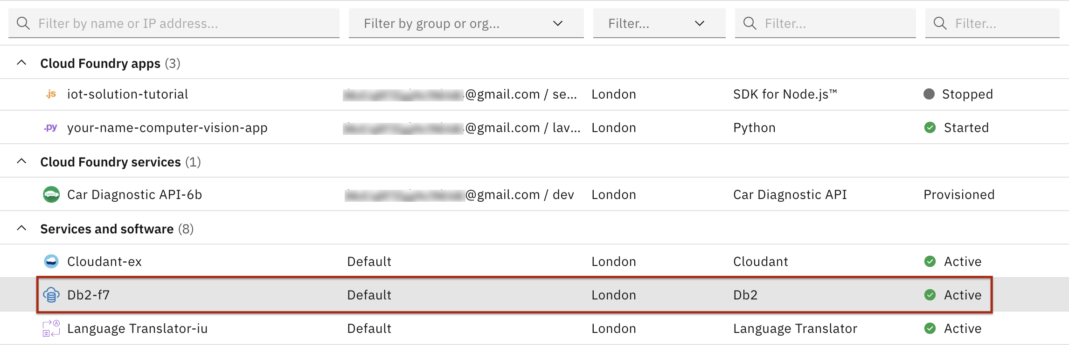

1. Click on Service Credentials in the left menu

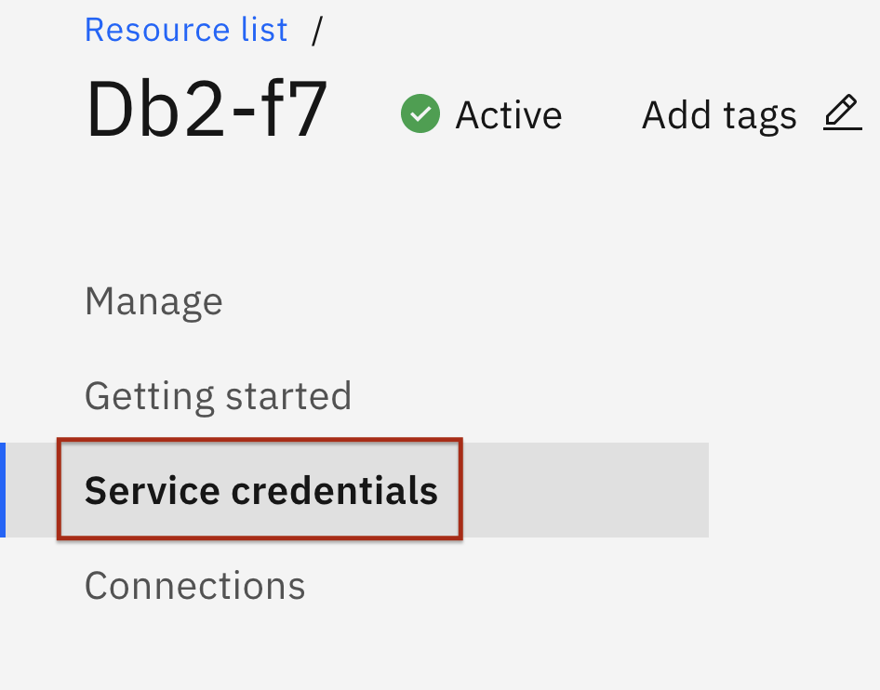

1. Click on the button to create **New credential**

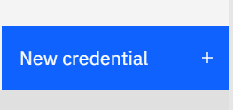

In the prompt that comes up click the “Add” button in the bottom right:

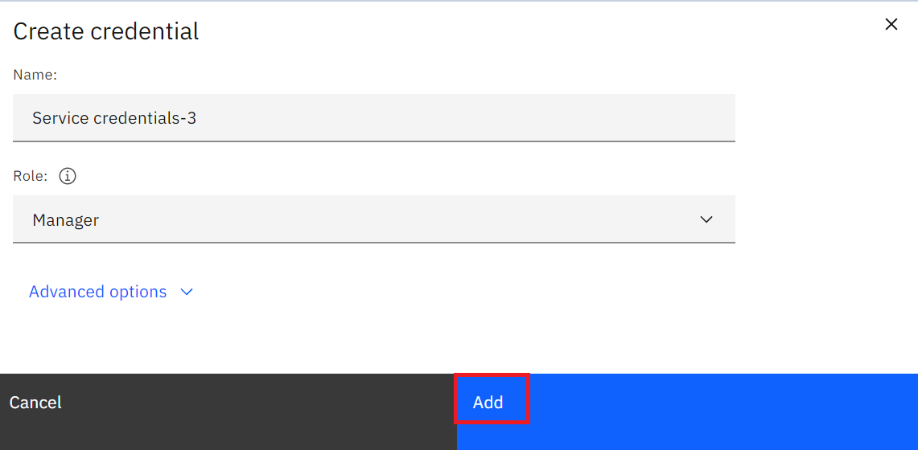

1. Check the box to **View credentials**
2. Copy and save the credentials making a note of the following:

* **port** is the database port
* **db** is the database name
* **host** is the hostname of the database instance
* **username** is the username you'll use to connect
* **password** is the password you'll use to connect

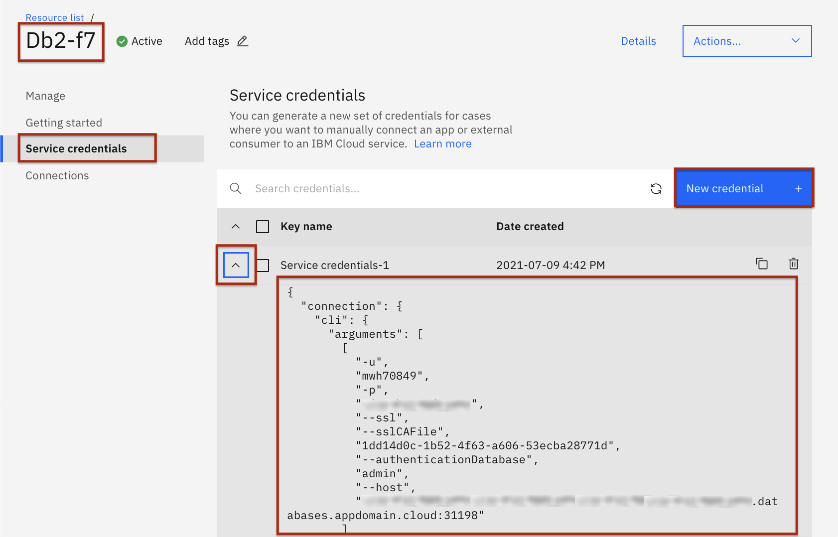

You need to scroll down to get the credentials details.

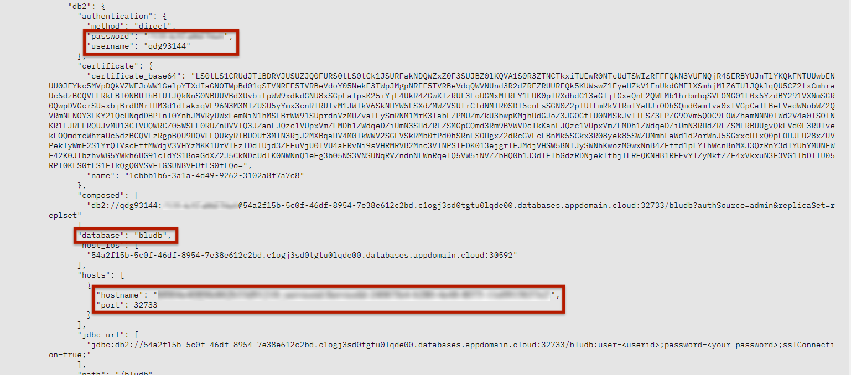

## Author(s)

#### Rav Ahuja

### Other Contributor(s)

Simran Garg

## Changelog

| **Date** | **Version** | **Changed by** | **Change Description** |
| --- | --- | --- | --- |
| 2021-07-09 | 2.1 | Malika | Updated screenshots |
| 2020-08-27 | 2.0 | Simran | Migrated lab to course in GitLab |

### © IBM Corporation 2020. All rights reserved.

# Creating tables, loading data and querying data

Notes

[**Discuss**](https://www.coursera.org/learn/sql-data-science/discussions/weeks/4)

0:00

Hello, and welcome to creating tables,

loading data, and querying data.

After completing this lesson,

you will be able to understand basic concepts related to creating tables, loading data,

and querying data using Python,

as well as demonstrate an example of how to perform these tasks using

the IBM DB2 on Cloud database and Jupyter notebooks.

For this example, we will be using DB2 as the database.

We first obtain a connection resource by connecting to the database

by using the connect method of the ibm\_db api.

There are different ways of creating tables in DB2.

One is using the Web console provided by DB2,

and the other option is to create tables from any SQL, R, or Python environments.

Let's take a look at how to create tables in DB2 from our Python application.

Here is a sample table of a commercial Trucks database.

Let's see how we can create the Trucks table in the DB2 using Python code.

To create a table,

we use the ibm\_db.exec\_immediate function.

The parameters for the function are connection,

which is a valid database connection resource that is returned from

the ibm\_db.connect or ibm\_db.pconnect function statement,

which is a string that contains the SQL statement,

and options which is an optional parameter that includes

a dictionary that specifies the type of cursor to return for results sets.

Here is the code to create a table called Trucks in Python.

We use the ibm\_db.exec\_immediate function of the ibm\_db api.

The connection resource that was created is passed as the first parameter to this function.

The next parameter is the SQL statement,

which is the create table query used to create the Trucks table.

The new table created will have five columns,

serial\_no will be the primary key.

Now let's take a look at loading data.

We use the ibm\_db.exec\_immediate function of the ibm\_db api.

The connection resource that was created is passed as the first parameter to this function.

The next parameter is the SQL statement,

which is the insert into query used to insert data in the Trucks table.

A new row will be added to the Trucks table.

Similarly, we add more rows to the Trucks table using the ibm\_db.exec\_immediate function.

Now that your Python code has been connected to

a database instance and the database table has been created and populated with data,

let's see how we can fetch data from the Trucks table that we

created on DB2 using Python code.

We use the ibm\_db.exec\_immediate function of the ibm\_db api.

The connection resource that was created is passed as the first parameter to this function.

The next parameter is the SQL statement,

which is the select from table query.

The Python code returns the output,

which shows the fields of the data in the Trucks table.

You can check if the output returned by the select query shown is correct,

by referring to the DB2 console.

Let's look at how we can use pandas to retrieve data from the database tables.

Pandas is a popular Python library that contains

high level data structures and

manipulation tools designed to make data analysis fast and easy in Python.

We load data from the Trucks table into a data frame called DF.

A data frame represents a tabular spreadsheet like

data structure containing an ordered collection of columns,

each of which can be a different value type.

Thanks for watching this video.

(Music)



## Introducing SQL Magic

**Effort: 10 mins**

### Objective

In this reading, you will learn about the SQL magic commands.

Jupyter notebooks have a concept of **Magic** commands that can simplify working with Python, and are particularly useful for data analysis. Your notebooks can have two types of magic commands:

* **Cell magics:** start with a double **%%** sign and apply to the entire cell
* **Line magics:** start with a single **%** (percent) sign and apply to a particular line in a cell

Their usage is of the format:

**%magicname arguments**

So far in the course you learned to accessed data from a database using the Python DB-API (and specifically ibm\_db). With this API execution of queries and fetching their results involves multiple steps. You can use the **SQL Magic** commands to execute queries more easily.

For example if you want to execute the a query to select some data from a table and fetch its results, you can simply enter a command like the following in your Jupyter notebook cell:

**%sql select \* from tablename**

Although SQL magic simplifies working with databases, it has some limitations. For example, unlike DB-API, there are no explicit methods to close a connection and free up resources.

In the following tutorial you will learn how to work with SQL magic.

## Author(s)

#### Rav Ahuja

## Change log

| **Date** | **Version** | **Changed by** | **Change Description** |
| --- | --- | --- | --- |
| 2020-09-05 | 2.0 | Malika Singla | Migarted to GitLab |

### © IBM Corporation 2020. All rights reserved.

# Analyzing data with Python

0:00

Hello, and welcome to analyzing data with Python.

After completing this video,

you will be able to understand basic concepts

related to performing exploratory analysis on data.

We will demonstrate an example of how to store data using

the IBM Db2 on Cloud database,

and then use Python to do some basic data analysis on this data.

In this video, we will be using

the McDonald's menu nutritional facts data for popular menu items at McDonald's,

while using Python to perform basic exploratory analysis.

McDonald's is an American fast food company

and the world's largest restaurant chain by revenue.

Although McDonald's is known for fast food items such as hamburgers,

French fries, soft drinks, milkshakes,

and desserts, the company has added to its menu salads,

fish, smoothies, and fruit.

McDonald's provides nutrition analysis of

their menu items to help you balance your McDonald's meal with other foods you eat.

The data set used in this lesson has been obtained from

the nutritional facts for McDonald's menu from Kaggle.

We need to create a table on Db2 to store

the McDonald's menu nutrition facts data set that we will be using.

We will also be using the console provided by Db2 for this process.

There are four steps involved in loading data into a table,

source, target, define, and finalize.

We first load the spreadsheet into the Db2 using the console.

We then select the target schema,

and then you will be given an option to load the data into

an existing table or create a new table.

When you choose to create a new table,

you have the option to specify the table name.

Next, you will see a preview of the data where you

can also define the columns and data types.

Review the settings and begin the load.

When the loading is complete,

you can see the statistics on the loaded data.

Next, view the table to explore further.

Db2 Warehouse allows you to analyze data using in-database analytics,

APIs, RStudio or Python.

The data has been loaded into our relational database.

You can run Python scripts that retrieve data from and write data to a Db2 database.

Such scripts can be powerful tools to help you analyze your data.

For example, you can use them to generate

statistical models based on data in your database,

and to plot the results of these models.

In this lesson, we will be using

Python scripts that will be run within a Jupyter notebook.

Now, after obtaining a connection resource,

by connecting to the database,

by using the connect method of the IBM\_DB API,

we use the SQL select query to verify

the number of rows that have been loaded in the table created.

The figure shows a snapshot of the output.

The output obtained is 260 which is similar

to the number of rows in the Db2 console.

Now let's see how we can use Pandas to retrieve data from the database tables.

We load data from the McDonalds\_nutrition table into

the data frame DF using the read\_SQL method.

The SQL select query and the connection object are

passed as parameters to the read\_SQL method.

We can view the first few rows of the data frame DF

that we created using the head method.

Now it's time to learn about your data.

Pandas methods are equipped with a set of common mathematical and statistical methods.

Let's use the describe method to view

the summary statistics of the data in the data frame,

then explore the output of the describe method.

We see that there are 260 observations or food items in our data frame.

We also see that there are nine unique categories of food items in our data frame.

We can also see summary statistics information such as frequency, mean,

median, standard deviation, et cetera for

the 260 food items across the different variables.

For example, the maximum value for total fat is 118.

Let's investigate this data further.

Let's try to understand one of the nutrients in the food items which is sodium.

A main source of sodium is table salt.

The average American eats five or more teaspoons of salt each day.

This is about 20 times as much as the body needs.

Sodium is found naturally in foods,

but a lot of it is added during processing and preparation.

Many foods that do not taste salty,

may still be high in sodium.

Large amounts of sodium can be hidden in canned,

processed and convenience foods.

Sodium controls fluid balance in our bodies,

and maintains blood volume and blood pressure.

Eating too much sodium may raise blood pressure and cause fluid retention,

which could lead to swelling of the legs,

and feet, or other health issues.

When limiting sodium in your diet,

a common target is to eat less than 2,000 milligrams of sodium per day.

Now using the nutrition data set for McDonald's,

let's do some basic data analysis to answer the question.

Which food item has the maximum sodium content?

We first use visualization to explore the sodium content of food items.

Using the swarm plot method provided by the Seaborne package,

we create a categorical scatter plot as shown on the right,

then give as the input,

category on the x-axis,

sodium on the y-axis,

and the data will be the data frame DF that

contains the nutritional data set from McDonald's.

The plot shows the sodium values for the different food items by category.

Notice a high value of around 3,600 for sodium on the scatter plot.

We will be learning about visualizations later in this module.

Let's further explore this high sodium value and identify

which food items on the menu have this value for sodium.

Let's do some basic data analysis using Python to

find which food items on the menu have maximum sodium content.

To check the values of sodium levels in the food items within the dataset,

we use the code as shown in code 1.

The describe method is used to understand the summary statistics associated with sodium.

Notice that the maximum value of sodium is given as 3,600.

Now let's further explore the row associated

with the maximum sodium variable as shown in code 2.

We use the idxmax method to compute the index values,

at which the maximum value of sodium is obtained in the data frame.

We see that the output is 82.

Now lets find the item name associated with the 82nd item in our data frame.

As shown in code 3,

we will use the .at method to find

the item name by passing the index of 82 and the column name item,

to be returned for the 82nd row.

Finally, we find that the food item on the menu that has

a highest sodium content is Chicken McNuggets, 40 pieces.

Visualizations are very useful for initial data exploration.

They can help us understand relationships,

patterns, and outliers in the data.

Let's first create a scatter plot with protein on the x-axis,

and total fat on the y-axis.

Scatter plots are very popular visualization tools and show

the relationship between two variables with a point for each observation.

To do this, we can use the joint plot function provided by the Seaborn package,

and give as input,

protein on the x-axis and total fat on the y-axis.

And the data will be the data frame DF that

contains the nutritional data set from McDonald's.

The output scatter plot is shown on the right side.

The plot has an interesting shape.

It shows the correlation between the two variables: protein and fat.

Correlation is a measure of association between two variables,

and has a value of between -1 and +1.

We see that the points on the scatter plot are

closer to a straight line in the positive direction.

So we have a positive correlation between the two variables.

On the top right corner of the scatter plot,

we have the values of the Pearson correlation-

0.81 and the significance of the correlation denoted

as P - which is a good value that shows the variables are certainly correlated.

The plot also shows two histograms:

one on the top and the other on the right side.

The histogram on the top is that of the variable protein,

and the histogram on the right side is that of the variable total fat.

We also noticed that there is a point on the scatter plot outside the general pattern.

This is a possible outlier.

Now let's see how we can visualize data using box plots.

Box plots are charts that indicate the distribution of one or more variables.

The box in a box plot captures the middle 50 percent of data.

Lines and points indicate possible skewness and outliers.

Let's create a box plot for sugar.

The function we are going to use is box plot from the Seaborn package.

We give the column name sugars as input to the box plot function.

The output is shown on the right side,

where we had the box plot with average values of sugar and food items around 30 grams.

We also notice a few outliers that indicate food items with extreme values of sugar.

There exist food items in the data set that have sugar content of around 128 grams.

Candies maybe among these high sugar content food items on the menu.

Now that you know how to do

basic exploratory data analysis using Pandas and visualization tools,

proceed to the labs in this module where you can practice the concepts learned.

Thank you for watching this video.

(Music)

# Summary & Highlights

Congratulations! You have completed this lesson. At this point in the course, you know:

* You can access a database from a language like Python by using the appropriate API. Examples include ibm\_db API for IBM DB2, psycopg2 for ProstgreSQL, and dblib API for SQL Server.
* DB-API is Python's standard API for accessing relational databases. It allows you to write a single program that works with multiple kinds of relational databases instead of writing a separate program for each one.
* The DB\_API connect constructor creates a connection to the database and returns a Connection Object, which is then used by the various connection methods.
* The connection methods are: The **cursor()** method, which returns a new cursor object using the connection. The **commit()** method, which is used to commit any pending transaction to the database. The **rollback()** method, which causes the database to roll-back to the start of any pending transaction. The **close()** method, which is used to close a database connection.
* You can use **SQL Magic** commands to execute queries more easily from Jupyter Notebooks. Magic commands have the general format **%sql select \* from tablename**. **Cell magics** start with a double %% (percent) sign and apply to the entire cell. **Line magics** start with a single % (percent) sign and apply to a particular line in a cell.

# Working with Real World Datasets

0:00

(Music)

Hello and welcome.

In this video,

we'll give you a few hints and tips for

working with Real World Data-sets.

Many of the real world data sets are

made available as .CSV files.

These are text files which contain

data values typically separated by commas.

In some cases, a different separator

such as a semicolon may be used.

For this video, we will use an example of

a file called DOGS.CSV.

Although this is a fictional data set that

contains names of dogs and their breeds,

we will use it to illustrate concepts that

you will then apply to real datasets.

Sample contents of the DOGS.CSV file are shown here.

The first row in the table in many cases contains

attribute labels which map to column names in a table.

In DOGS.CSV,

the first row contains the name of three attributes.

Id is the name of the first attribute and

the subsequent rows contain Id values of 1, 2, and 3.

The name of the dog is the second attribute.

In this case the dog names Wolfie,

Fluffy, and Huggy are the values.

The third attribute is called breed,

either the dominant breed or pure breed name.

It has values of

German Shepherd, Pomeranian, and Labrador.

As we've just seen,

CSV files can have the first or

a header row that contains the names of the attributes.

If you're loading the data into the database using

the visual load tool in the database console,

ensure the header in first row is enabled.

This will map the attribute names in the first row of

the CSV file into column names in the database table,

and the rest of the rows into

the data rows in the table, as shown here.

Note that the default column names may not

always be database or query friendly,

and if that is the case, you may

want to edit them before the table is created.

Now, let's talk about querying

column names that are lower or mixed case,

that is, a combination of upper and lowercase.

Let's assume we loaded the DOGS.CSV

file using the default column names from the CSV.

If we try to retrieve the contents of

the Id column using the query,

select id from DOGS,

we'll get an error as

shown indicating the id is not valid.

This is because the database parser

assumes uppercase names by default.

Whereas when we loaded the CSV file into

the database it had the Id column name in mixed case i.e

an uppercase I and a lowercase d. In

this case, to select data from

a column with a mixed case name,

we need to specify the column name in

its correct case within double quotes as follows.

Select \* "Id" from DOGS.

Ensure you use double quotes around

the column name and not single quotes.

Next, we'll cover querying

column names that have spaces and other characters.

In a CSV file, if the name of the column contain spaces,

by default the database may map them to underscores.

For example, in the name of dog column,

there are spaces in between the three words.

The database may change it to Name\_of\_Dog.

Play video starting at :4:10 and follow transcript4:10

Other special characters like parentheses or

brackets may also get mapped to underscores.

Therefore, when you write a query

ensure you use proper case formatting within

quotes and substitute special characters

to underscores as shown in this example.

Select "Id," "Name\_of\_Dog,"

"Breed\_\_dominant\_breed\_if\_not\_pure\_breed\_"from dogs.

Please note the underscores separating

the words within double quotes.

Also note the double underscore

between breed and dominant as shown.

Finally, it's also important to note

the trailing underscore after

the word breed near the end of the query.

This is used in place of the closing bracket.

When using quotes in Jupyter notebooks,

you may be issuing queries in a notebook by

first assigning them to Python variables.

In such cases, if your query

contains double quotes for example,

to specify a mixed case column name,

you could differentiate the quotes

by using single quotes for

the Python variable to enclose

this SQL query and double quotes for the column names.

For example, selectQuery ='select "Id" from dogs.'

Now, what if you need to

specify single quotes within the query,

for example, to specify a value in the where clause?

In this case you can use backslash

as the escape character as follows,

select Query = 'select \* from dogs where

Play video starting at :6:7 and follow transcript6:07

"Name\_of\_Dog"=\'Huggy\' '. If you have

very long queries such as join queries or nested queries,

it may be useful to split the query into

multiple lines for improved readability.

In Python notebooks, you

can use the backslash character to

indicate continuation to the next row

as shown in this example.

%sql select "Id," Name\_of\_Dog,"

\ from dogs \ where"Name\_of\_Dog" = 'Huggy.'

It would be helpful at this point to take

a moment to review the special characters as shown.

Please keep in mind that you might get

an error if you split the query into

multiple lines in

a Python notebook without the backslash.

When using SQL magic, you can use

the double percent SQL in

the first line of the cell in Jupyter Notebooks.

It implies that the rest of the content of

the cell is to be interpreted by SQL magic.

For example %% sql new row select "Id",

"Name\_of\_dog," new row, from dogs,

new row, where "Name\_of\_dog = 'Huggy.'

Again, please note the special characters as shown.

When using %% sql the backslash

is not needed at the end of each line.

At this point you might be asking,

how would you restrict the number of rows retrieved?

It's a good question because a table

may contain thousands or even millions

of rows, and you may only want to see some sample data

or look at just a few rows to

see what kind of data the table contains.

You may be tempted to just do

select \* from table name to retrieve the results

in a Pandas data frame and do a head function on it.

But, doing so may take a long time for a query to run.

Instead, you can restrict

the results set by using the limit clause.

For example, use the following query to retrieve

just the first three rows in a table called census data.

Select \* from census\_data limit 3.

In this video we looked at some considerations

and tips for working with real-world datasets.

Thanks for watching.

(Music)

# Getting Table and Column Details

Notes

[**Discuss**](https://www.coursera.org/learn/sql-data-science/discussions/weeks/5)

0:00

(Music)

Hello and welcome.

In this video,

we'll look at how to get information about

tables and their columns in a database.

Now how would you get a list of tables in the database?

Sometimes your database may contain several tables,

and you may not remember the correct name.

For example, you may wonder

whether the table is called dog,

dogs or four legged mammals.

Database systems typically contain

system or catalog tables,

from where you can query

the list of tables and get their properties.

In DB2 this catalog is called syscat tables.

In SQL Server, it's

information schema tables, and in Oracle

it's all tables or user tables.

To get a list of tables in a DB2 database,

you can run the following query.

Select star from syscat tables.

This select statement will return

too many tables including system tables,

so it's better to filter the result as shown here.

Select tabschema, tabname,

create underscore time from syscat tables,

where tabschema equals ABC12345.

Please ensure that you replace

ABC12345 with your own DB2 username.

When you do a select star from syscat tables,

you get all the properties of the tables.

Sometimes we're interested in

specific properties such as creation time.

Let's say you've created

several tables with similar names.

For example, dog one,

dog underscore test, dog test one and so on. But,

you want to check which of these tables was

the last one you created; to do so,

you can issue a query like select tabschema,

tabname, create underscore time from syscat tables:

Where a tabschema equals QCM54853.

The output will contain the schema name,

table name, and creation time

for all tables in your schema.

Next, let's talk about how to

get a list of columns in a table.

If you can't recall

the exact name of a column for example,

whether it had any lowercase characters

or an underscore in its name,

in DB2 you can issue a query like the one shown here.

Select star from syscat columns

where tab name equals dogs.

For your information, in my SQL,

you can simply run the command show columns from dogs,

or you may want to know

specific properties like the datatype

and length of the datatype.

In DB2, you can issue

a statement like, select distinct name,

coltype, length from sysibm,

syscolumns where tbname equals dogs.

Here we look at the results

of retrieving column properties,

for a real table called

Chicago Crime Data from a Jupyter notebook.

Notice in the output,

you can tell certain column names show different cases.

For example, the column titled arrest has an uppercase A,

and the rest of the characters are lowercase.

So, keep in mind that when you

refer to this column in your query,

not only must you enclose

the word arrest within double quotes,

you must also preserve

the correct case inside the quotes.

In this video, we saw how to

retrieve table and column information.

Thanks for watching.

(Music)



# Loading Data

## Objective(s)

At the end of this lab you will be able to:

* Read data from a CSV files and load it into database

## Exercise

When loading data ifrom a CSV file you need to ensure the data in the dataset maps to the correct datatype and format in the database. One area that can be particularly problematic is DATEs, TIMEs, and TIMESTAMPs because their formats can vary significantly.

In case the database does not automatically recognize the datatype or format correctly, or the default setting does not match, you will need to manually correct it before loading otherwise you may see an error like the one below when you try to LOAD:

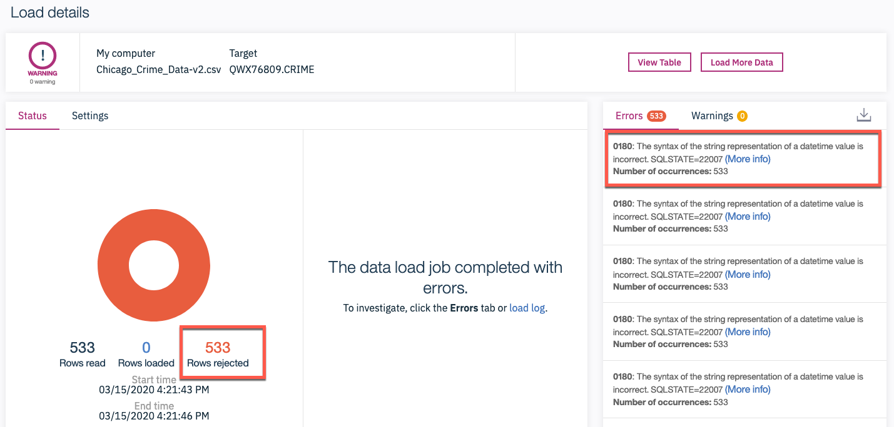

In order to prevent such errors when loading data, in the Db2 console you can preview the datatype and format of the automatically identified values with the values in the datasets in the LOAD screen such as the one below. If there is an issue, it is usually identified with an Warning icon (red triangle with an exclamation mark) next to the datatype of the column (e.g. DATE column in the example below). To correct this, you may first need to click on the "Clock" icon next to the "Time and Date format" to see the formats, if they are not already visible.

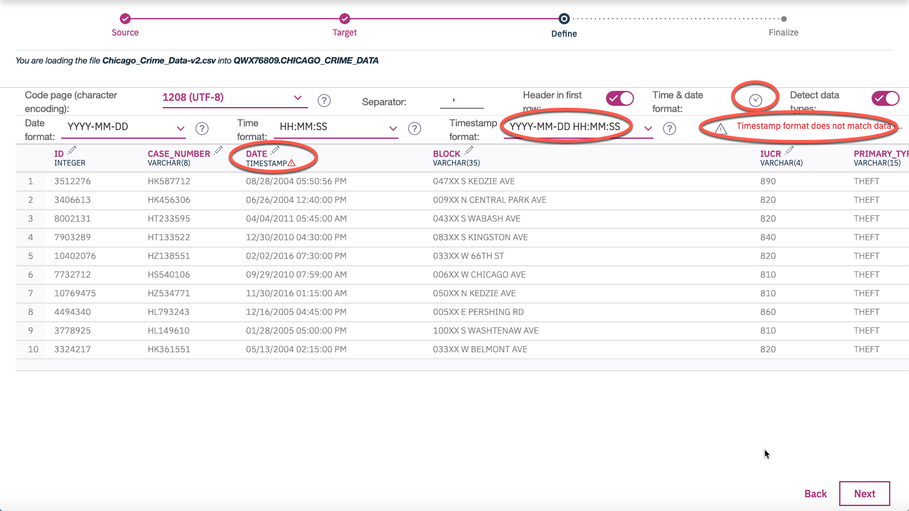

First check if there is a pre-defined format in the drop down list that matches the format the date/time/timestamp is in the source dataset. If not, type the correct format. Upon doing so, the Mismatch Warning (and exclamation sign) should disappear. In this example below we changed/overwrote the default Timestamp format of \*\*YYYY-MM-DD HH:MM:SS \*\*to **MM/DD/YYYY HH:MM:SS TT** to match the value of **08/28/2004 05:50:56 PM** in the dataset.

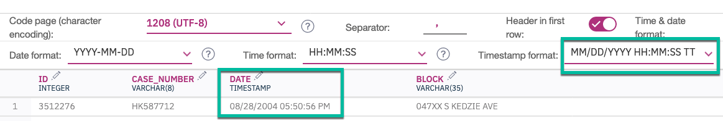

Good luck!

## Author(s)

[Rav Ahuja](https://www.linkedin.com/in/ravahuja/?utm_medium=Exinfluencer&utm_source=Exinfluencer&utm_content=000026UJ&utm_term=10006555&utm_id=NA-SkillsNetwork-Channel-SkillsNetworkCoursesIBMDeveloperSkillsNetworkDB0201ENSkillsNetwork22-2022-01-01)

## Changelog

| **Date** | **Version** | **Changed by** | **Change Description** |
| --- | --- | --- | --- |
| 2020-08-27 | 0.2 | Simran | Migrated Lab to Markdown and added to course repo in GitLab |
|  |  |  |  |
|  |  |  |  |

### © IBM Corporation 2020. All rights reserved.